**Large Shapes (for Before)**

**Master 7a**

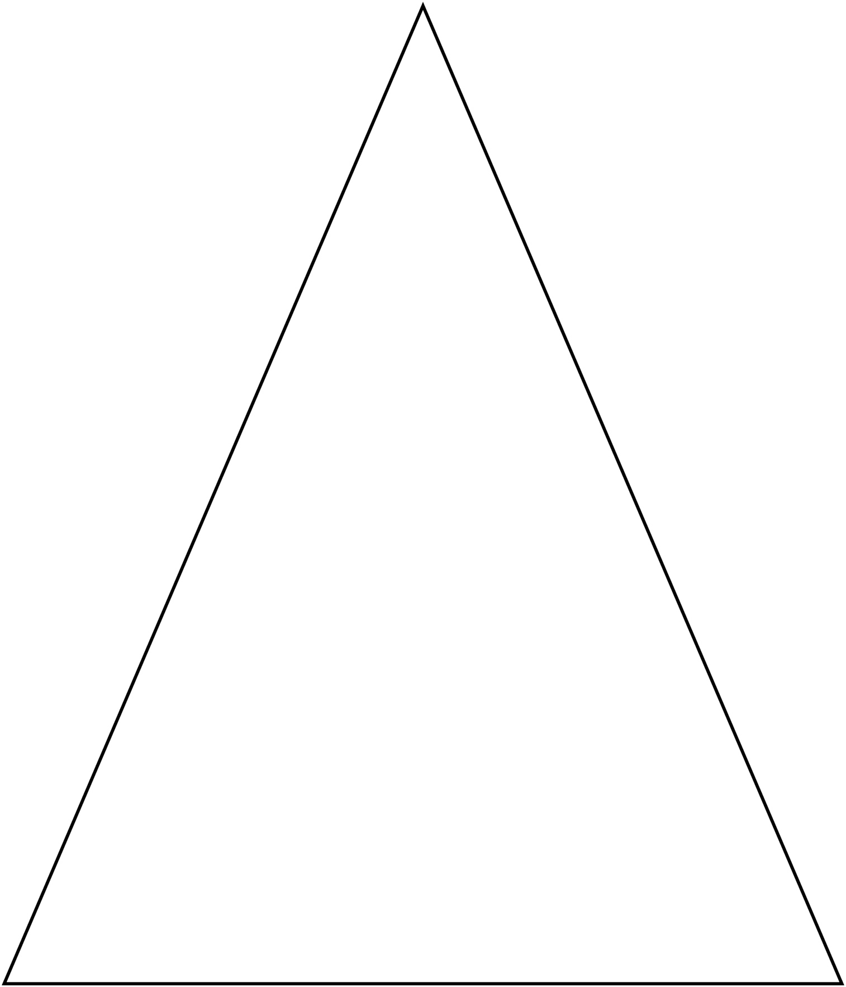

**Large Shapes (for Before)**

**Master 7b**

