Sorting Shapes Using Two Attributes Behaviours/Strategies
- Student randomly places shapes  without thinking about attributes  and is unable to sort set of shapes  based on two attributes.  “I didn’t know where to  put the shapes.” | - Student chooses a shape, but is  unable to analyze its geometric  attributes and is unable to sort  shapes based on two attributes.  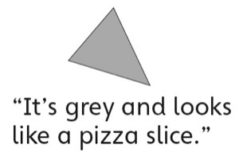 | - Student sorts some shapes based  on two attributes, but struggles  when orientation or shapes are  unfamiliar.  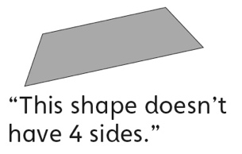 | - Student sorts a set of shapes based on single attributes, but struggles to sort using both attributes simultaneously (ignores overlap).  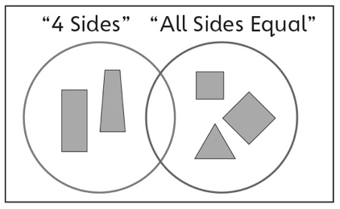
Observations/Documentation
- Student sorts a set of shapes based on two attributes, but struggles to explain why the shapes were placed where they were.  “I just know they go where  I put them.” | - Student sorts a set of shapes  based on two attributes, but  struggles to identify the sorting  rules used to sort the shapes.  “I don’t know what attributes  they used.” | - Student sorts a set of shapes based on two attributes and identifies the sorting rules in given sorts, but has difficulty communicating them.  “I can’t explain it.” | - Student sorts a set of shapes  based on two attributes and  identifies and describes the sorting rules in given sorts.

Big Idea |  |  |  |  | Indicators from Learning Progression
Curriculum Expectations addressed

Student Names
Student can identify geometric and non-geometric attributes of shapes.
(Activities 1, 2, 3, 4, 5)
Student can sort shapes using two attributes or by numbers of lines of symmetry.
(Activities 1, 4, 5)
Student can name familiar 2-D shapes.
(Activities 1, 2, 3, 4, 5)
Student can identify a shape from its attributes.
(Activities 2, 5)
Student can construct 2-D shapes with given attributes.
(Activity 3)
Student can use math language to describe shapes.
(Activities 1, 2, 3, 4, 5)
Student can describe how 2 shapes are alike and how they are different.
(Activities 1, 3, 5)
Student can identify lines of symmetry on 2-D shapes.
(Activities 4, 5)
Student can identify the attributes used to sort a given sort.
(Activity 5)

Name: _______________________

 | Not Observed | Sometimes | Consistently
Identifies geometric and non-geometric attributes of shapes.
(Activities 1, 2, 3, 4, 5)
Sorts shapes using two attributes or by numbers of lines of symmetry.
(Activities 1, 4, 5)
Names familiar 2-D shapes.
(Activities 1, 2, 3, 4, 5)
Identifies a shape from its attributes.
(Activities 2, 5)
Constructs 2-D shapes with given attributes.
(Activity 3)
Uses math language to describe shapes.
(Activities 1, 2, 3, 4, 5)
Describes how 2 shapes are alike and how they are different.
(Activities 1, 3, 5)
Identifies lines of symmetry on 2-D shapes.
(Activities 4, 5)
Identifies the attributes used to sort a given sort.
(Activity 5)

Strengths:

Next Steps:

