Constructing 2-D Shapes from Other Shapes Behaviours/Strategies
- Student looks at the outline, but does not  know which 2-D shapes to use to construct a  composite shape (hexagon). | - Student places blocks randomly with no thought to the outline to construct a composite shape (hexagon) from other 2-D shapes.  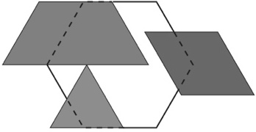 | - Student constructs a composite shape (hexagon) from other 2-D shapes, but leaves gaps or overlaps when using blocks to cover hexagon.  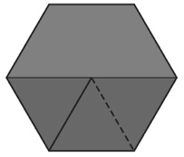
Observations/Documentation
- Student constructs a composite shape (hexagon) from other 2-D shapes, but cannot construct it in a different way.  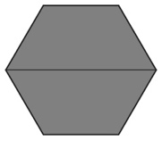 | - Student constructs a composite shape (hexagon) from other 2-D shapes, but struggles to describe and identify shapes used.  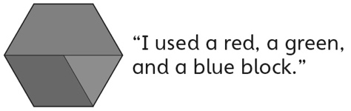 | - Student constructs a composite shape (hexagon) from other 2-D shapes in different ways and identifies shapes used.  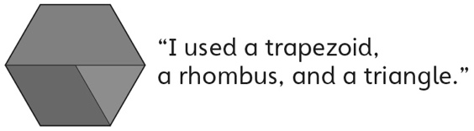
Observations/Documentation

