Covering Outlines with 2-D Shapes Behaviours/Strategies
- Student covers a picture outline with shapes,  but places blocks randomly with no thought to outline.  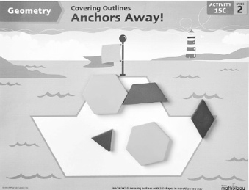 | - Student covers a picture outline with shapes, but leaves gaps or overlaps.  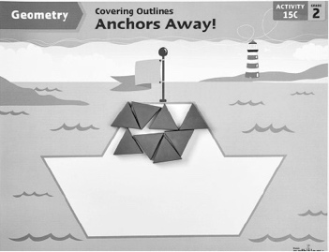 | - Student covers a picture outline with shapes,  but always tries to place matching blocks in the  same relative position.  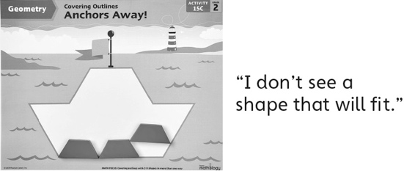
Observations/Documentation
- Student covers a picture outline with shapes and uses guess and test to fill a space.  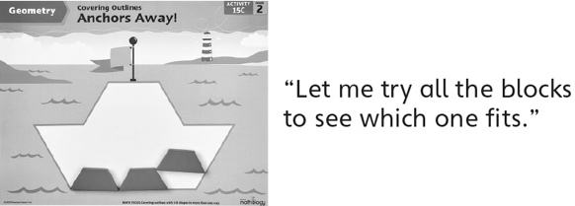 | 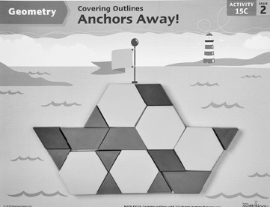  - Student successfully completes a picture outline with shapes, but thinks there is only one way to cover it. | - Student successfully completes a picture outline with shapes in one way and sees more than one way to cover it.
Observations/Documentation

