**Pictures for Symmetry**

**Master 40a**

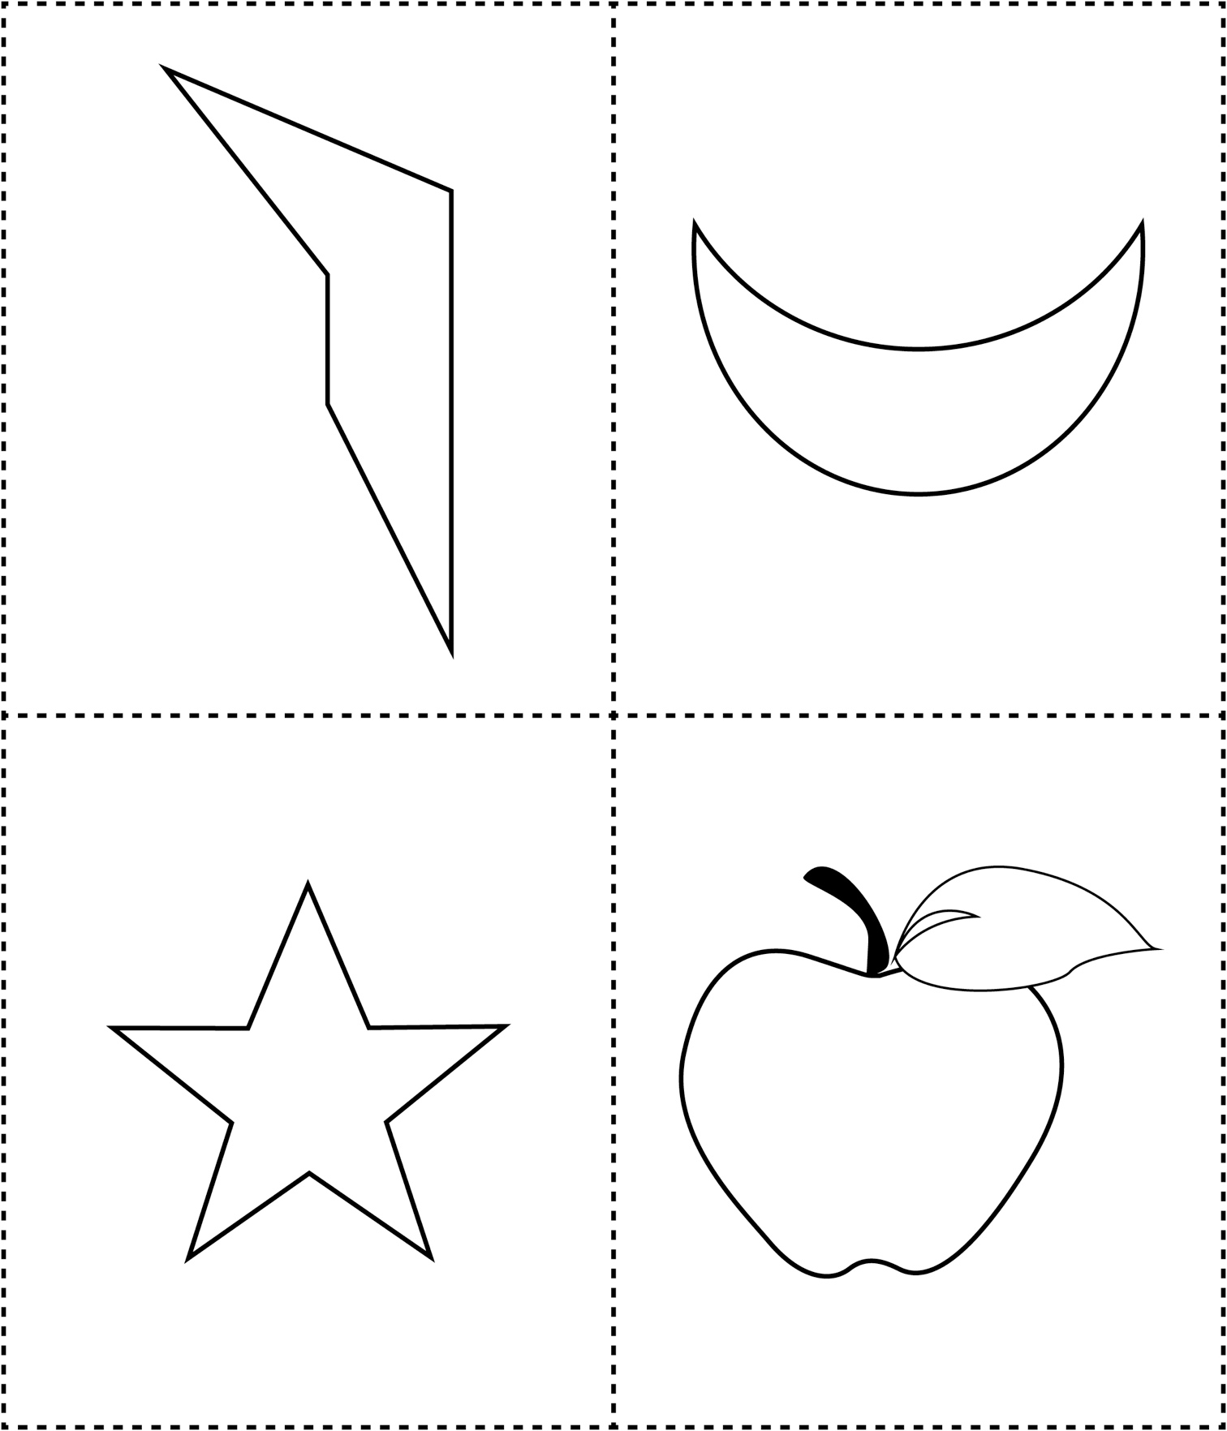

**Pictures for Symmetry**

**Master 40b**

