**Task Cards**

**Master 43a**

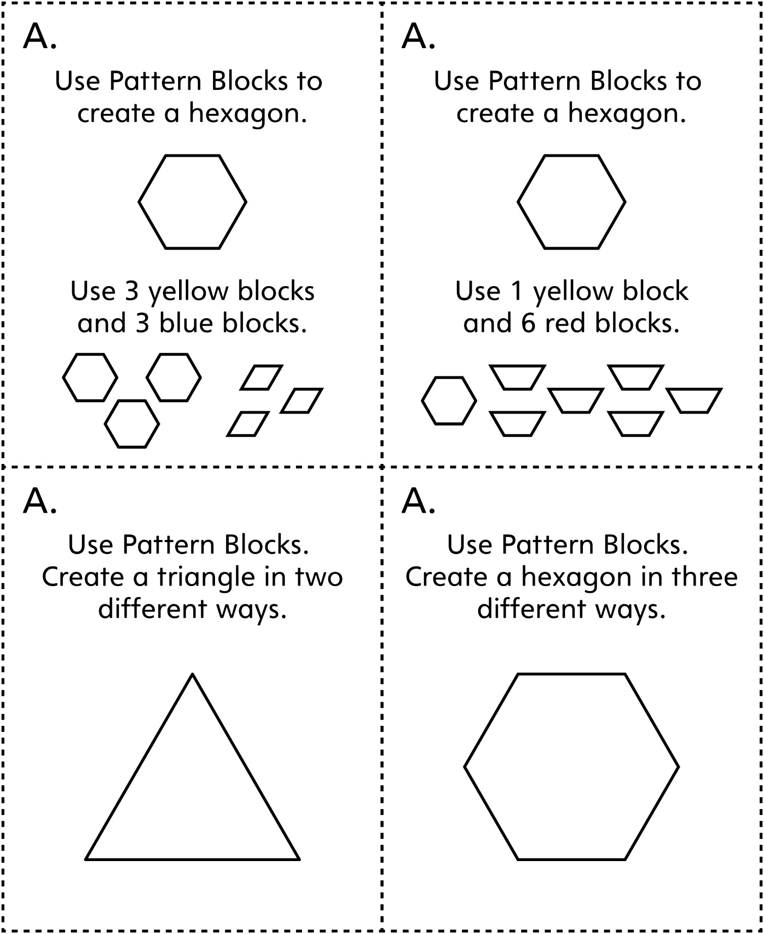**Note:** Task cards are grouped by type. For example, all cards labelled A focus on using shapes to create other shapes.



**Task Cards**

**Master 43b**

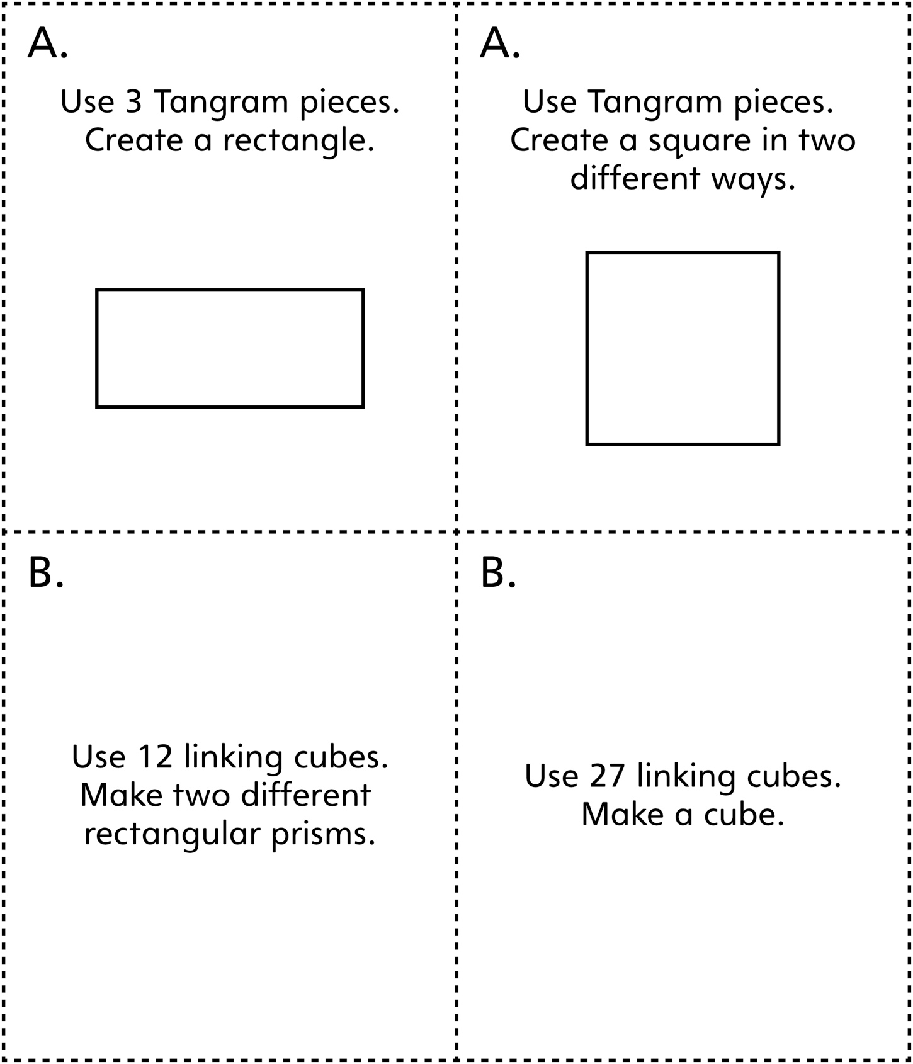

**Task Cards**

**Master 43c**

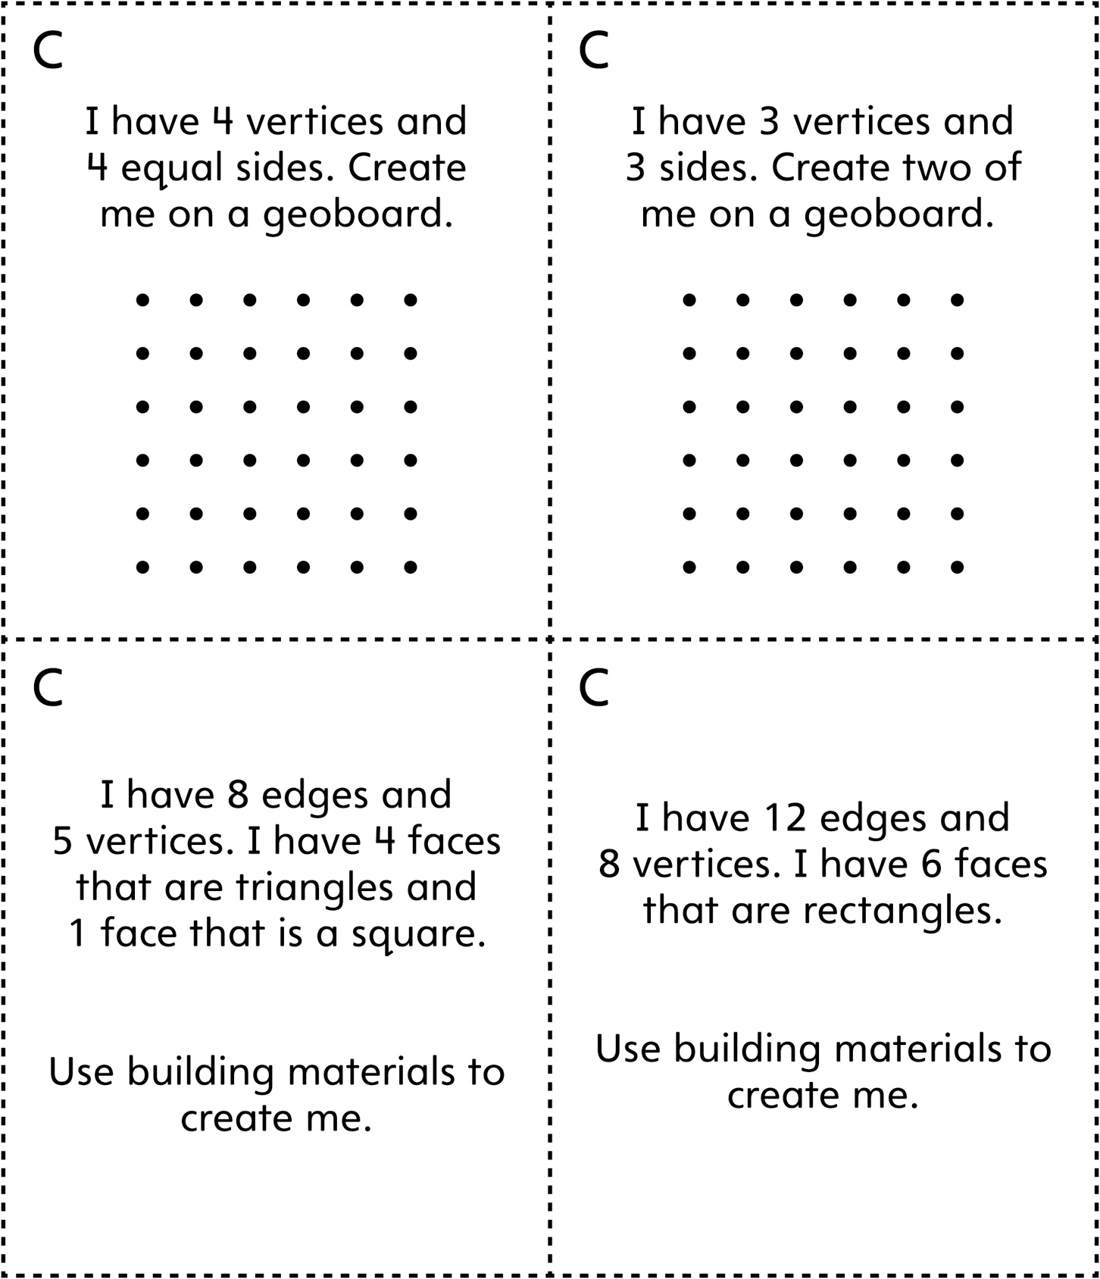

**Task Cards**

**Master 43d**

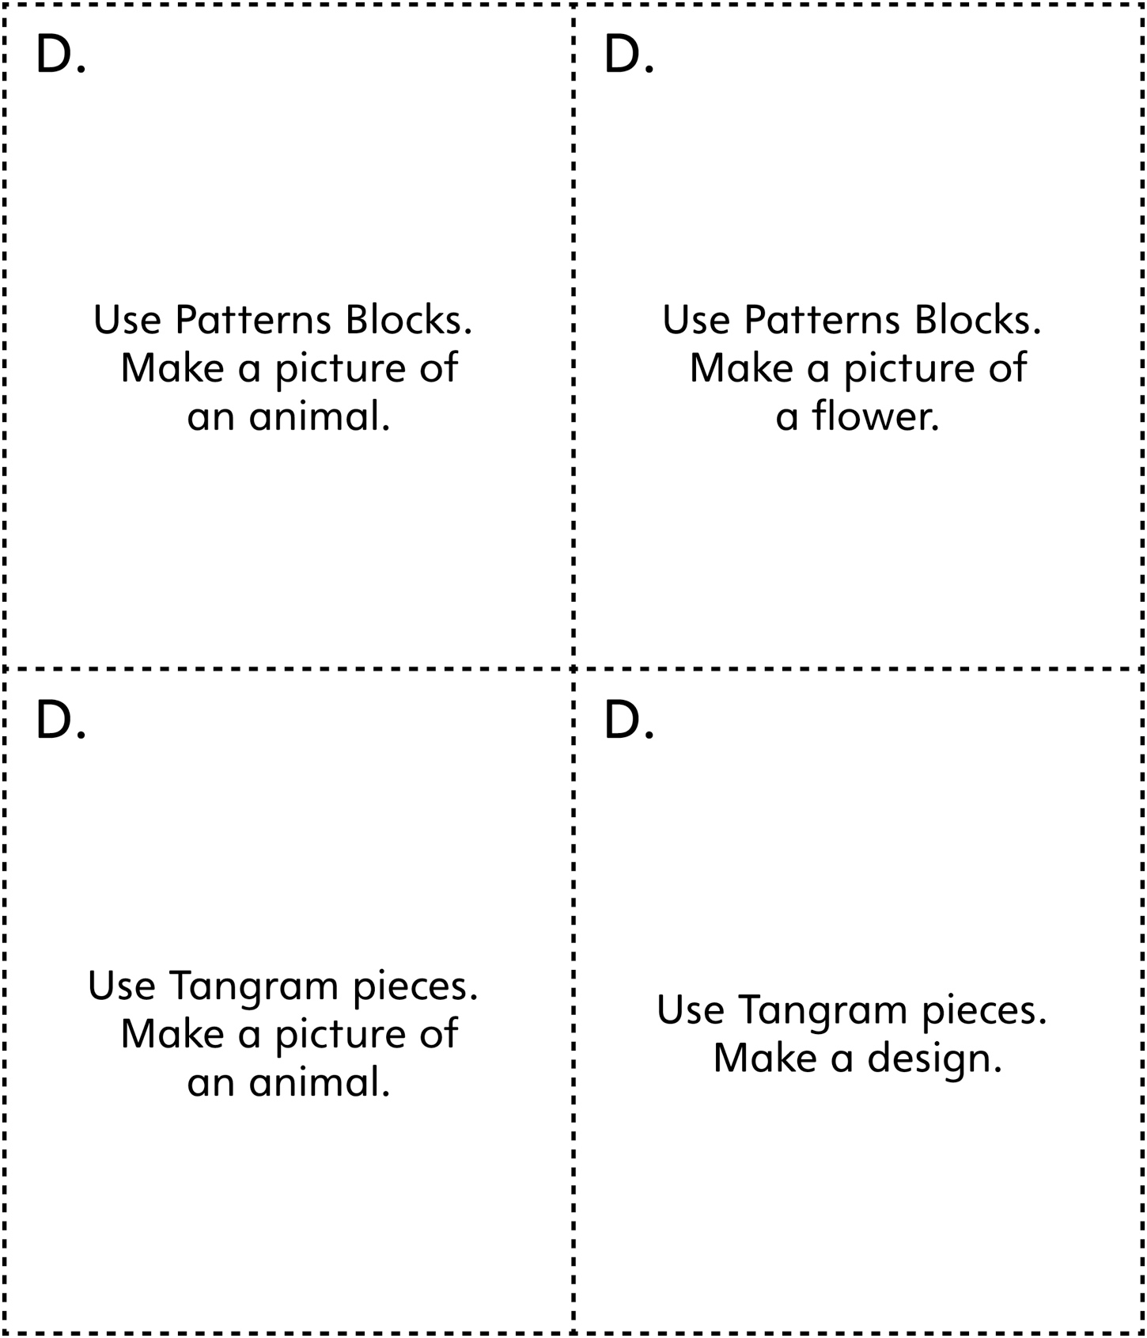

**Task Cards**

**Master 43e**

