Describing Different Perspectives Behaviours/Strategies
- Student chooses an object, but does not show  understanding of the concept of perspective. | - Student chooses an object, but struggles to view the object from different perspectives (cannot isolate a particular view). | - Student views objects from different  perspectives, but struggles to describe the  perspectives.
Observations/Documentation
- Student views objects from different perspectives and uses gestures to describe the perspectives, but struggles to describe them with words.  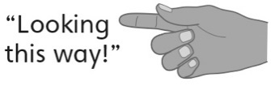 | - Student views objects from different  perspectives and describes the perspectives,  but struggles to describe what the objects  might look like from a different perspective. | - Student successfully views and describes views of objects from multiple perspectives.
Observations/Documentation

