Reading and Writing Codes Behaviours/Strategies
- Student describes the movement from one  location to another on a grid, but struggles to  write it as a code.  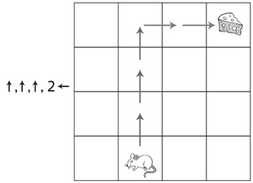 | - Student describes the movement from one  location to another on a grid and writes code,  but makes perspective errors.  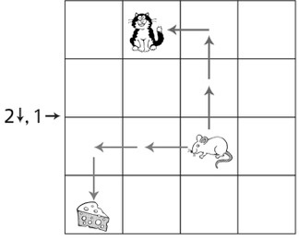 | - Student describes the movement from one  location to another on a grid and writes code  that is accurate in direction, but not in quantity.  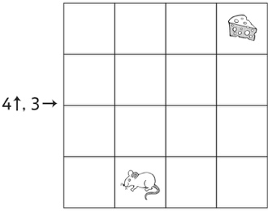
Observations/Documentation
- Student describes the movement from one  location to another on a grid and writes accurate code, but starts over to make a code to avoid the cat. | - Student describes the movement from one  location to another on a grid and writes accurate code, but makes errors in where or how to adjust the code. | - Student describes the movement from one  location to another on a grid, reads and writes  code, and accurately adjusts code to avoid cats.
Observations/Documentation

Big Idea |  |  |  |  | Indicators from Learning Progression
Curriculum Expectations addressed

Student Names
Student can make paths and write codes to describe them.
(Activity 22)
Student can write codes for movements on a grid.
(Activities 23, 24, 25)
Student can read code to move on a grid.
(Activities 23, 24, 25)
Student can write code from memory.
(Activity 23)
Student can write code using numbers and arrows.
(Activities 24, 25)
Student can identify the incorrect code amongst a group of codes.
(Activity 24)
Student can adjust a code to avoid an obstacle.
(Activity 25)
Student can write a code for someone who has a different perspective of the grid.
(Activity 25)

Name: _______________________

 | Not Observed | Sometimes | Consistently
Makes paths and writes codes to describe them.
(Activity 22)
Writes codes for movements on a grid.
(Activities 23, 24, 25)
Reads code to move on a grid.
(Activities 23, 24, 25)
Writes code from memory.
(Activity 23)
Writes code using numbers and arrows.
(Activities 24, 25)
Identifies the incorrect code amongst a group of codes.
(Activity 24)
Adjusts a code to avoid an obstacle.
(Activity 25)
Writes a code for someone who has a different perspective of the grid.
(Activity 25)

Strengths:

Next Steps:

