Drawing Perspective Diagrams Behaviours/Strategies
- Student builds a structure, but struggles to  create 2-D representations of it (e.g., top/front/  side views). | - Student creates one 2-D representation of a  structure (e.g., top, front, or side view), but is  confused by the other views.  “I drew the front. It only has one view.” | - Student accurately creates 2-D representations (e.g., top/front/side views) of 3-D objects.  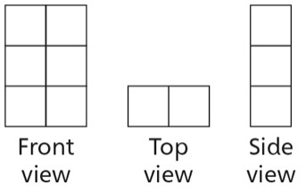
Observations/Documentation
Visualizing Different Perspectives Behaviours/Strategies
- Student builds a structure, but does not show  understanding of the concept of perspective. | - Student builds a structure, but struggles to  visualize and describe the views of the structure from multiple perspectives, as he or she cannot isolate a particular view or distinguish different views. | - Student successfully visualizes and describes the views of a 3-D solid from multiple perspectives (e.g., top/front/side views).
Observations/Documentation

