Using Positional Language Behaviours/Strategies
- Student asks questions, but is uncomfortable with positional language and uses gestures (points) or asks questions that are not yes/no questions.  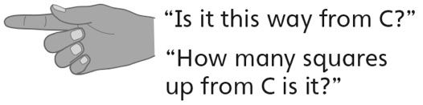 | - Student uses positional language in questions, but struggles with a few positional words, such as right and left.  “I don’t know if that is right or left.” | - Student uses positional language in questions,  but makes counting errors or counts on the  diagonal.  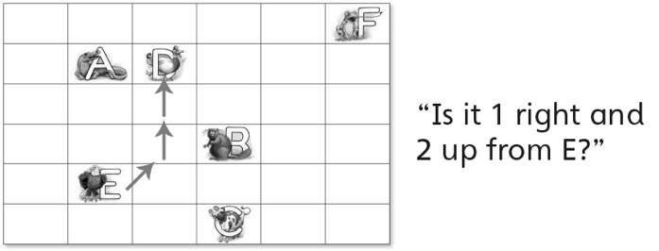
Observations/Documentation
- Student uses positional language in questions, but asks random questions that do not eliminate possible letters. | - Student uses positional language in questions, but is unable to keep track of which letters were eliminated by earlier questions. | - Student asks thoughtful questions using  positional language and correctly identifies the  mystery letter.
Observations/Documentation

