**Months of the Year Game Board**

**Intervention: Master 59a**

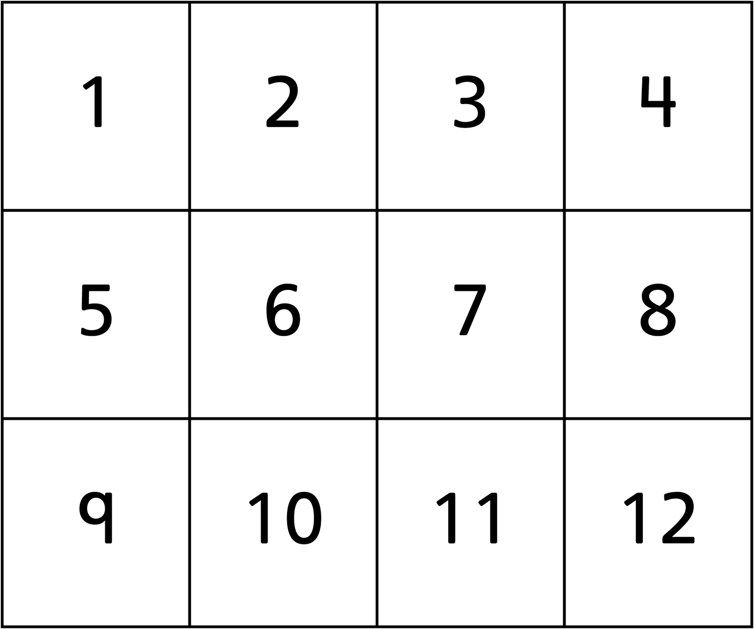

**Months of the Year Game Board**

**Intervention: Master 59b**

**(for Extension)**

