**Clock Cards**

**Intervention: Master 63a**

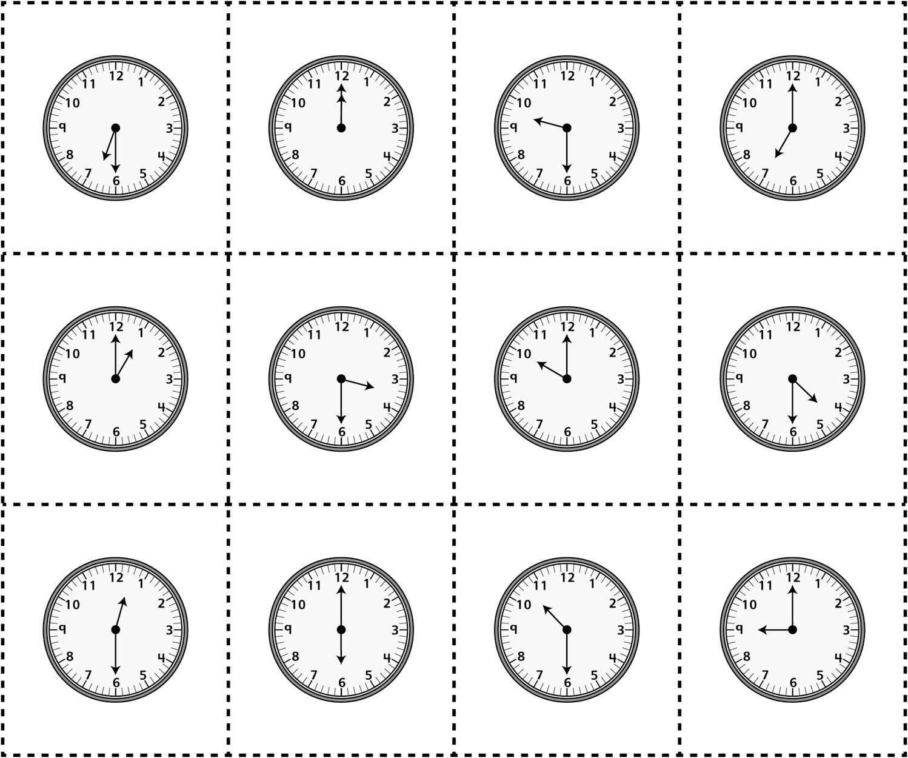

**Clock Cards**

**Intervention: Master 63b**

**(for Accommodations)**

