**Domino Cards**

**Intervention: Master 8a**

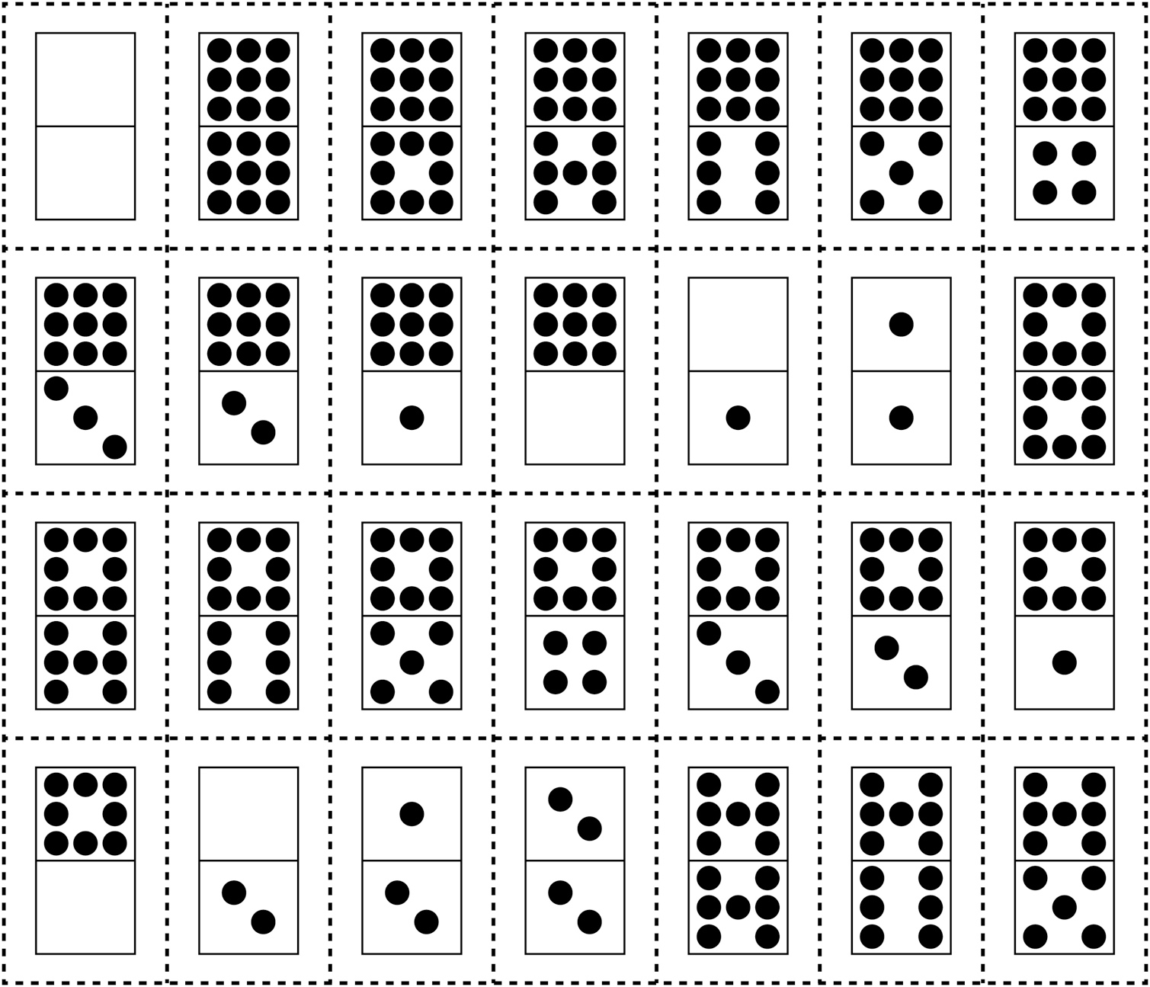

**Domino Cards**

**Intervention: Master 8b**

