**Matching Cards**

**Intervention: Master 20a**

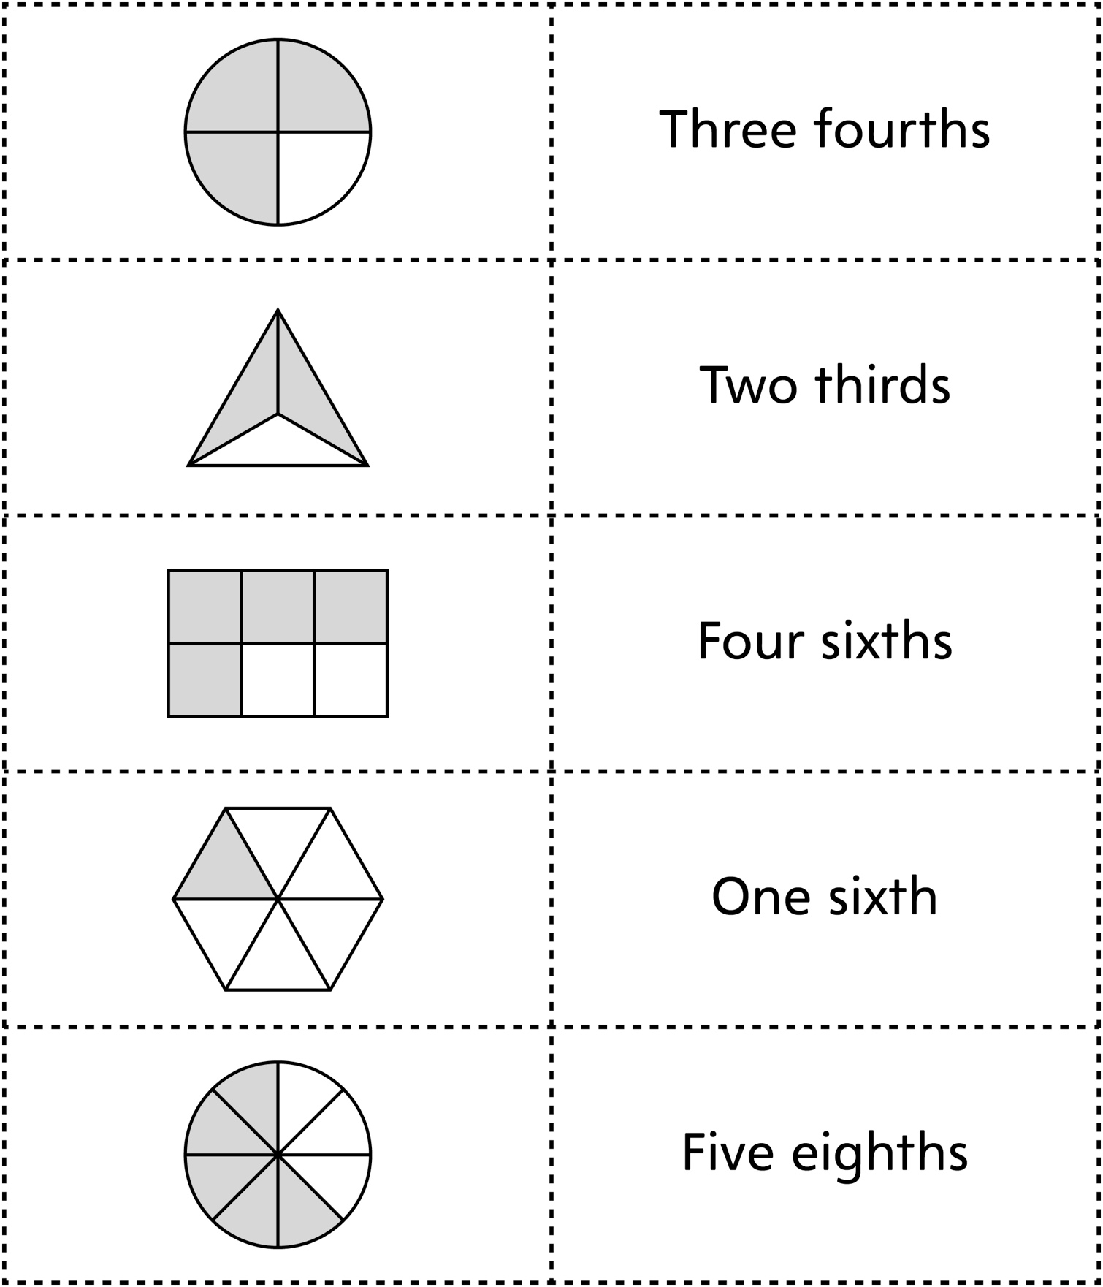

**Matching Cards**

**Intervention: Master 20b**

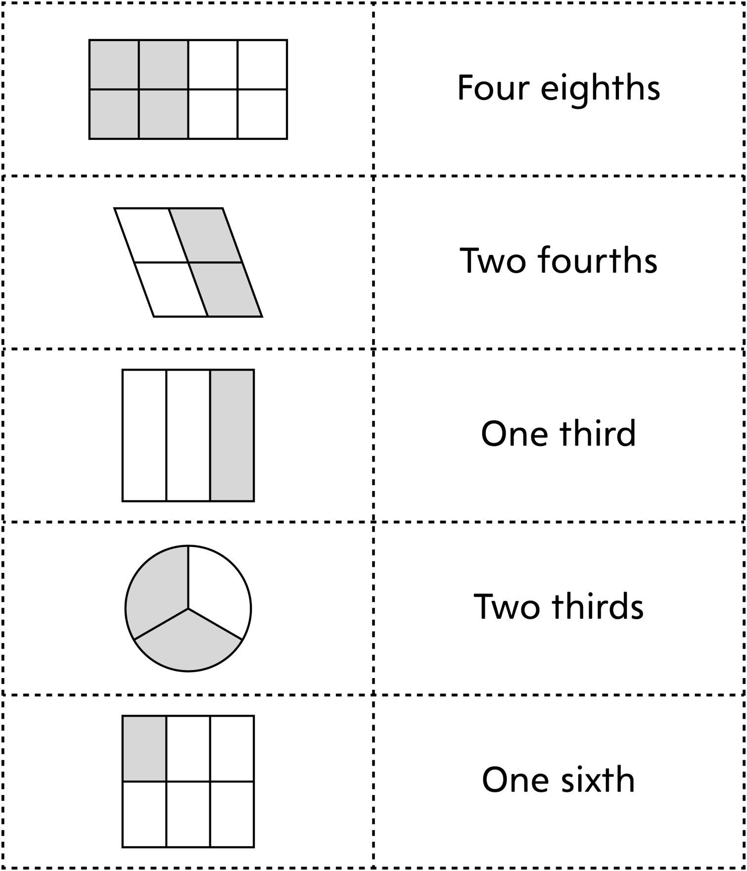

**Matching Cards**

**Intervention: Master 20c**

