Finding the Unknown Part Behaviours/Strategies
- To find a part given the whole and another part, student guesses, adds that many cubes, and then counts all from 1 to check.  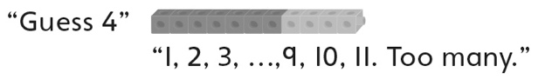 | - To find a part given the whole and another part, student counts on from the part as cubes are added, and then counts the added cubes.  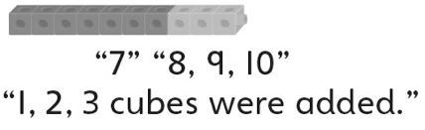 | - To find a part given the whole and another part,  student counts on from the part as cubes are  added and uses fingers to track the count.  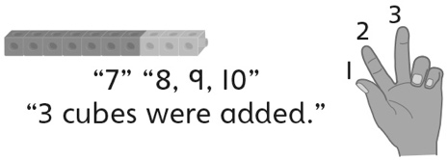
Observations/Documentation
- To find a part given the whole and another part, student counts on from the part or back from the whole, using fingers to track the count.  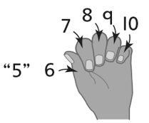 | - Student starts with parts of different sizes,  but does not consider starting with a part of 0 or 10. | - Student efficiently finds the unknown part given  the whole and another part.
Observations/Documentation

