Addition Computational Behaviours/Strategies
- Student counts three times to add quantities.  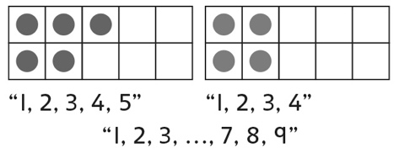 | - Student counts on from the  smaller set to add quantities.  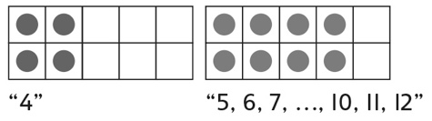 | - Student counts on from the larger  set to add quantities.  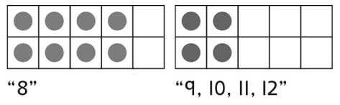 | - Student fluently adds quantities  and demonstrates an  understanding of addition.  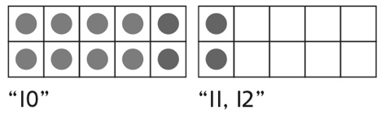
Observations/Documentation
Subtraction Computational Behaviours/Strategies
- Student counts three times to  subtract quantities (e.g., counts  counters in ten-frames, counts to  remove counters, and then counts the leftover counters  from 1). | - Student counts back to subtract  quantities, but begins the count  with the number of counters in  the ten-frames.  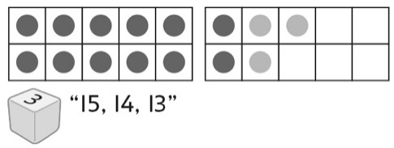 | - Student counts back to subtract  quantities, but removes more  counters than there are.  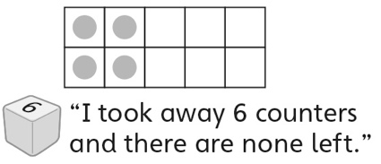 | - Student fluently subtracts  quantities and demonstrates an  understanding of subtraction.  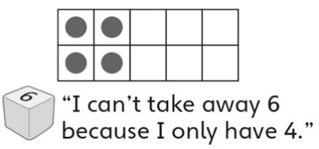
Observations/Documentation

