Decomposing 10 to Write Equalities Behaviours/Strategies
- Student spills counters, but does not understand conservation of number (rearranging counters does not change the quantity) and counts each time the counters are spilled  .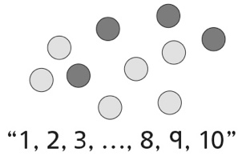 | - Student places counters randomly on ten frames and struggles to count the number of  each colour.  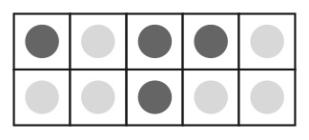 | - Student groups counters of the same colour  together on ten-frames and counts all counters  by 1s.  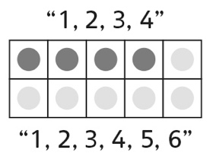
Observations/Documentation
- Student counts or subitizes counters, but  struggles to understand equality (does not  associate two full ten-frames with equality). | - Student understands equality, but has difficulty recording different expressions of the same quantity as equalities (cannot write number sentence). | - Student understands equality and successfully  records different expressions of the same  quantity as equalities.  3 + 7 = 4 + 6  2 + 8 = 5 + 5
Observations/Documentation

