**Geometry Poem**

**Math Every Day: Master 14**

Solids aren’t flat, they’re fat.

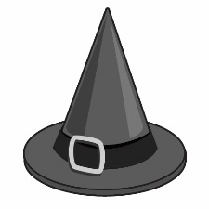

**A cone is** like a pointy hat.

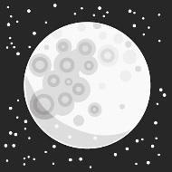

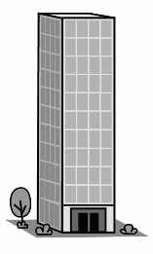**A sphere is** like a full moon in the sky.

**A prism is** a building high.

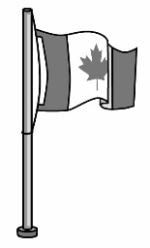

**A cylinder is** like a tall flag pole.

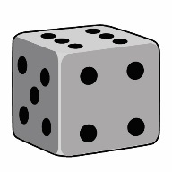

**A cube is** something fun you roll.

Solids are here. Solids are there.

Solids are almost everywhere.