Fill Me In!
Math Every Day: Master 15a

Pattern Block Outlines

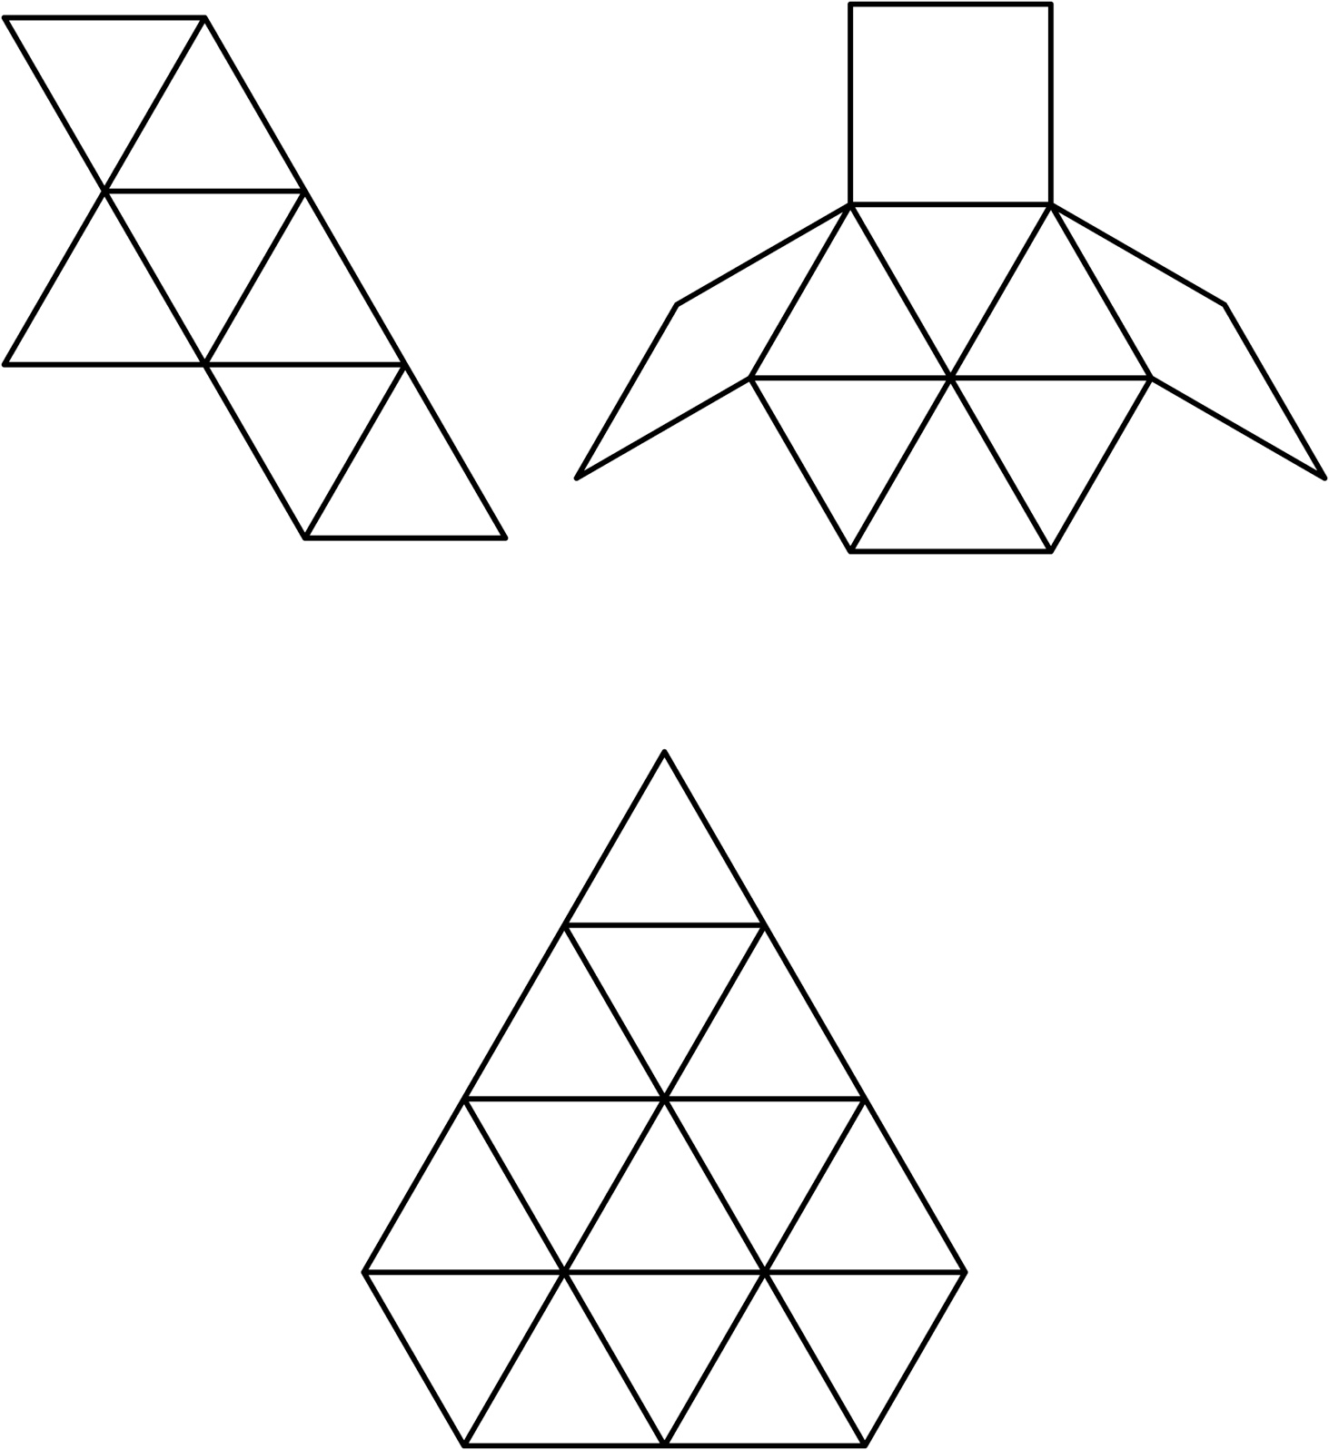

Fill Me In!
Math Every Day: Master 15b

Pattern Block Outlines

