**Draw the Shape Cards**

**Math Every Day: Master 16a**

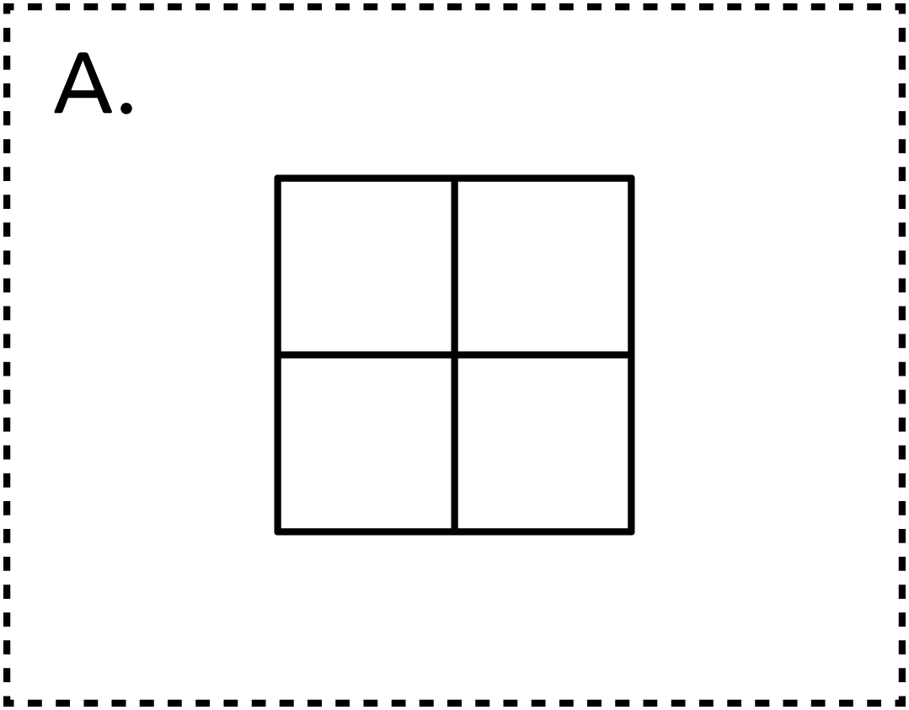

**Draw the Shape Cards**

**Math Every Day: Master 16b**

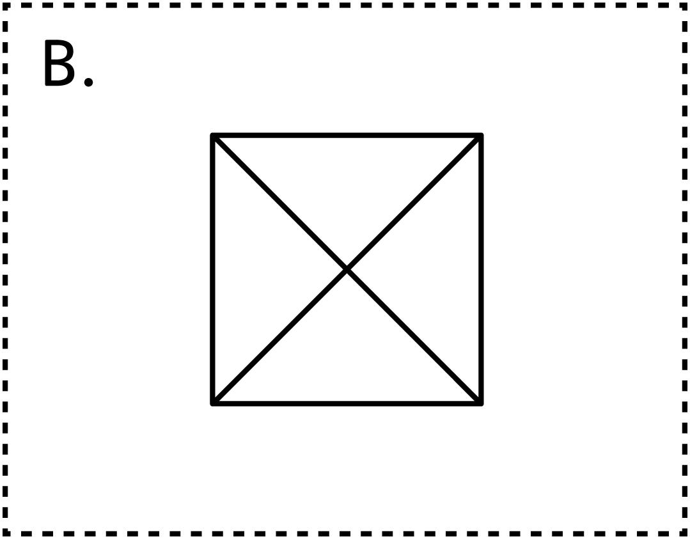

**Draw the Shape Cards**

**Math Every Day: Master 16c**

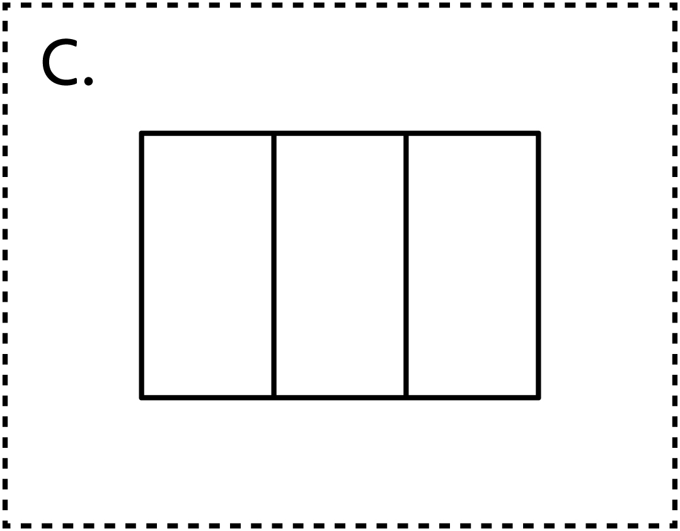

**Draw the Shape Cards**

**Math Every Day: Master 16d**

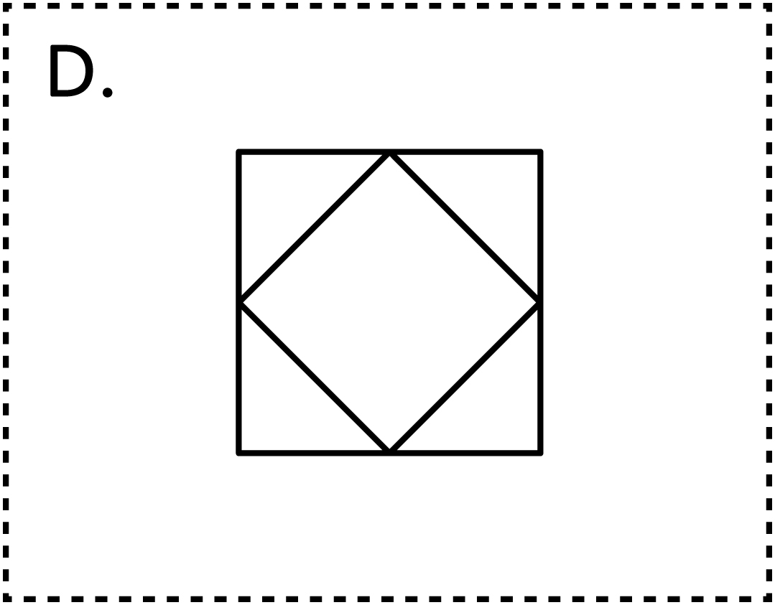

**Draw the Shape Cards**

**Math Every Day: Master 16e**

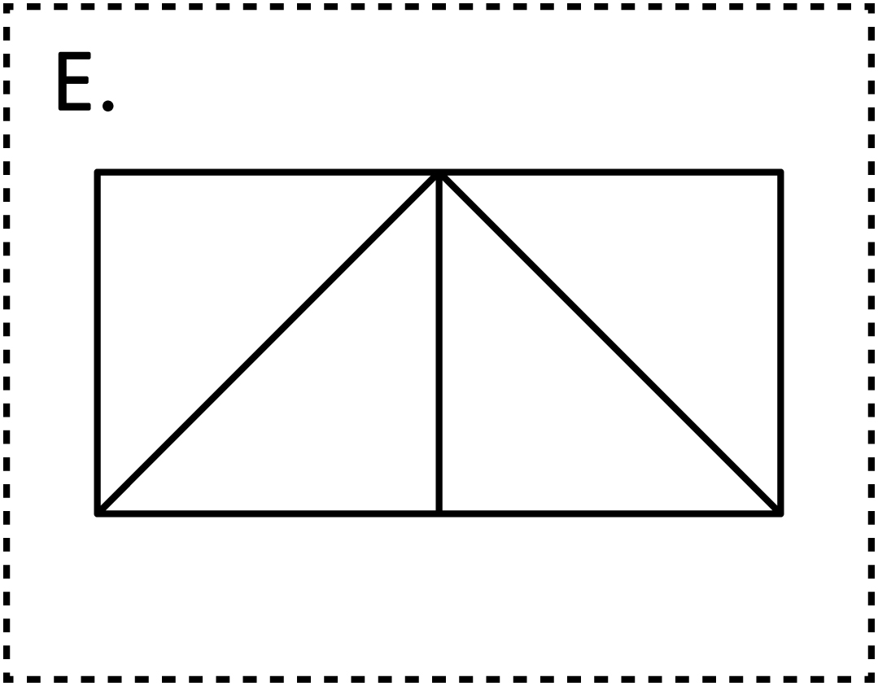

**Draw the Shape Cards**

**Math Every Day: Master 16f**

