Ordinal Number Cards (1st–12th)
Math Every Day: Master 10a

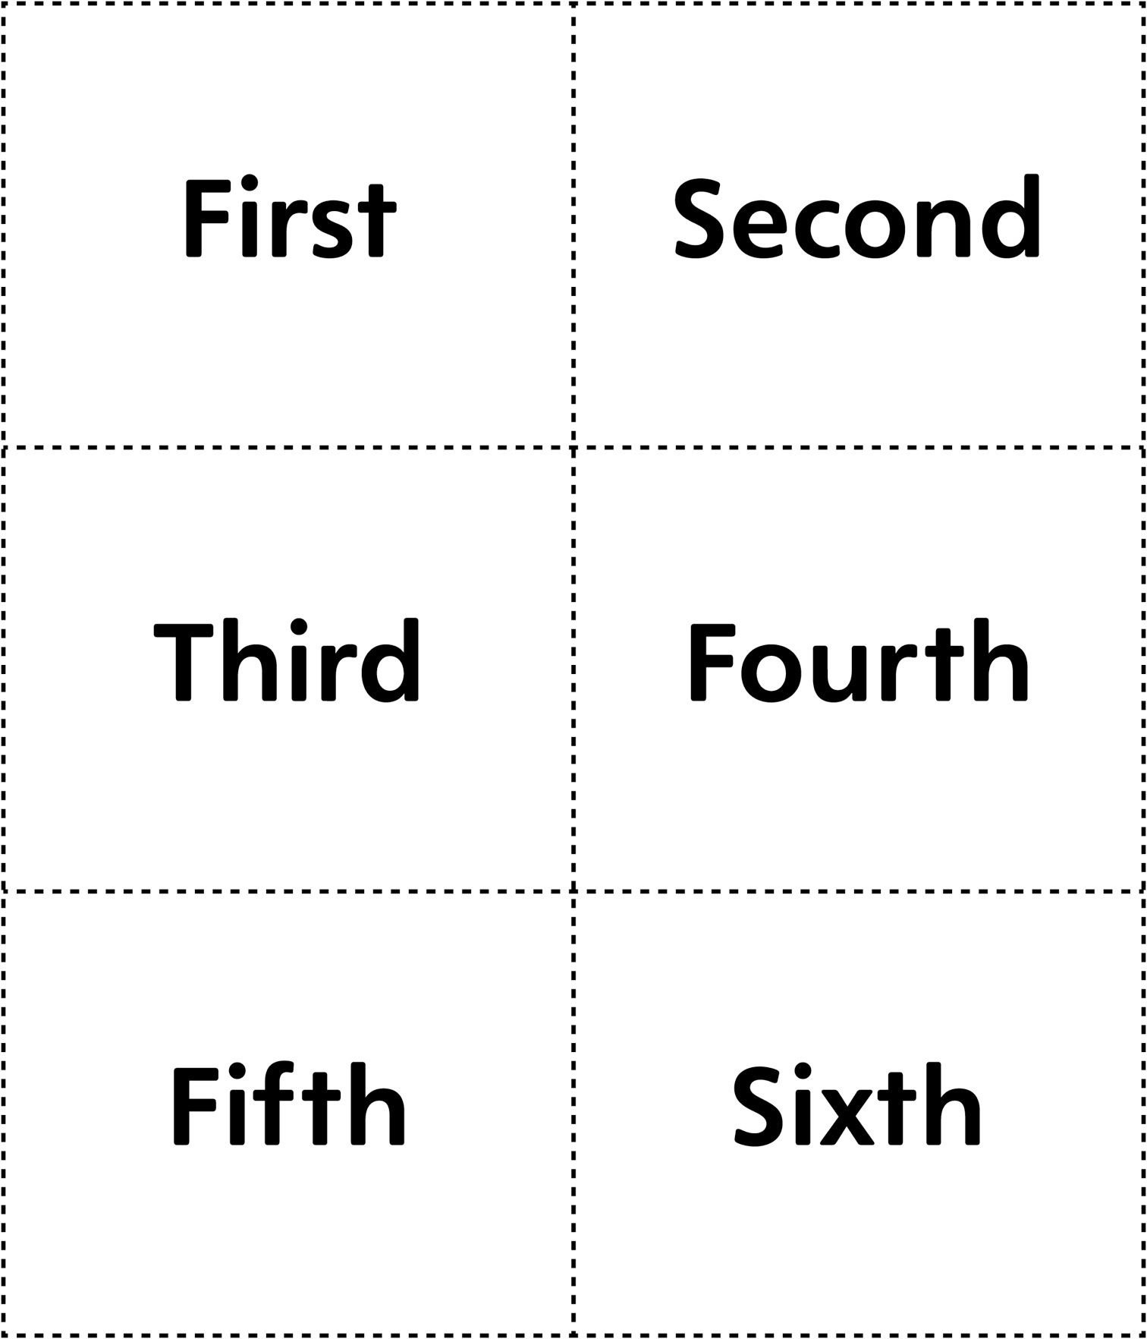

Ordinal Number Cards (1st–12th)
Math Every Day: Master 10b

