**Repeating Patterns Around Us**

**Math Every Day: Master 6**

**Wall Art**

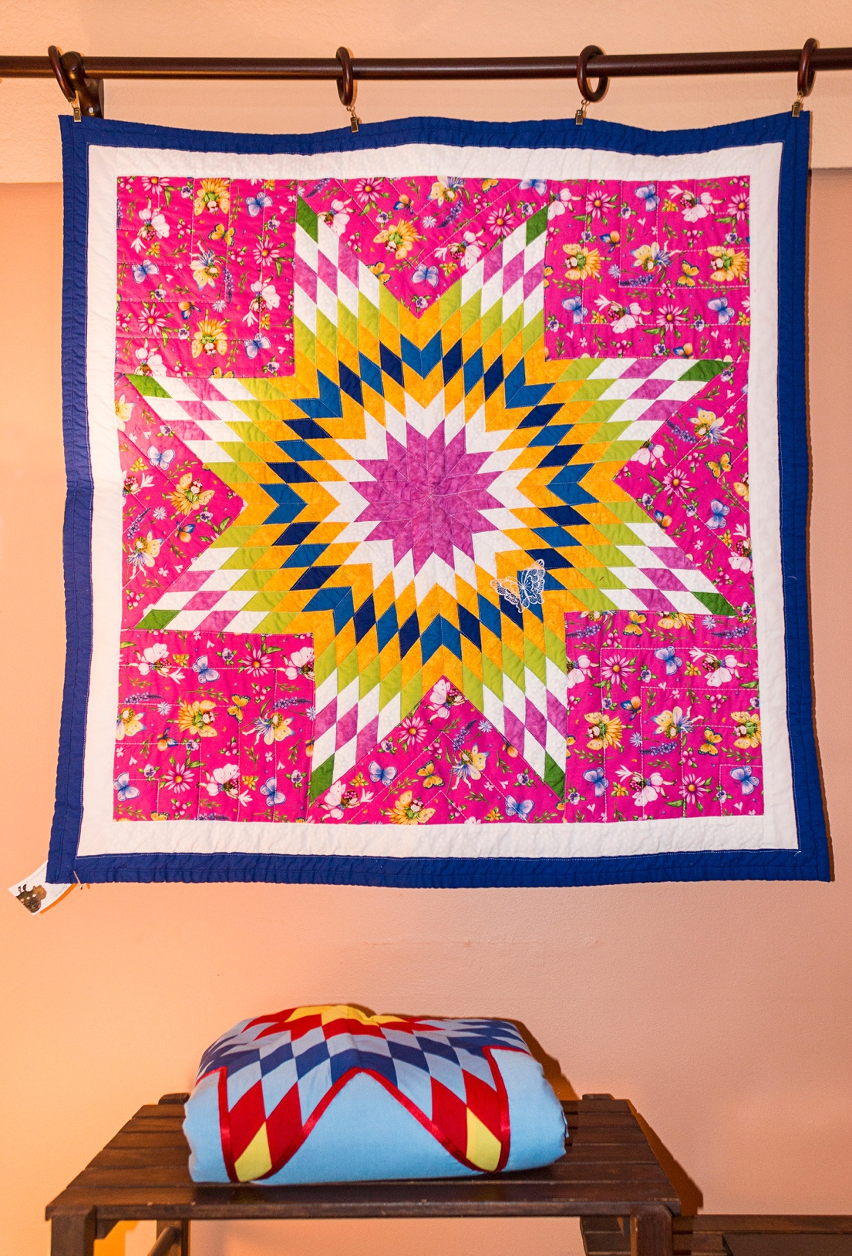

**Crosswalk**

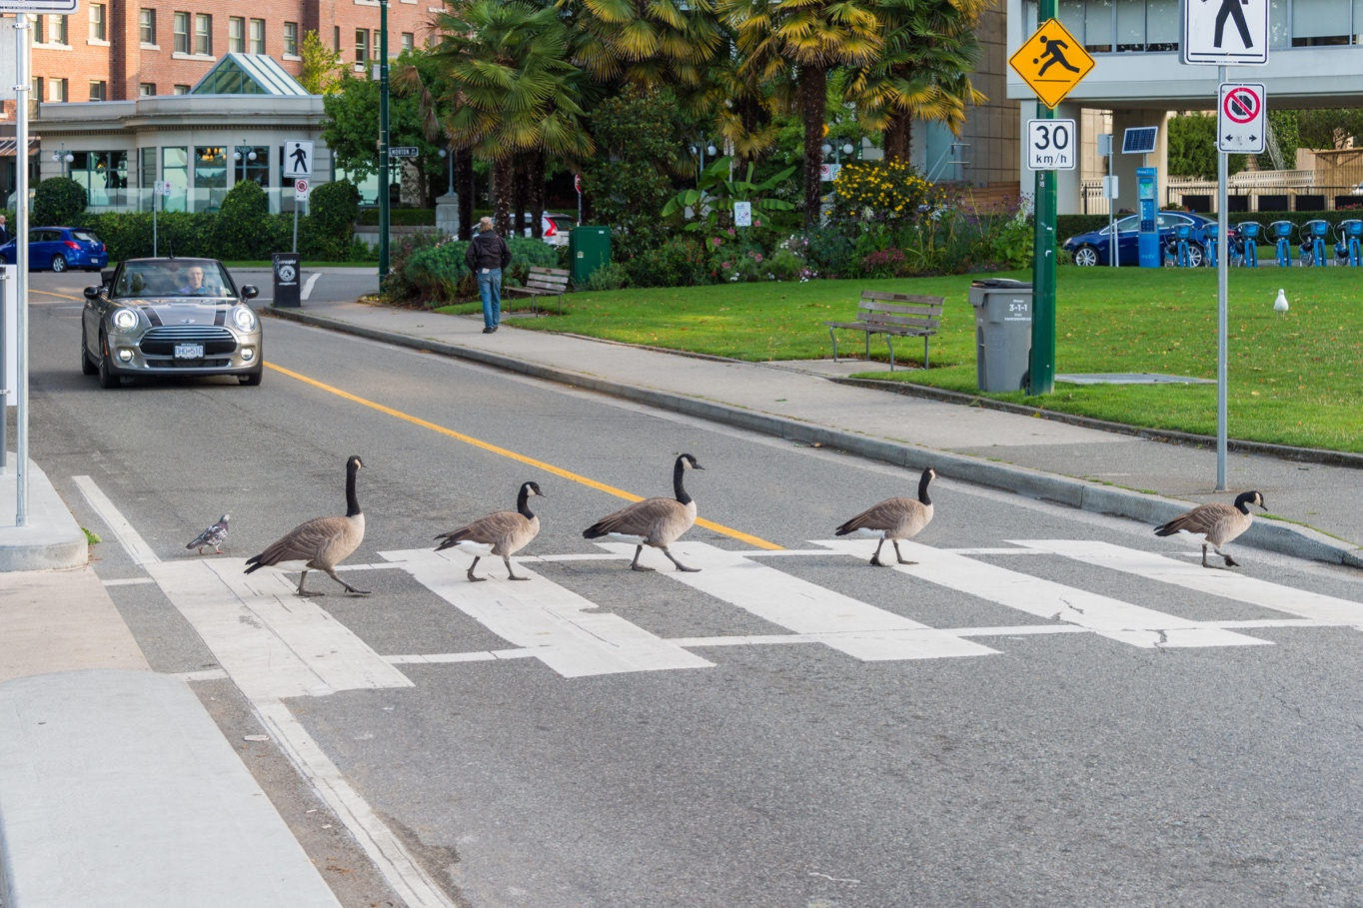

**Paving Stones**

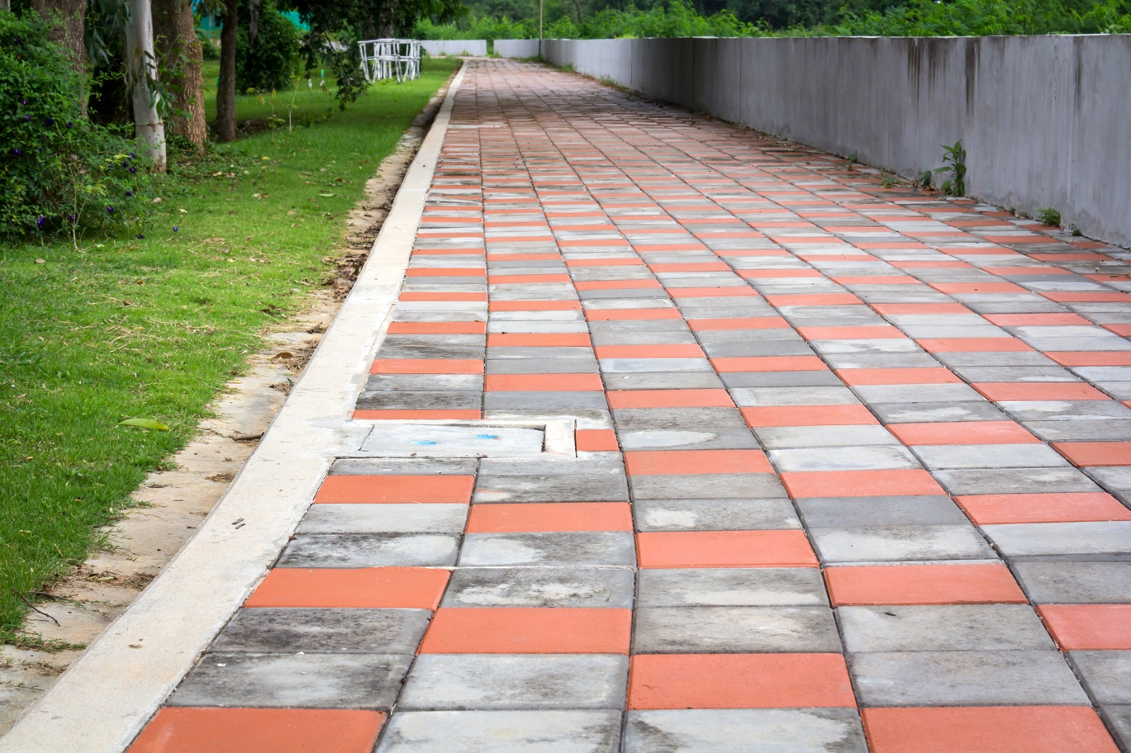

**Garden Path**

