Estimating, Measuring, and Comparing Distance Around Behaviours/Strategies
- Student attempts to estimate  objects by length (distance  around) with non-standard units,  but estimates are extreme/  unreasonable.  “About 100 paper clips!” | - Student estimates objects by  length (distance around) with non-standard units, but struggles to use string to measure.  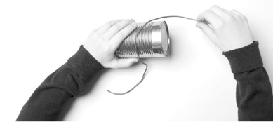 | - Student measures objects by  length (distance around) using  multiple copies of a non-standard  unit, but units are not placed end-to-end (there are gaps or overlaps).  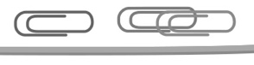 | - Student measures objects by  length (distance around) using  multiple copies of a non-standard  unit, but does not align the base  of the first unit with the end of the  object being measured.  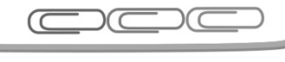
Observations/Documentation
- Student measures objects by  length (distance around) by  iterating a single non-standard  unit, but has difficulty tracking the  length of the paper clip or loses  track of the count.  “I forget how many times I moved  the paper clip.” | - Student measures objects by  length (distance around) with  non-standard units, but forgets to  include the unit when stating the  measure.  “It is 8 long.” | - Student measures objects by  length (distance around) with non-standard units, but struggles to compare and order objects. | - Student successfully estimates,  measures, compares, and orders  objects by length (distance around) with non-standard units.
Observations/Documentation

