Estimating, Measuring, and Comparing Mass Behaviours/Strategies
- Student struggles to estimate and compare  objects by mass with non-standard units and  thinks a larger object has a greater mass.  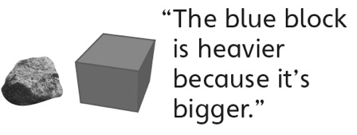 | - Student measures and compares objects by  mass with non-standard units, but thinks the  heavier object is in the higher pan of the pan  balance.  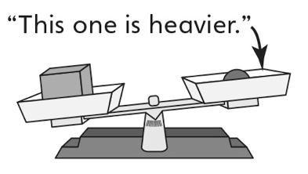 | - Student measures and compares objects by  mass with non-standard units, but struggles with the technical use of the pan balance (e.g., has accuracy issues or thinks the arrangement of objects in the pans will impact the mass).
Observations/Documentation
- Student estimates and measures objects by  mass with non-standard units, but struggles to  order the objects from lightest to heaviest. | - Student estimates, measures, compares, and  orders objects by mass with non-standard units, but struggles to see a relationship between the size of the unit and the number of units. | - Student successfully estimates, measures,  compares, and orders objects by mass with non-standard units, and sees a relationship between the units.
Observations/Documentation

