Estimating, Measuring, and Comparing Area Behaviours/Strategies
- Student estimates objects by area with non-standard units, but estimates are extreme/  unreasonable.  “About 100 tiles!” | - Student measures objects by area by iterating  a single non-standard unit, but randomly slides the unit along the surface without tracking where one unit would end and the next unit would begin. | - Student measures objects by area using multiple copies of a non-standard unit, but randomly covers the rectangle with tiles (has gaps or overlaps).  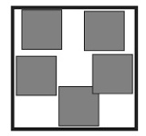
Observations/Documentation
- Student measures objects by area using  multiple copies of a non-standard unit, but  counts the tiles by 1s.  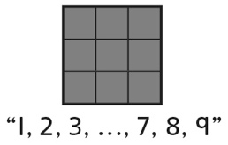 | - Student estimates and measures objects by  area with non-standard units, but struggles to  compare areas.  “These rectangles look different.  They can’t have the same area.” | - Student successfully estimates, measures, and  compares objects by area with non-standard  units and recognizes that shapes that look  different can have the same area.
Observations/Documentation

