Estimating, Measuring, Comparing, and Ordering Capacity Behaviours/Strategies
- Student estimates objects by capacity using an intermediary object, but estimates are extreme/unreasonable.  “About 100 cups!” | - Student uses an intermediary object to  measure objects by capacity, but randomly fills containers, paying no attention to the count. | - Student measures objects by capacity using  an intermediary object, but does not fill the  containers.  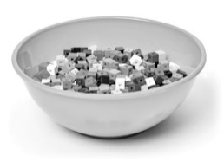
Observations/Documentation
- Student measures objects by capacity using an intermediary object, but has difficulty keeping track of the count or is unsure how to deal with a partial cup.  “There is still room for more cubes,  but a whole cup won’t fit.” | - Student measures objects by capacity using an intermediary object, but struggles to order the containers from least to greatest capacity.  “How do I order the containers?” | - Student successfully estimates, measures,  compares, and orders objects by capacity using  an intermediary object.
Observations/Documentation

