Analogue Clock Cards
Master 42a

(Part 1)

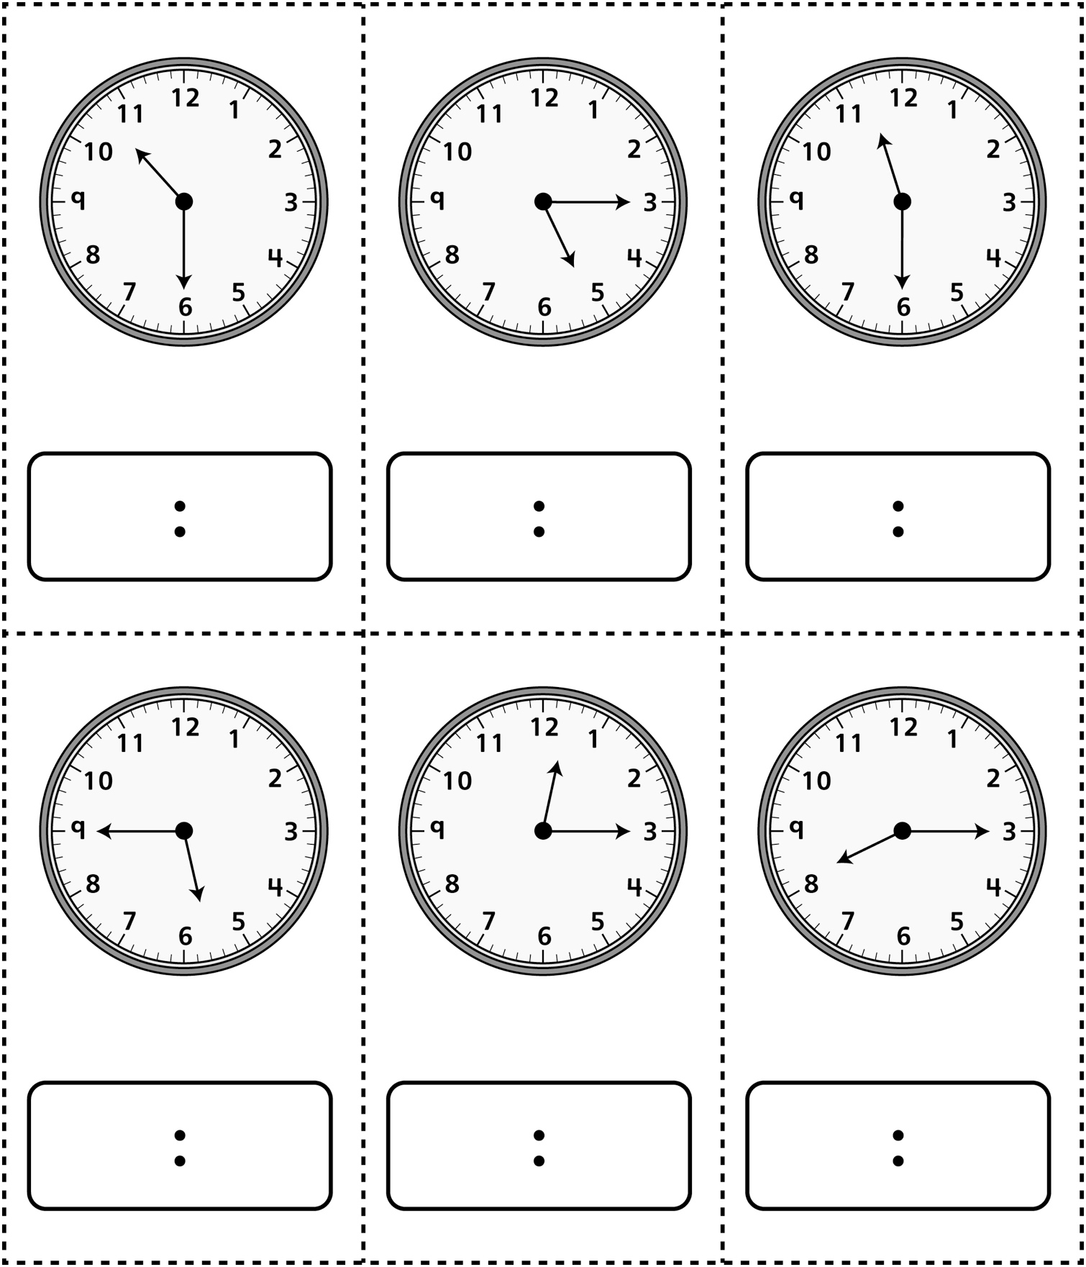
Analogue Clock Cards
Master 42a

(Part 2)

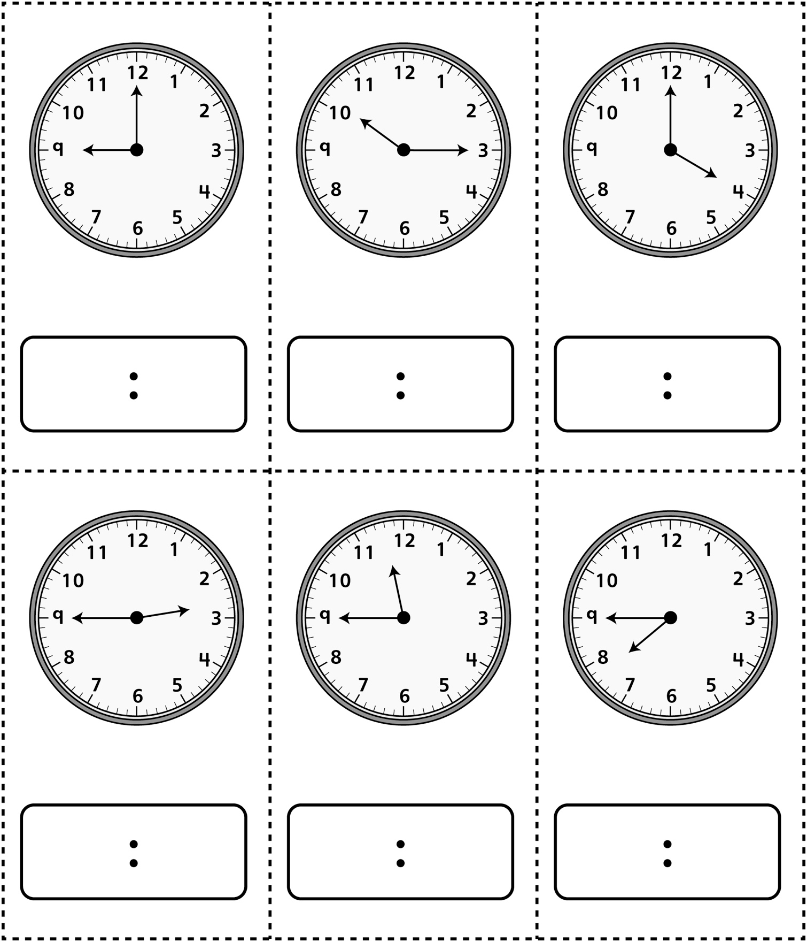
Analogue Clock Cards
(for Combined Grades Extension) (Part 1)
Master 42b

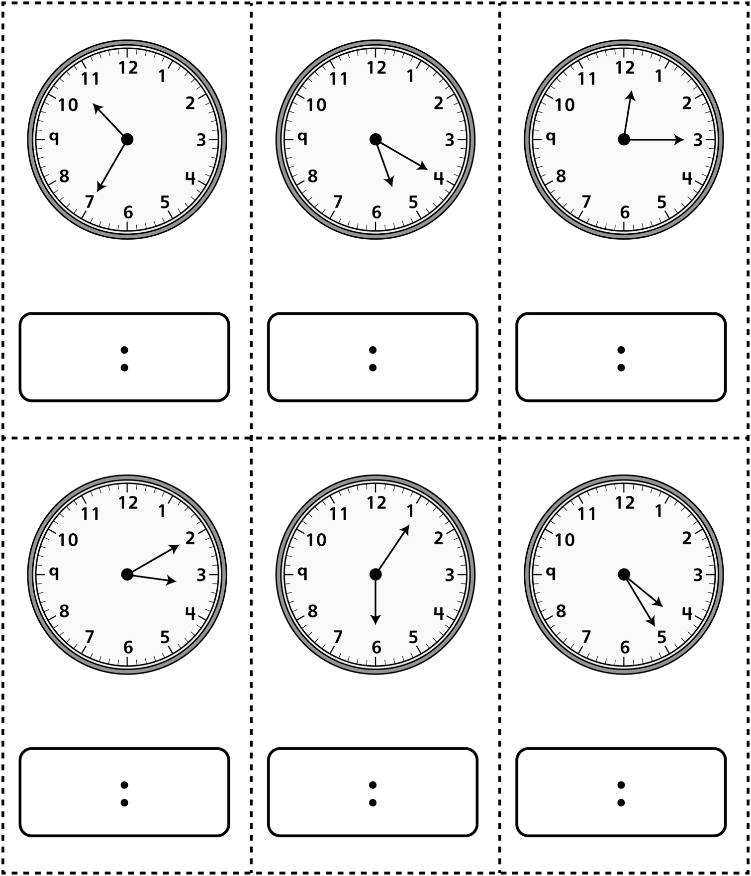
Analogue Clock Cards
(for Combined Grades Extension) (Part 2)
Master 42b

