Telling and Writing Time to the Quarter-Hour Behaviours/Strategies
- Student explores measurement of non-visible  attributes (time), but does not realize that each number on the analogue clock represents 5 minutes. | - Student explores measurement of non-visible  attributes (time), but struggles to skip-count by 5s.  “5, 10, 20, 30” | - Student explores measurement of non-visible  attributes (time), but mixes up the hour and  minute hands on the analogue clock.  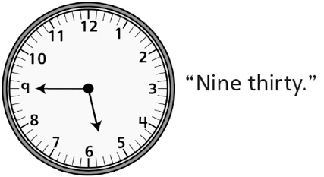
Observations/Documentation
- Student explores measurement of non-visible  attributes (time), but struggles when the hour  hand is between two numbers. | - Student explores measurement of non-visible  attributes (time), tells time on an analogue  clock, but struggles to read or write time on a  digital clock.  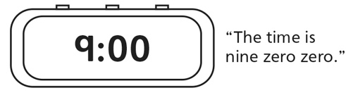 | - Student successfully explores measurement  of non-visible attributes (time), and reads and  writes time to the quarter-hour on analogue  and digital clocks.
Observations/Documentation

