Identifying Changes in Temperature Behaviours/Strategies
- Student explores measurement of non-visible  attributes (temperature), but has difficulty  understanding the meanings of hot, warm, and cold. | - Student explores measurement of non-visible  attributes (temperature), but has difficulty  understanding how a thermometer measures  hot and cold. | 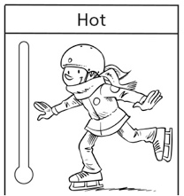  - Student explores measurement of non-visible attributes (temperature) and understands how a thermometer works, but glues pictures under the incorrect headings.
Observations/Documentation
- Student explores measurement of non-visible  attributes (temperature) and glues pictures  under the correct headings, but does not know  how much of the thermometers to colour.  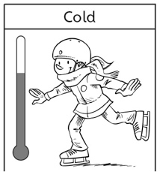 | - Student explores measurement of nonvisible  attributes (temperature) and colours  thermometers correctly, but is unable to explain thinking.  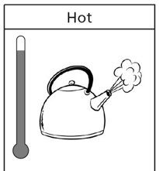 | - Student explores measurement of non-visible attributes (temperature), places pictures and colours thermometers correctly, and explains thinking.  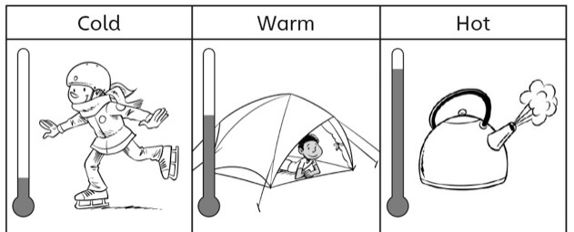
Observations/Documentation

