Time and Temperature Cards
Master 50a
10:45 | 2nd day of the week | September
 |  | Wednesday | 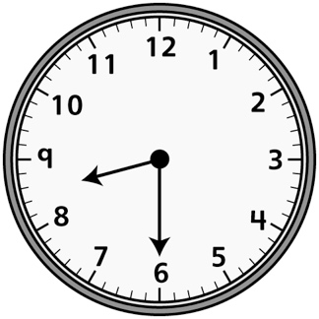
7th day of  the week | March | 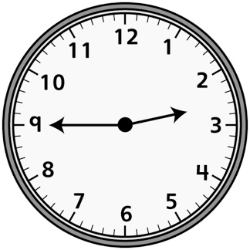
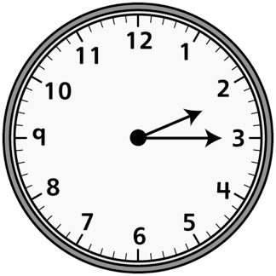 | February | Sunday | Fourth  month
July |  | 12 o’clock | Day before Friday

Time and Temperature Cards
(for Accommodations)
Master 50b
8:00 | 2nd day of  the week | September
 | February
Saturday | 3rd month | 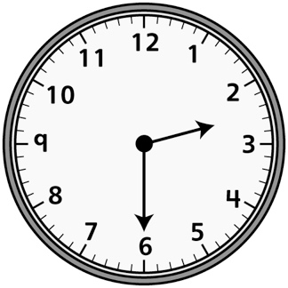 | 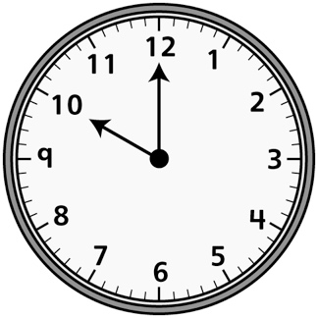

Time and Temperature Cards
(for Combined Grades Extension)
Master 50c
10:35 | Day before Tuesday | September | Very cold
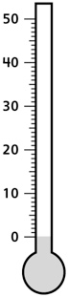 | January | Wednesday | 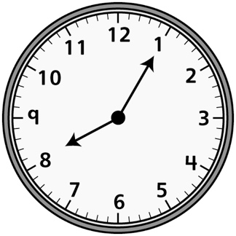
7 days after Saturday | April | Hot | 100°C
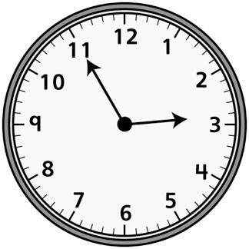 | Spring Break | Sunday | One month after June
 | 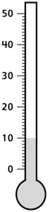 | 12:20 | Day before Friday

