Skip-Counting by 5s Spider Webs
Master 6a

Start at 0. Skip-count by 5s.

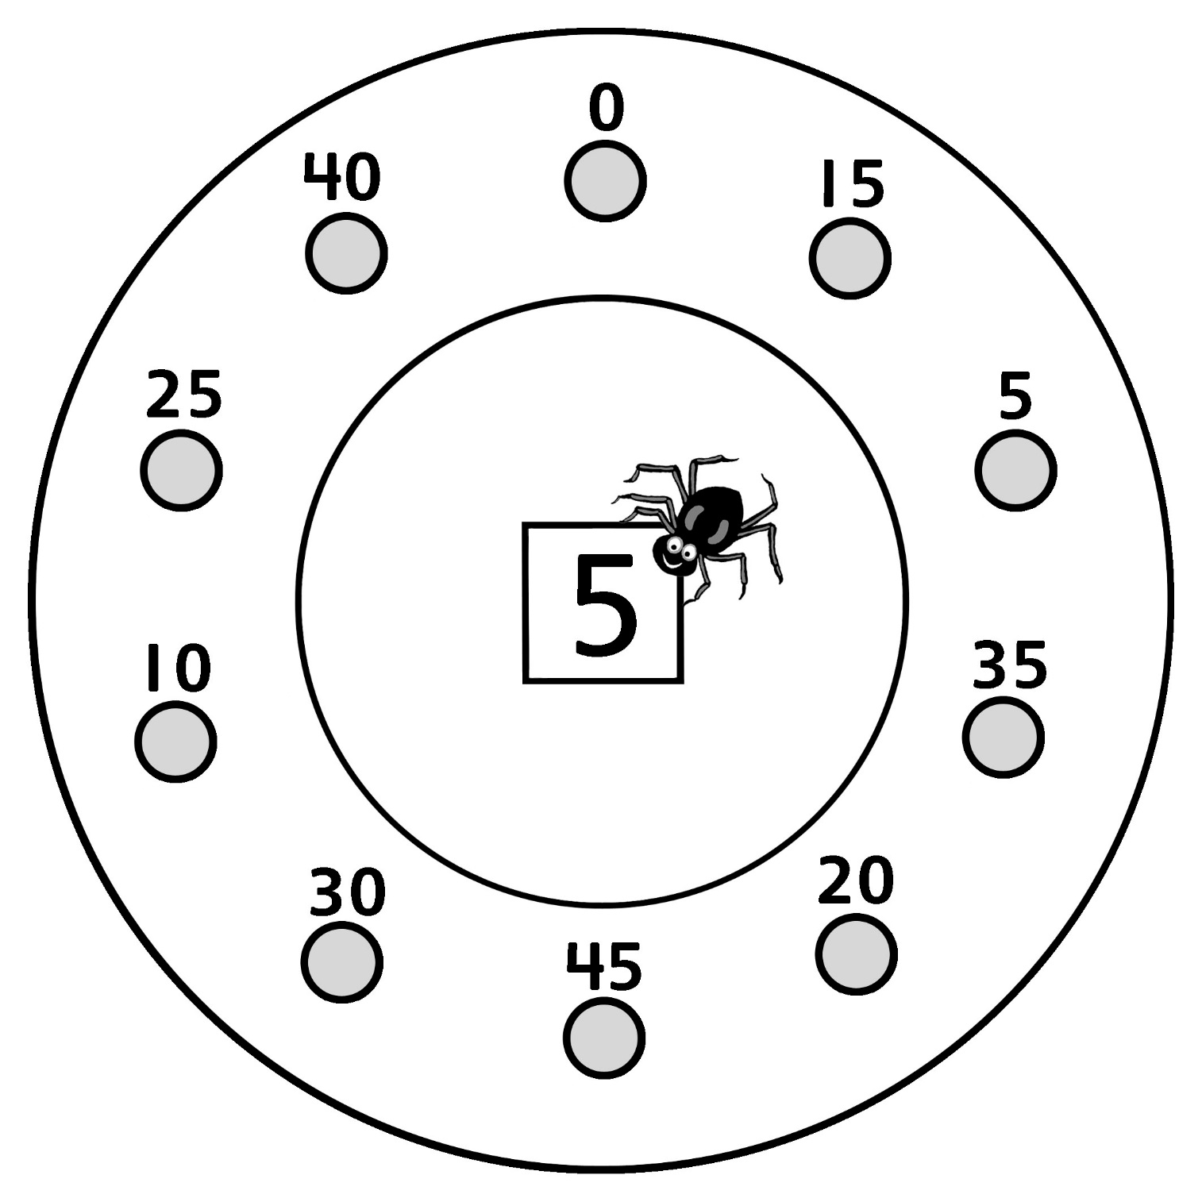

Skip-Counting by 5s Spider Webs
Master 6b

Start at 25. Skip-count by 5s.

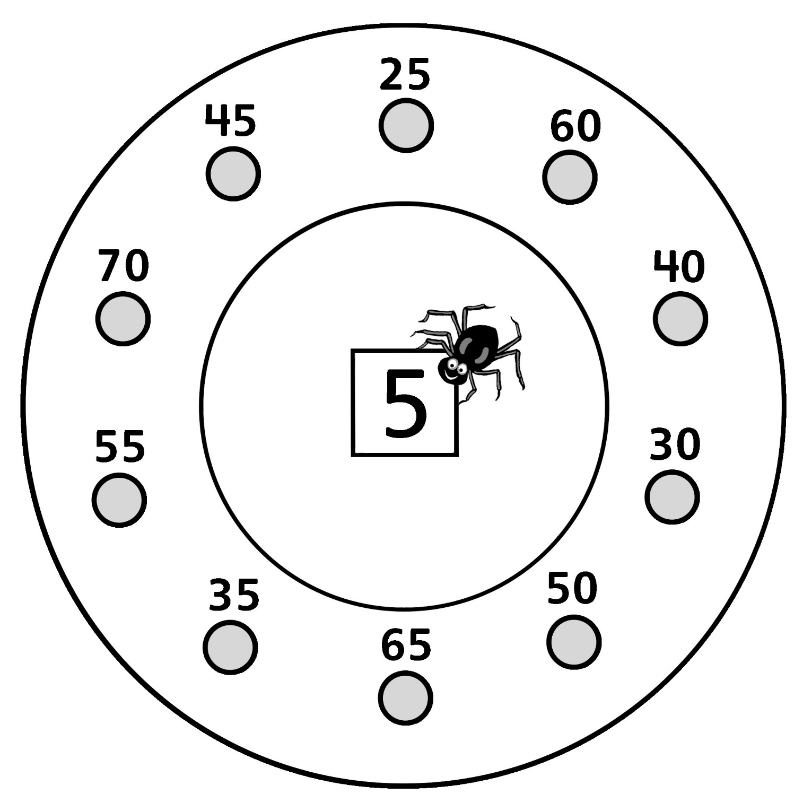

Skip-Counting by 5s Spider Webs
Master 6c

Start at 50. Skip-count by 5s.

