**Item Cards**

**Master 111a**

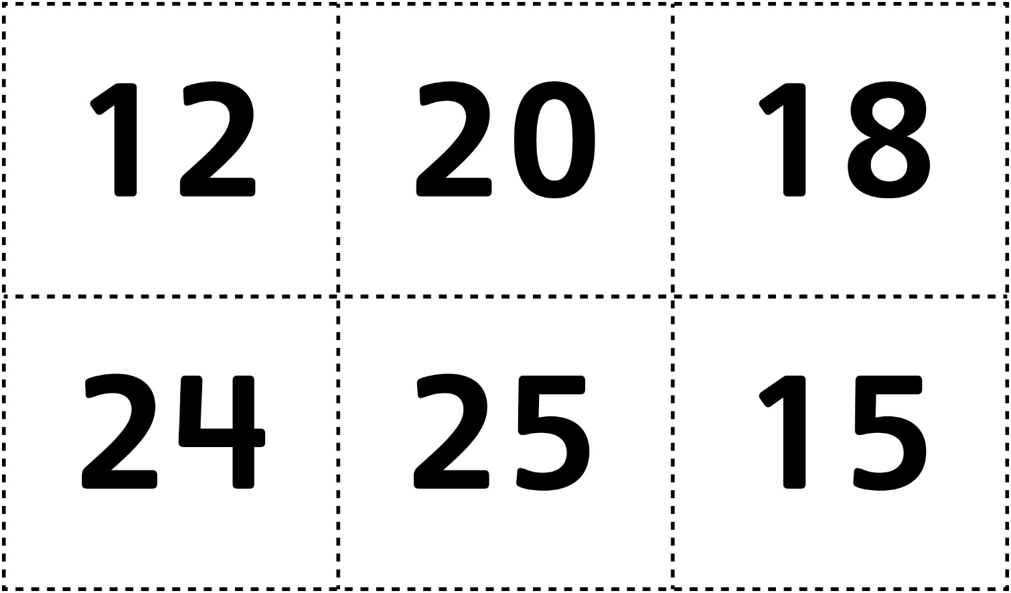

**Item Cards**

**Master 111b**

**(for Combined Grades Extension)**

