Equal Sharing Behaviours/Strategies
- Student turns over a card, but  struggles to say the number name sequence forward and does not start with correct number of items. | - Student shares items, but does not share the items equally. | - Student shares items equally by  sharing one item at a time. | - Student successfully shares items equally by sharing more than one item at a time (partitive sharing).
Observations/Documentation
Equal Grouping Behaviours/Strategies
- Student arranges objects in groups, but not all groups are of the same size. | - Student arranges objects in equal groups, but ignores the leftovers.  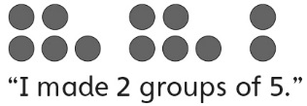 | - Student arranges objects in equal groups, but struggles to write a number sentence. | - Student successfully arranges  objects in equal groups and  writes a repeated addition and  multiplication sentence.  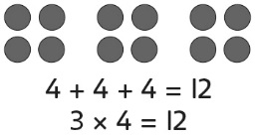
Observations/Documentation

Big Idea |  |  |  |  | Indicators from Learning Progression
Curriculum Expectations addressed

Student Names
Student can group items in 2s, 5s, and 10s.
(Activities 37, 42)
Student realizes that the quantity will be the same when items are grouped in different ways.
(Activity 37)
Student can model and solve equal-sharing problems.
(Activities 38, 42)
Student can model and solve equal-grouping problems.
(Activities 39, 42)
Student recognizes that as the number of items in a group increases, the number of equal groups decreases.
(Activity 39)
Student can use repeated addition of groups to solve problems.
(Activity 40)
Student can write repeated addition/multiplication sentences to represent problems.
(Activities 40, 41, 42)
Student can relate repeated addition on a number line to multiplication.
(Activity 41)

Name: _______________________

 | Not Observed | Sometimes | Consistently
Groups items in 2s, 5s, and 10s.
(Activities 37, 42)
Realizes that the quantity will be the same when items are grouped in different ways.
(Activity 37)
Models and solves equal-sharing problems.
(Activities 38, 42)
Models and solves equal-grouping problems.
(Activities 39, 42)
Recognizes that as the number of items in a group increases, the number of equal groups decreases.
(Activity 39)
Uses repeated addition of groups to solve problems.
(Activity 40)
Writes repeated addition/multiplication sentences to represent problems.
(Activities 40, 41, 42)
Relates repeated addition on a number line to multiplication.
(Activity 41)

Strengths:

Next Steps:

