Our Savings Plan
Master 129

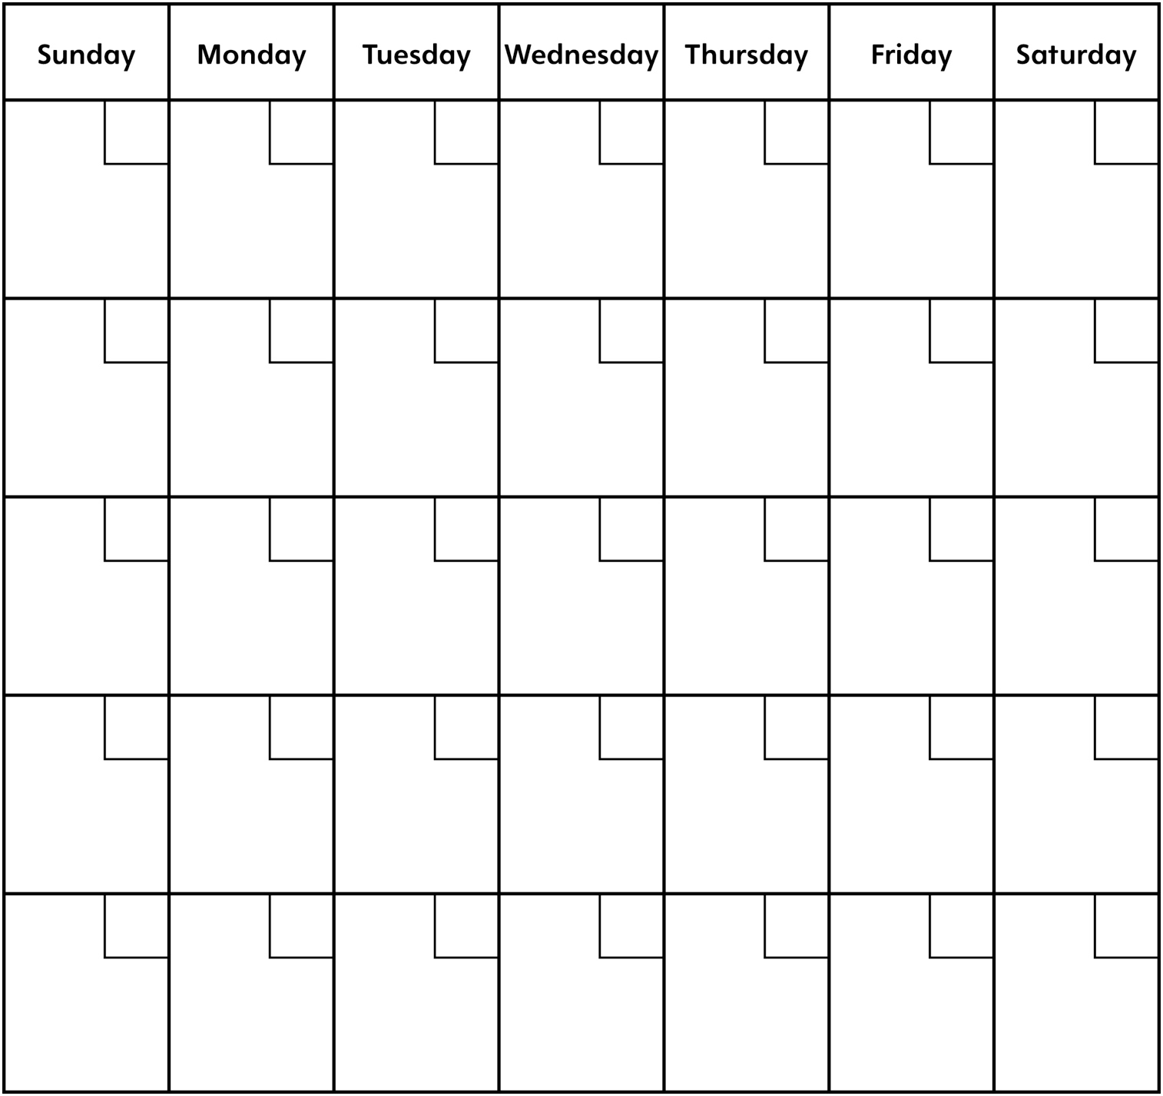

Money Student A saved: _____________
Money Student B saved: _____________
Total amount saved: _____________ Money spent: ______________
Amount left in savings: _________

