Ordinal Numbers Behaviours/Strategies
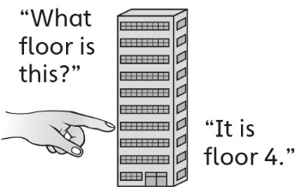  - Student knows the floor number, but  is unable to  represent it  with an ordinal number name. | - Student uses some ordinal number names, but has difficulty with those that sound different from the counting numbers (first, second, third).  “1th, 2th, 3th” | - Student uses ordinal number names to describe  relative position, but does not realize that the  position of an object can change, depending on  the starting point.  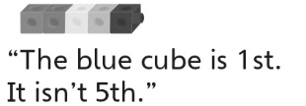
Observations/Documentation
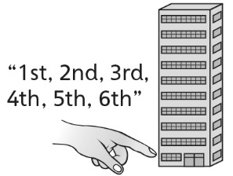  - Student uses ordinal number names in context to describe relative position, but is unable to count forward or backward from a given ordinal number (always counts from 1 or from the first floor). | - Student uses ordinal number names to 20th to describe relative position, but does not know what comes next.  “18th, 19th, 20th. I don’t know  what comes next.” | - Student uses ordinal numbers in context  to describe relative position and has an  understanding of their repeating sequence.
Observations/Documentation

