**Building Numbers Cards**

**Master 33a**

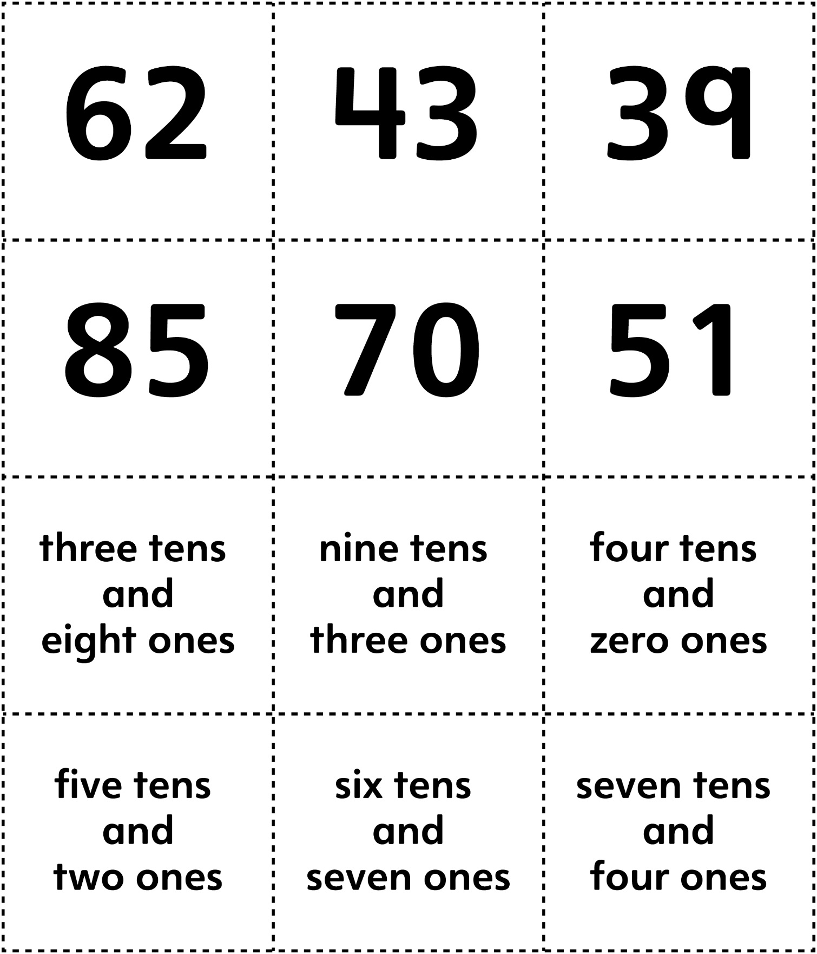

**Building Numbers Cards (for Accommodations)**

**Master 33b**

