Comparing and Regrouping Fractional Parts Behaviours/Strategies
- Student turns over a card, but  struggles to partition wholes into  equal parts and does not know  how many parts are in the whole.  “How many parts do I need  to show sixths?” | - Student turns over a card, but  struggles to partition wholes  into equal parts and chooses an  inappropriate whole (e.g., uses  Pattern Blocks to show fourths). | - Student chooses a whole, but  struggles to partition it into equal  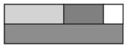  parts, and parts are not all equal or they do not cover the whole exactly. | - Student partitions wholes into  equal parts, but struggles to  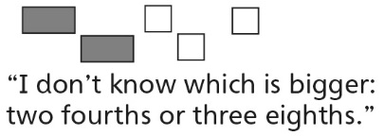  compare with unit fractions.
Observations/Documentation
- Student partitions wholes into  equal parts, but compares parts of different wholes. | - Student partitions wholes into  equal parts, but struggles to  combine equal parts to make  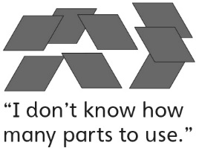  wholes. | - Student combines equal parts to  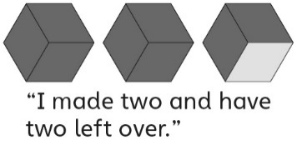  make wholes, but struggles to name the wholes and leftover parts. | - Student successfully partitions  wholes into equal parts, compares with unit fractions, and combines equal parts to make wholes.
Observations/Documentation

Big Idea |  |  |  |  | Indicators from Learning Progression
Curriculum Expectations addressed

Student Names
Student can partition a whole into equal parts and name the unit fraction.
(Activities 17, 18, 19, 20, 21)
Student realizes that the number of equal parts names the part.
(Activities 17, 18, 19, 20, 21)
Student realizes that dividing a whole into more equal parts produces smaller parts.
(Activities 17, 18, 19)
Student realizes that dividing a whole into smaller parts produces more parts.
(Activities 17, 18, 19)
Student can compare fractional parts to determine which is bigger/smaller.
(Activities 18, 19, 21)
Student can regroup fractional parts into wholes.
(Activities 20, 21)
Student uses math language when comparing parts and naming wholes and leftover parts.
(Activities 18, 19, 20, 21)

Name: _______________________

 | Not Observed | Sometimes | Consistently
Partitions a whole into equal parts and names the unit fraction.
(Activities 17, 18, 19, 20, 21)
Realizes that the number of equal parts names the part.
(Activities 17, 18, 19, 20, 21)
Realizes that dividing a whole into more equal parts produces smaller parts.
(Activities 17, 18, 19)
Realizes that dividing a whole into smaller parts produces more parts.
(Activities 17, 18, 19)
Compares fractional parts to determine which is bigger/smaller.
(Activities 18, 19, 21)
Regroups fractional parts into wholes.
(Activities 20, 21)
Uses math language when comparing parts and naming wholes and leftover parts.
(Activities 18, 19, 20, 21)

Strengths:

Next Steps:

