Closer To Cards
Master 61a

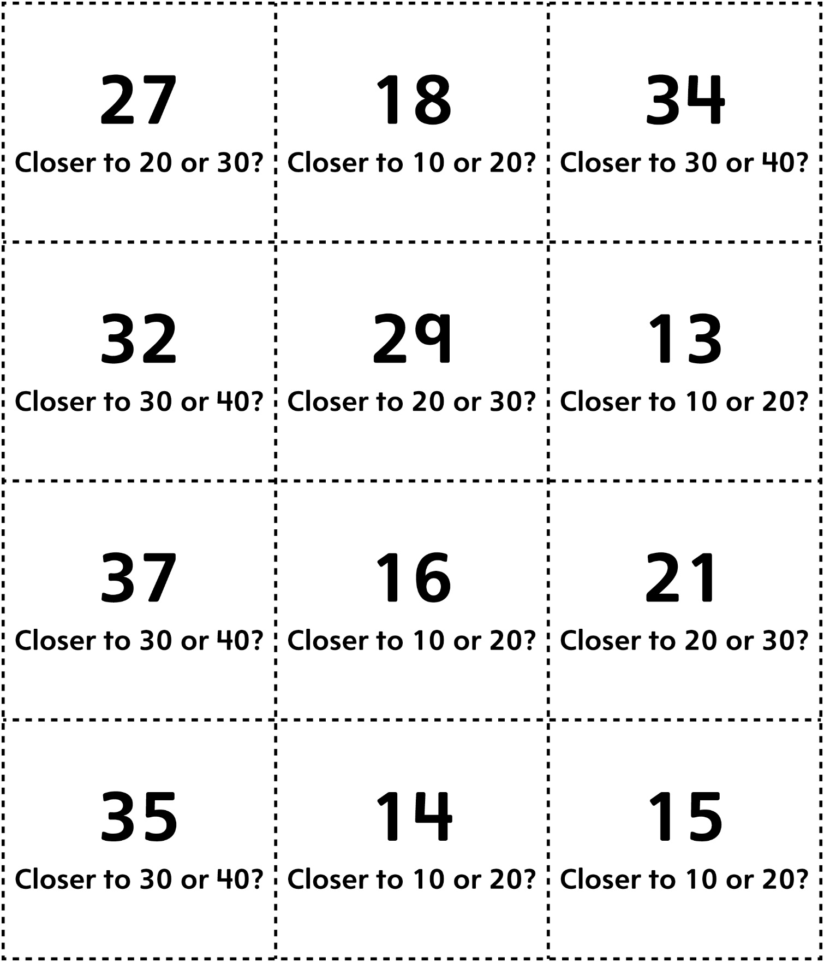
Closer To Cards (for Accommodations)
Master 61b

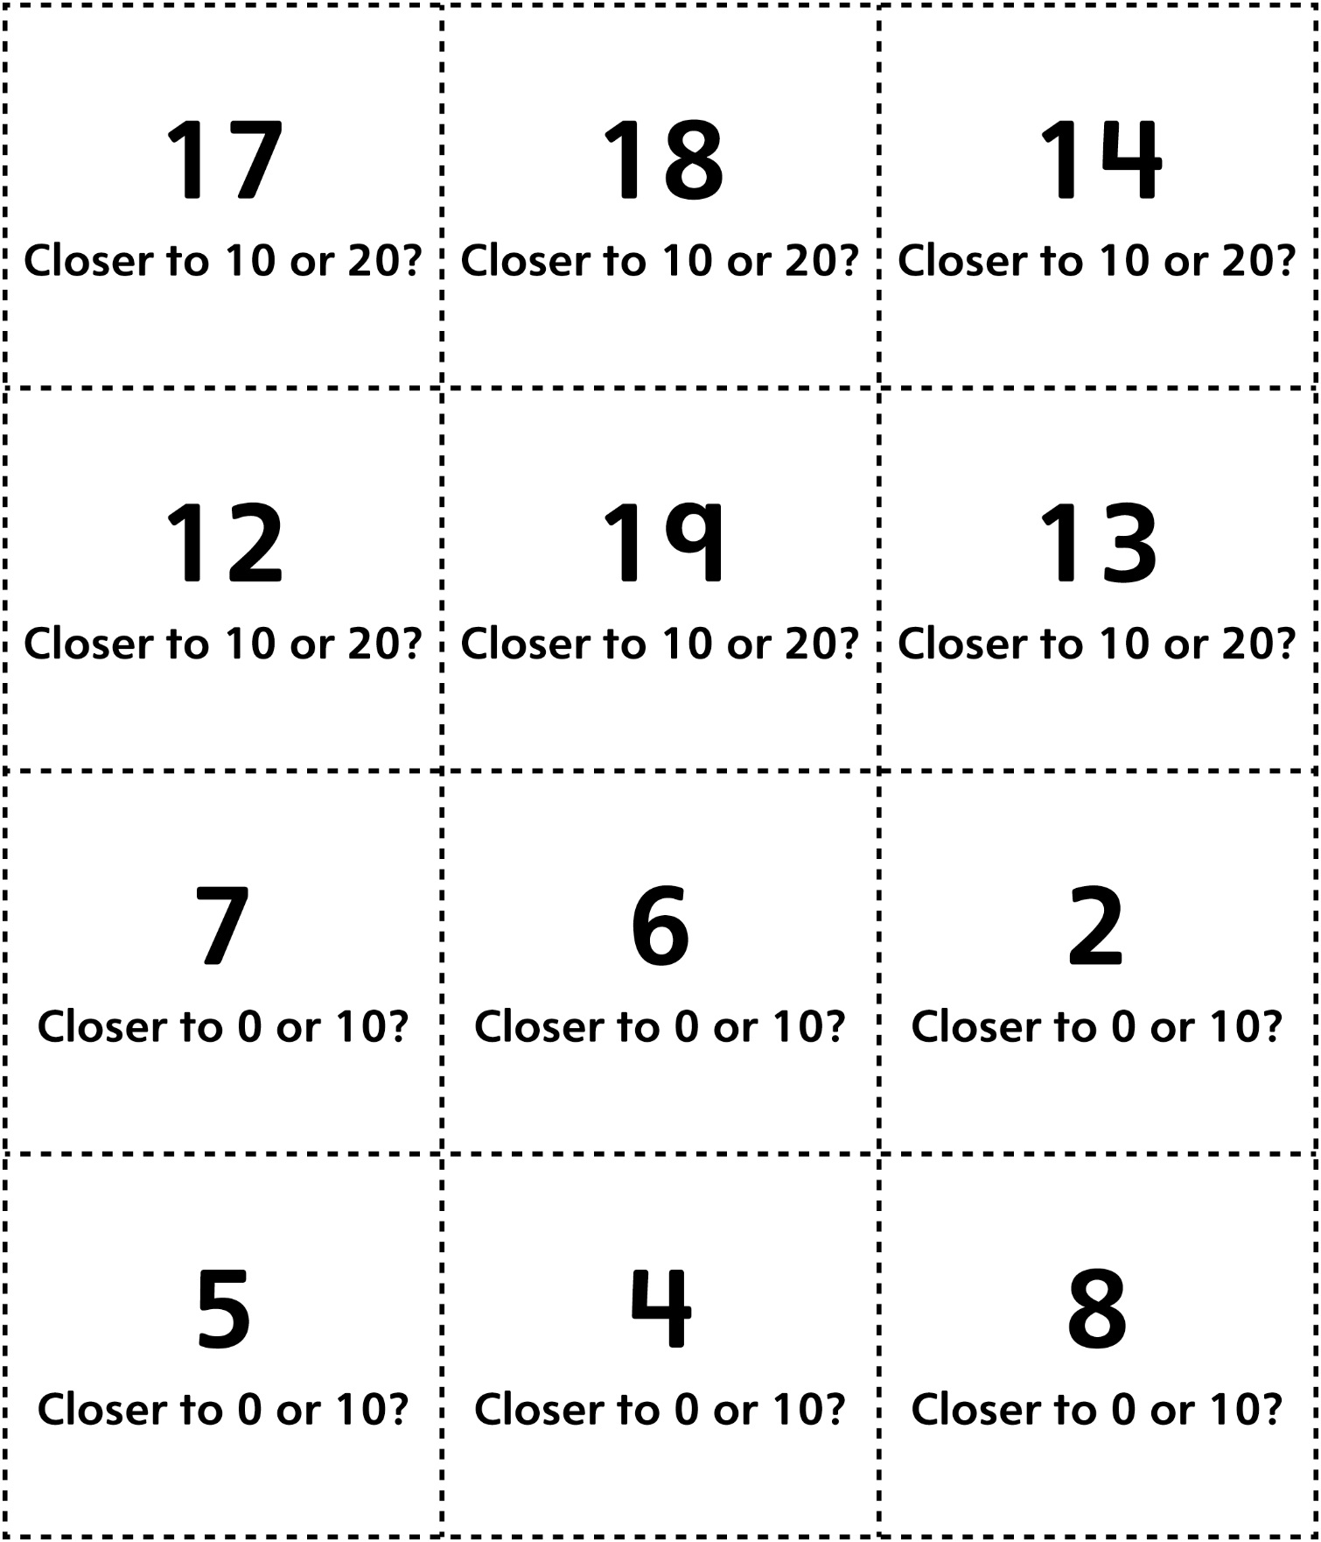
Closer To Cards (for Extension)
Master 61c

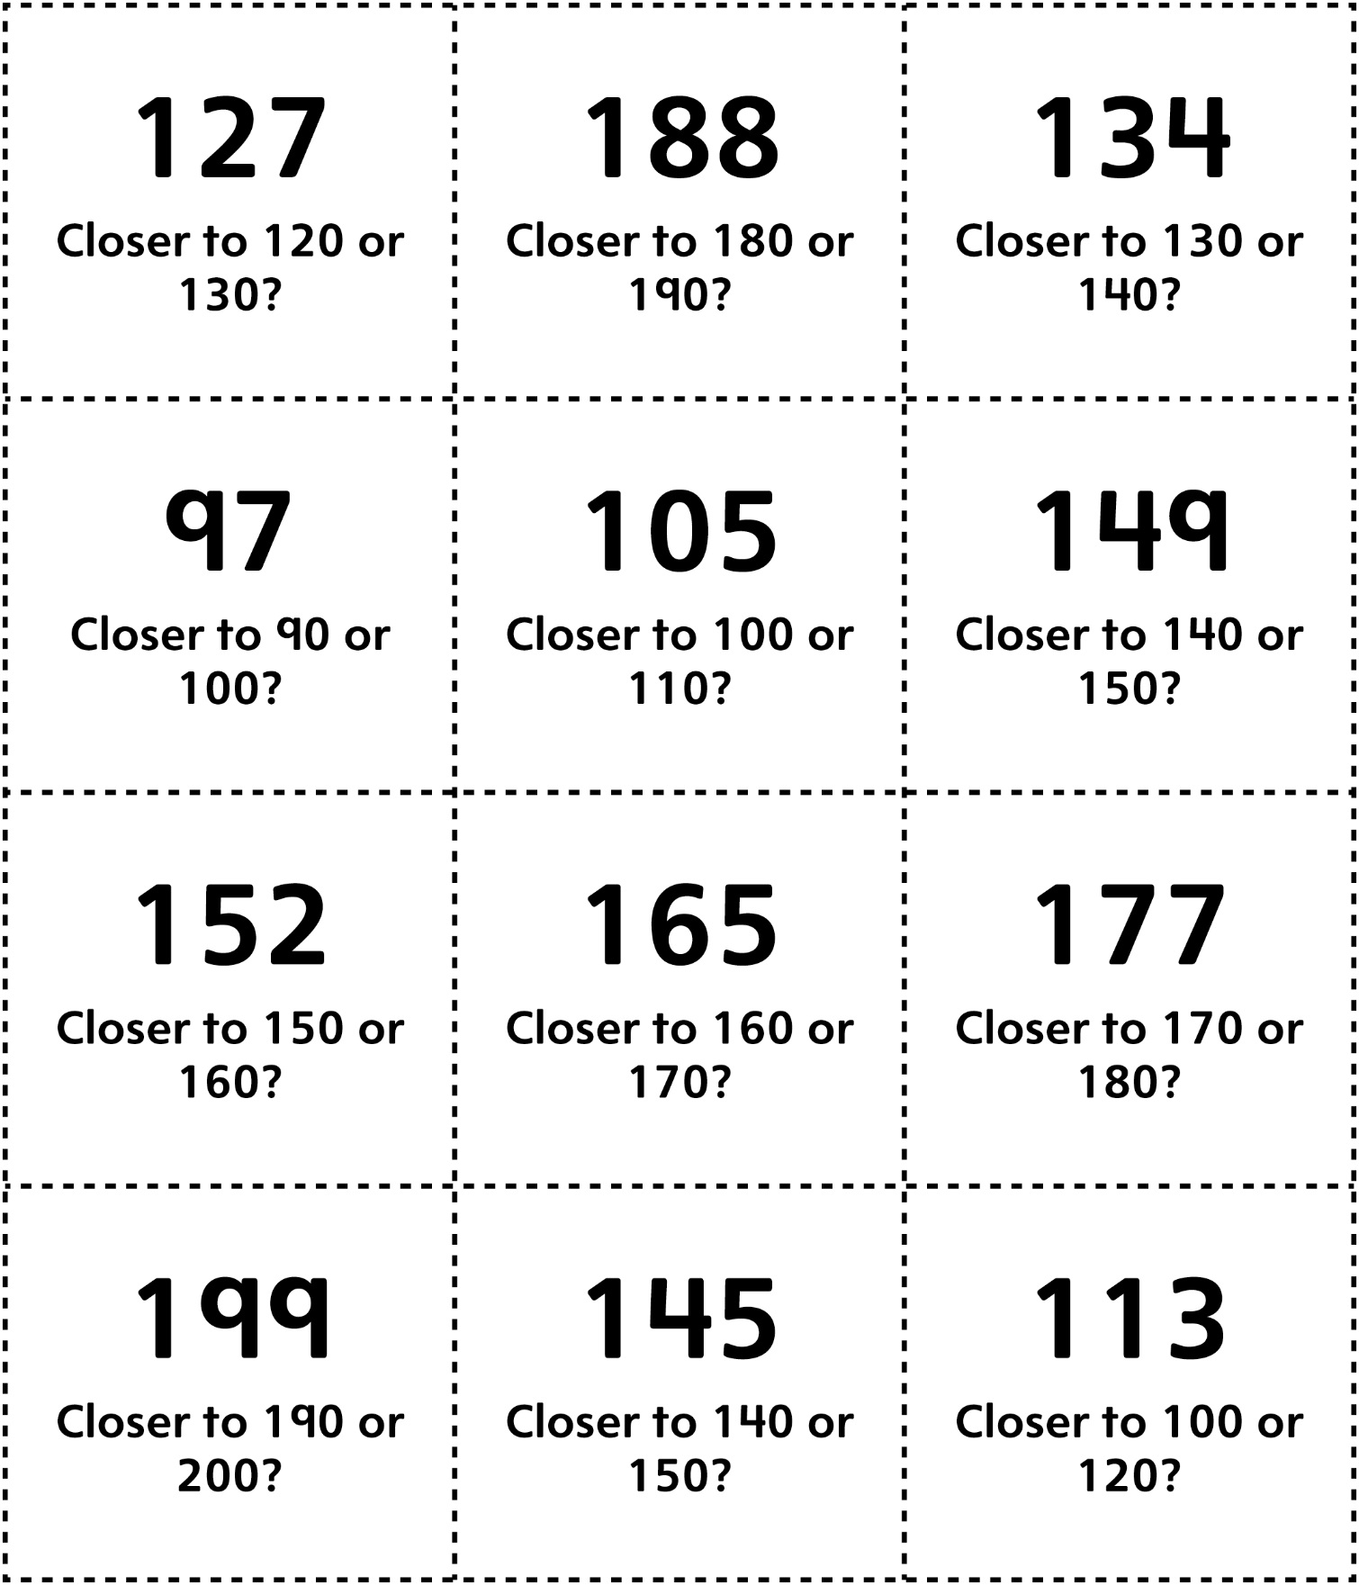

Closer To Cards
Master 61d

(for Combined Grades Extension)

