Target Number Cards
Master 64a

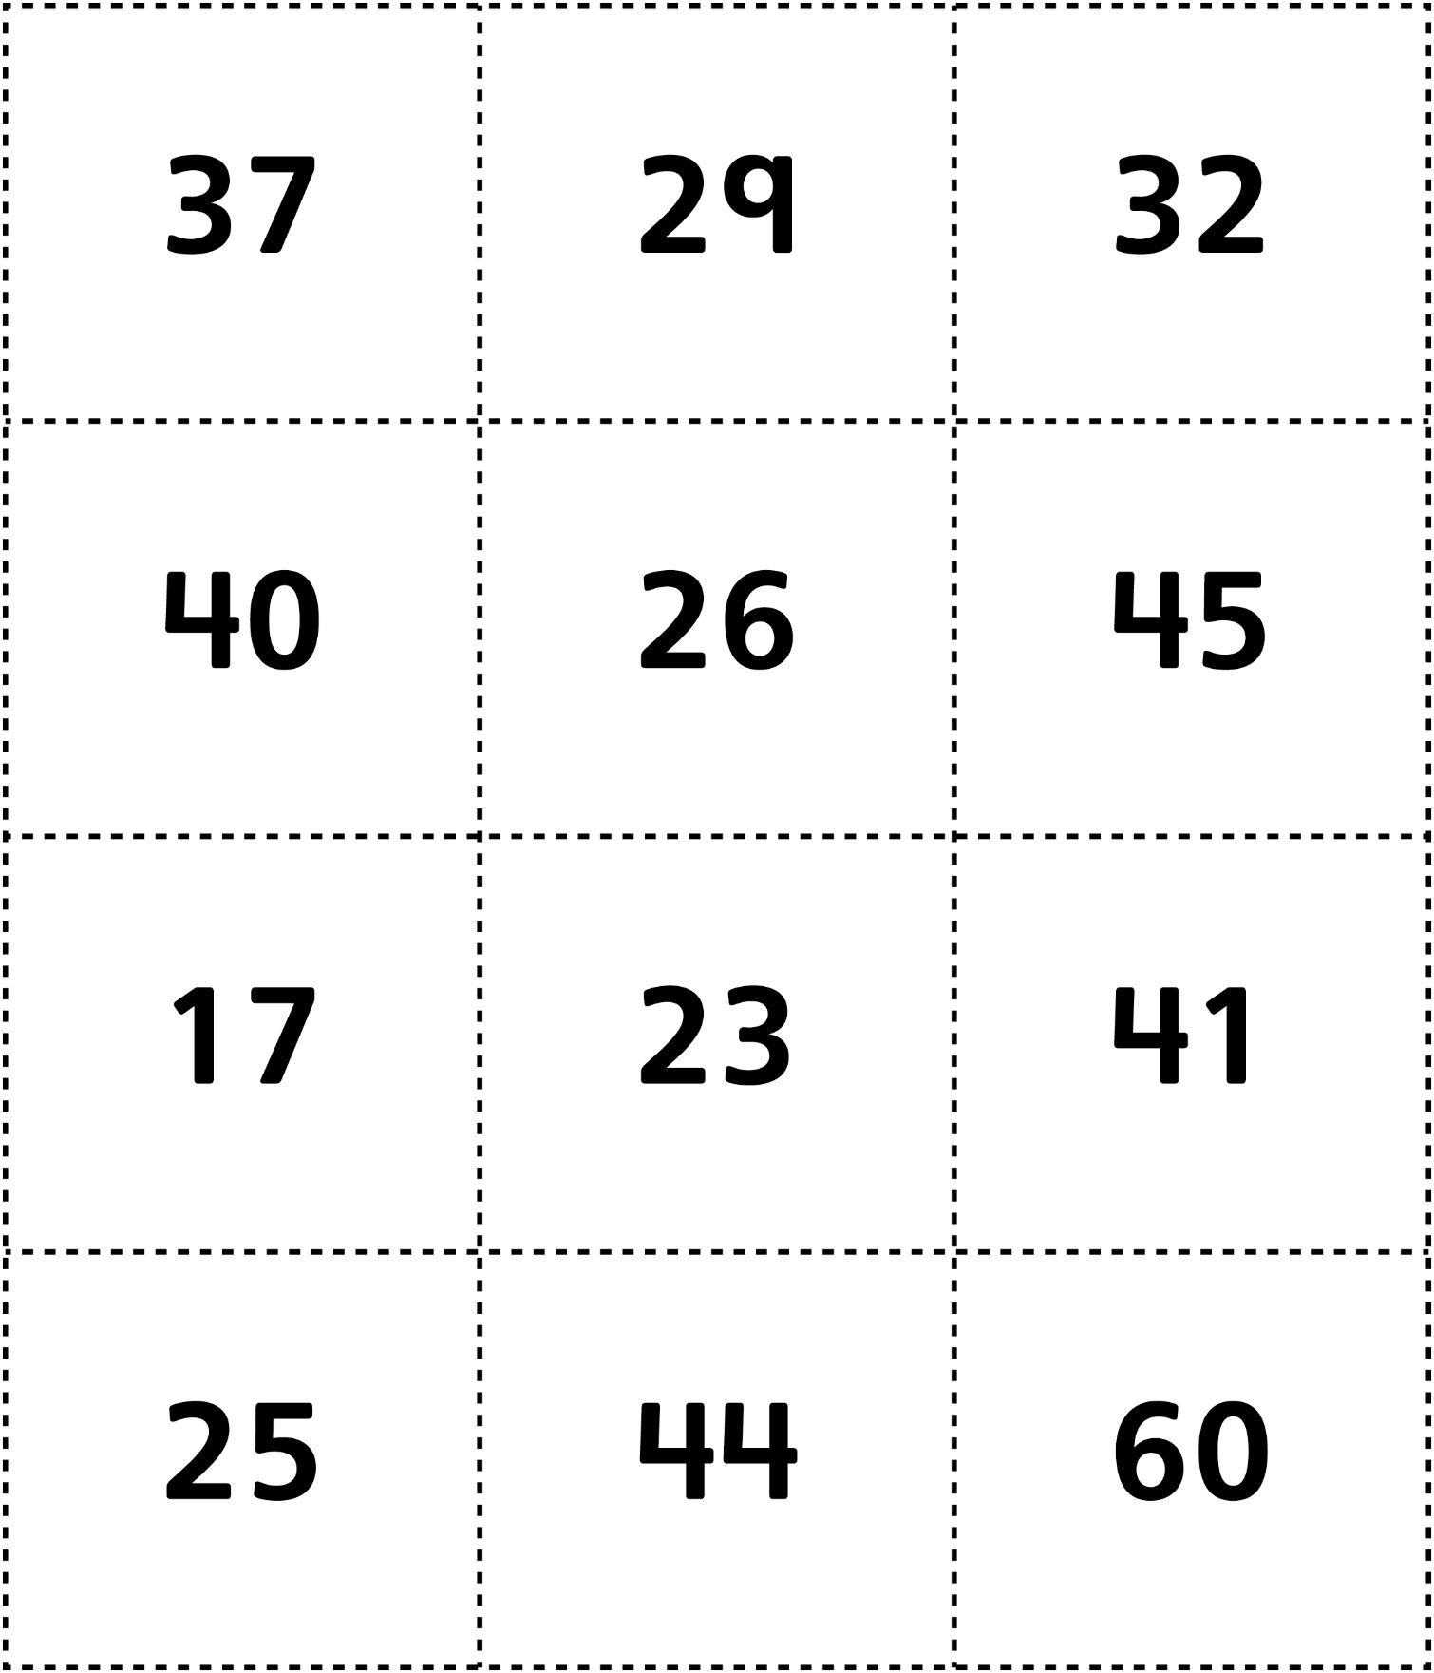

Target Number Cards (for Accommodations)
Master 64b

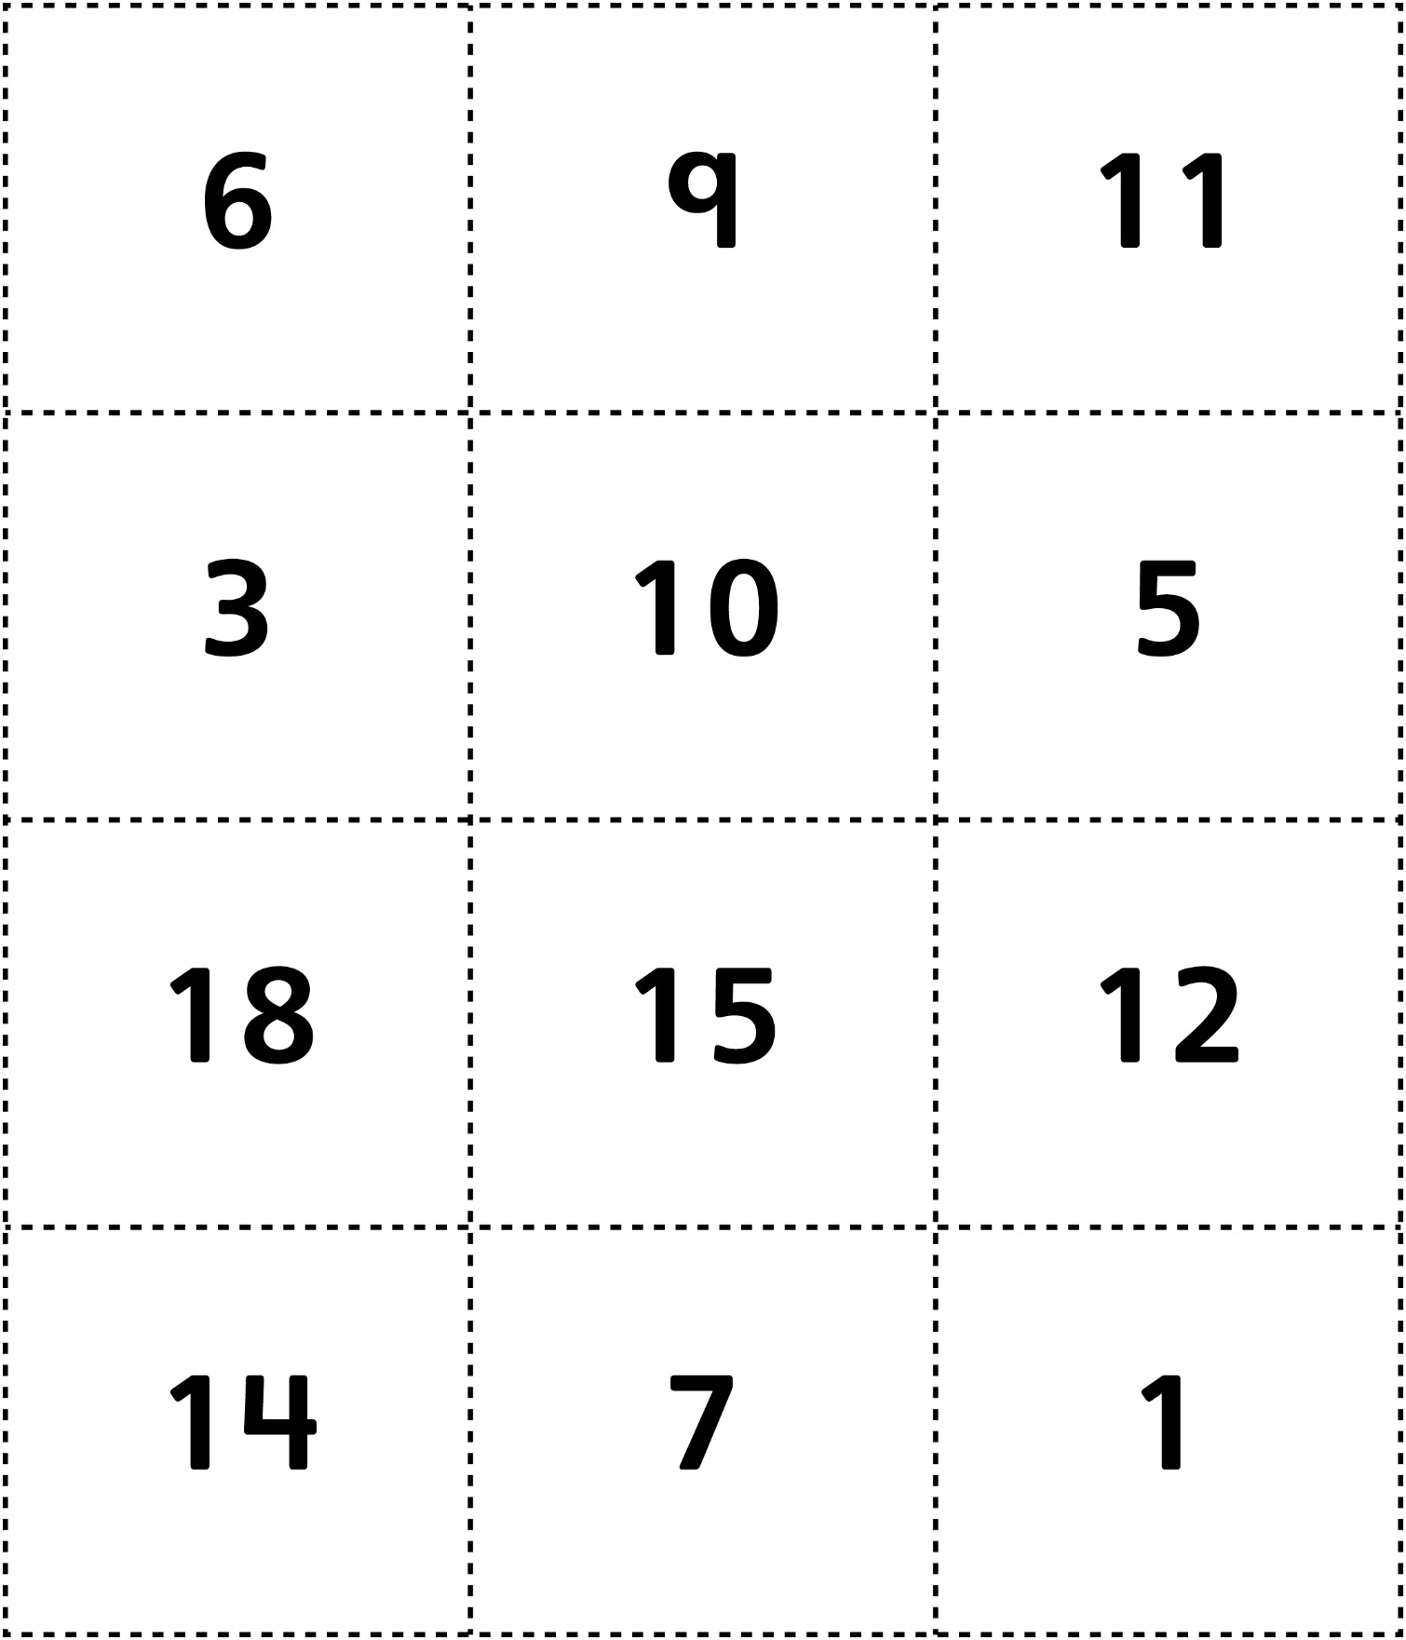

Target Number Cards
Master 64c

(for Combined Grades Extension)

