Conceptual Understanding of Story Problems Behaviours/Strategies
- Student reads story problem, but  is unable to model add-to and  take-from situations with concrete  materials. | - Student models and solves problems, but cannot use symbols and equations to represent the problems. | - Student uses symbols to write a  subtraction equation, but struggles to see the relation among the numbers.  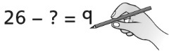 | - Student models and solves addition and subtraction problem types and uses symbols and equations to represent the problems.  50 – 21 = ?  17 + ? = 41
Observations/Documentation
Addition and Subtraction Computational Behaviours/Strategies
- Student counts three times to  add or subtract quantities, but  struggles to coordinate number  words with counting actions.  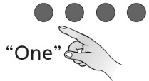 | - Student counts three times to add or subtract quantities.  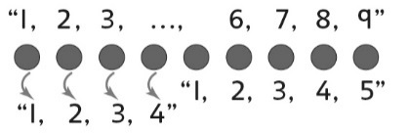 | - Student counts on or back to add  or subtract quantities.  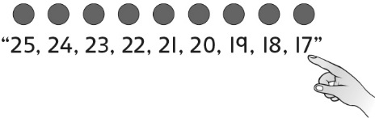 | - Student uses mental strategies to  add or subtract quantities.  “9 and 1 more is 10.  10 and 16 is 26.  16 and 1 is 17.  So, 17 books were signed out.”
Observations/Documentation

