Conceptual Understanding of Addition and Subtraction Behaviours/Strategies
- Student takes objects from bin, but has difficulty using them to create an addition and subtraction problem. | - Student creates an addition  problem, but has difficulty creating a subtraction problem. | - Student creates addition and  subtraction problems, but cannot  use symbols and equations to  represent them.  “I don’t know how to write a  number sentence.” | - Student creates addition and  subtraction problems and  uses symbols and equations to  represent them.  11 + 9 = ? “Answer is 20.”  21 − ? = 13 “Answer is 8.”
Observations/Documentation
Addition and Subtraction Computational Behaviours/Strategies
- Student counts three times to add or subtract quantities.  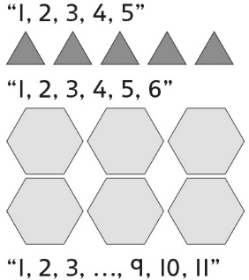 | - Student guesses and then counts  on or back to add or subtract  quantities to check.  Guess 7: 13, 14, 15, 16, 17, 18, 19  “Not enough.” | - Student counts on or back to add  or subtract quantities.  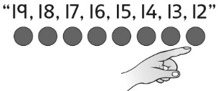 | - Student uses mental strategies  flexibly and accurately to add or  subtract quantities.  “I know 10 + 10 is 20.  So, 10 + 11 is 1 more, or 21.”
Observations/Documentation

