Conceptual Understanding of Story Problems Behaviours/Strategies
- Student reads story problem, but  is unable to model add-to and  take-from situations with concrete materials. | - Student models the problem, but  uses the wrong operation to solve it. | - Student models and solves the  problem, but cannot use symbols  and equations to represent it. | - Student successfully models, solves, and symbolizes addition and subtraction problem types and represents thinking on the Think Board.
Observations/Documentation
Addition and Subtraction Computational Behaviours/Strategies
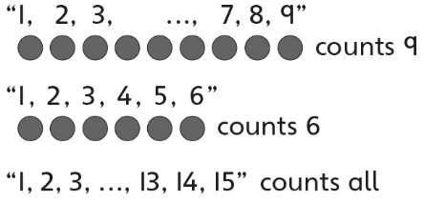  - Student counts three times to add or subtract quantities. | - Student counts on or back to add  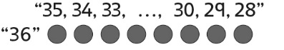  or subtract quantities. | 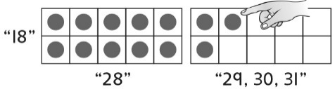  - Student counts efficiently to add or subtract quantities (e.g., makes 10 and then counts on or subitizes). | - Student uses mental strategies  flexibly and accurately to add or  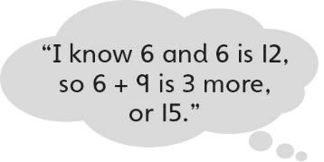  subtract quantities.
Observations/Documentation

Big Idea |  |  |  |  | Indicators from Learning Progression
Curriculum Expectations addressed

Student Names
Student realizes that the order in which two numbers are added does not matter.
(Activity 26)
Student realizes that when zero is added to a number or subtracted from a number, the number does not change.
(Activity 26)
Student can write number sentences to represent addition and subtraction situations/story problems.
(Activities 26, 27, 28, 29, 30, 31)
Student can fluently add and subtract with quantities to 10.
(Activity 26)
Student can model and solve addition and subtraction problem types.
(Activities 27, 28, 29, 30, 31)
When solving a problem, student can represent thinking on a Think Board.
(Activities 28, 31)
Student can flexibly and accurately add and subtract quantities to solve story problems.
(Activities 27, 28, 29,
30, 31)
Student can create addition and subtraction story problems.
(Activity 30)

Name: _______________________

 | Not Observed | Sometimes | Consistently
Realizes that the order in which two numbers are added does not matter.
(Activity 26)
Realizes that when zero is added to a number or subtracted from a number, the number does not change.
(Activity 26)
Writes number sentences to represent addition and subtraction situations/story problems.
(Activities 26, 27, 28, 29,
30, 31)
Fluently adds and subtracts with quantities to 10.
(Activity 26)
Models and solves addition and subtraction problem types.
(Activities 27, 28, 29, 30, 31)
When solving a problem, represents thinking on a Think Board.
(Activities 28, 31)
Flexibly and accurately adds and subtracts quantities to solve story problems.
(Activities 27, 28, 29, 30, 31)
Creates addition and subtraction story problems.
(Activity 30)

Strengths:

Next Steps:

