Recalling Complements of 10 Behaviours/Strategies
- Student says numbers randomly and is unable  to find complements of 10.  “4 seeds and 4 seeds” | - Student finds complements of 10 by counting  on with fingers.  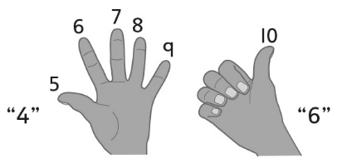 | - Student finds complements of 10 by visualizing a ten-frame.  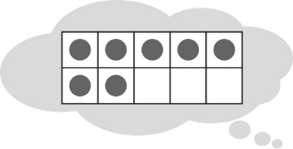
Observations/Documentation
- Student recalls many complements of 10, but  struggles with 0.  “I have 0 seeds. I don’t know how many  more are needed.” | - Student recalls complements of 10, but does  not realize that the order of the numbers does  not matter (e.g., 7 + 3 and 3 + 7 are the same). | - Student fluently recalls complements of 10.
Observations/Documentation

