Using a Core to Create a Repeating Pattern Behaviours/Strategies
- Student models the core and repeats only the  last element as the repeating core.  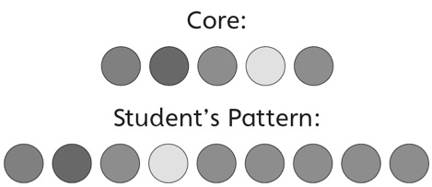 | - Student models the core, but places the  elements in the wrong order when using copies of the core to create a repeating pattern.  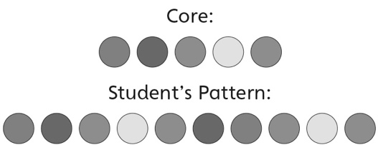 | - Student creates some repeating patterns based  on copies of the core, but struggles when the  last element in the core is the same as the first.  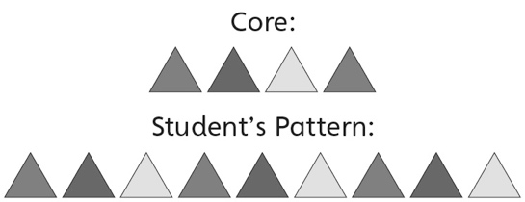
Observations/Documentation
- Student creates repeating patterns based on  copies of the repeating unit (core), but struggles to represent the core with letters.  “I don’t know how to show it with letters.” | - Student creates repeating patterns based  on copies of the repeating unit (core) and  represents the core with letters, but struggles  to use math language when describing patterns. | - Student successfully creates repeating patterns  based on copies of the repeating unit (core),  represents the core with letters, and uses math  language to describe patterns.  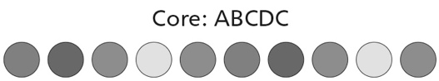
Observations/Documentation

