Reproducing and Extending Increasing Patterns Behaviours/Strategies
- Student reproduces increasing patterns, but  is unable to extend patterns and adds tiles  randomly.  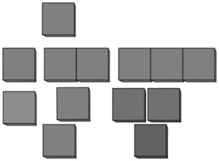 | - Student reproduces increasing patterns, but  struggles to extend them and does not add the same amount each time. | - Student reproduces increasing patterns and  attempts to extend them by adding the same  amount each time, but the amount added is  incorrect.
Observations/Documentation
- Student extends increasing patterns by adding  the same amount each time, but shape of  patterns is not maintained. | - Student reproduces and extends increasing  patterns, but is unable to write the pattern rule. | - Student successfully reproduces and extends  increasing patterns and explains the rules.
Observations/Documentation

