**Equal or Not Equal? Cards**

**Master 35a**

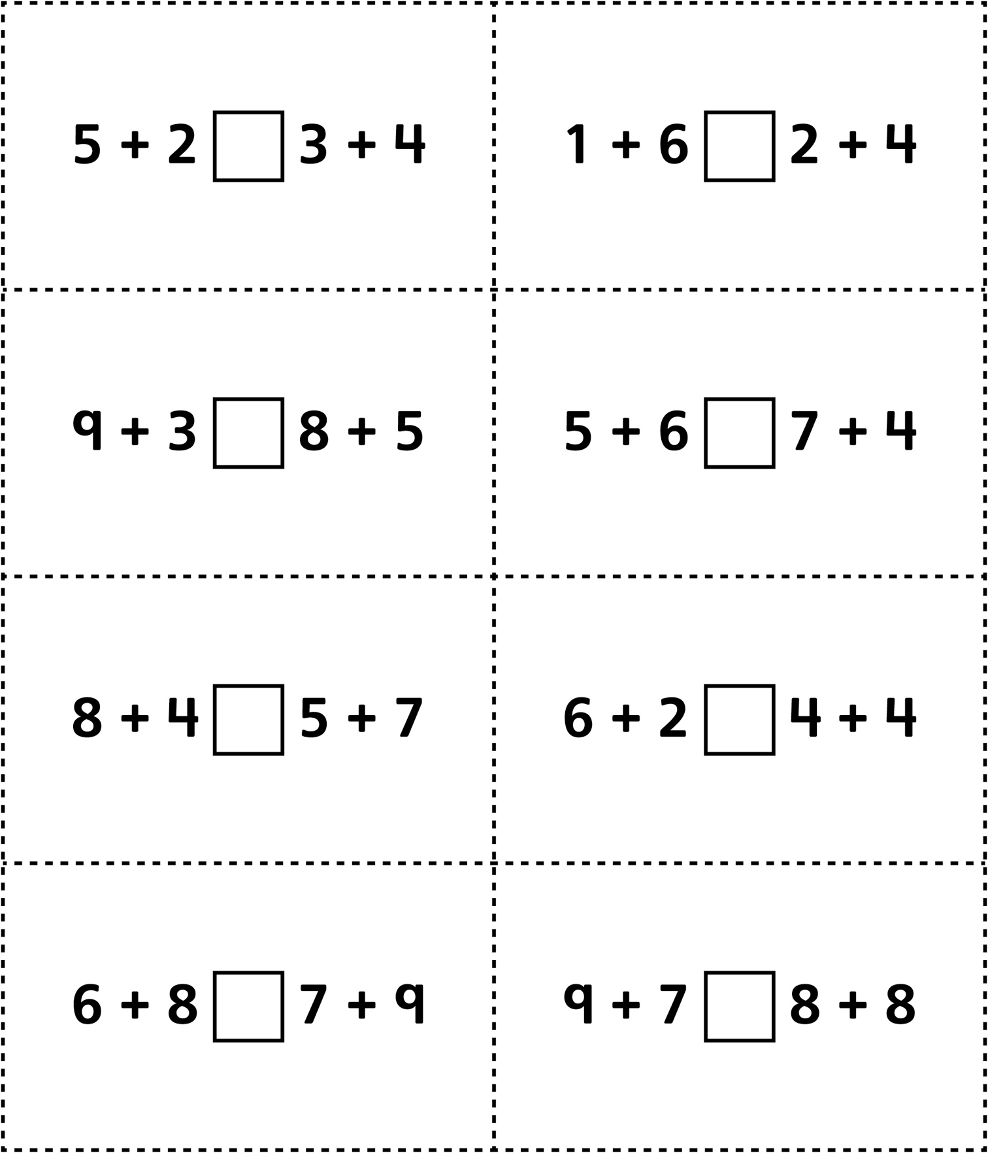

**Equal or Not Equal? Cards   
(for Accommodations)**

**Master 35b**

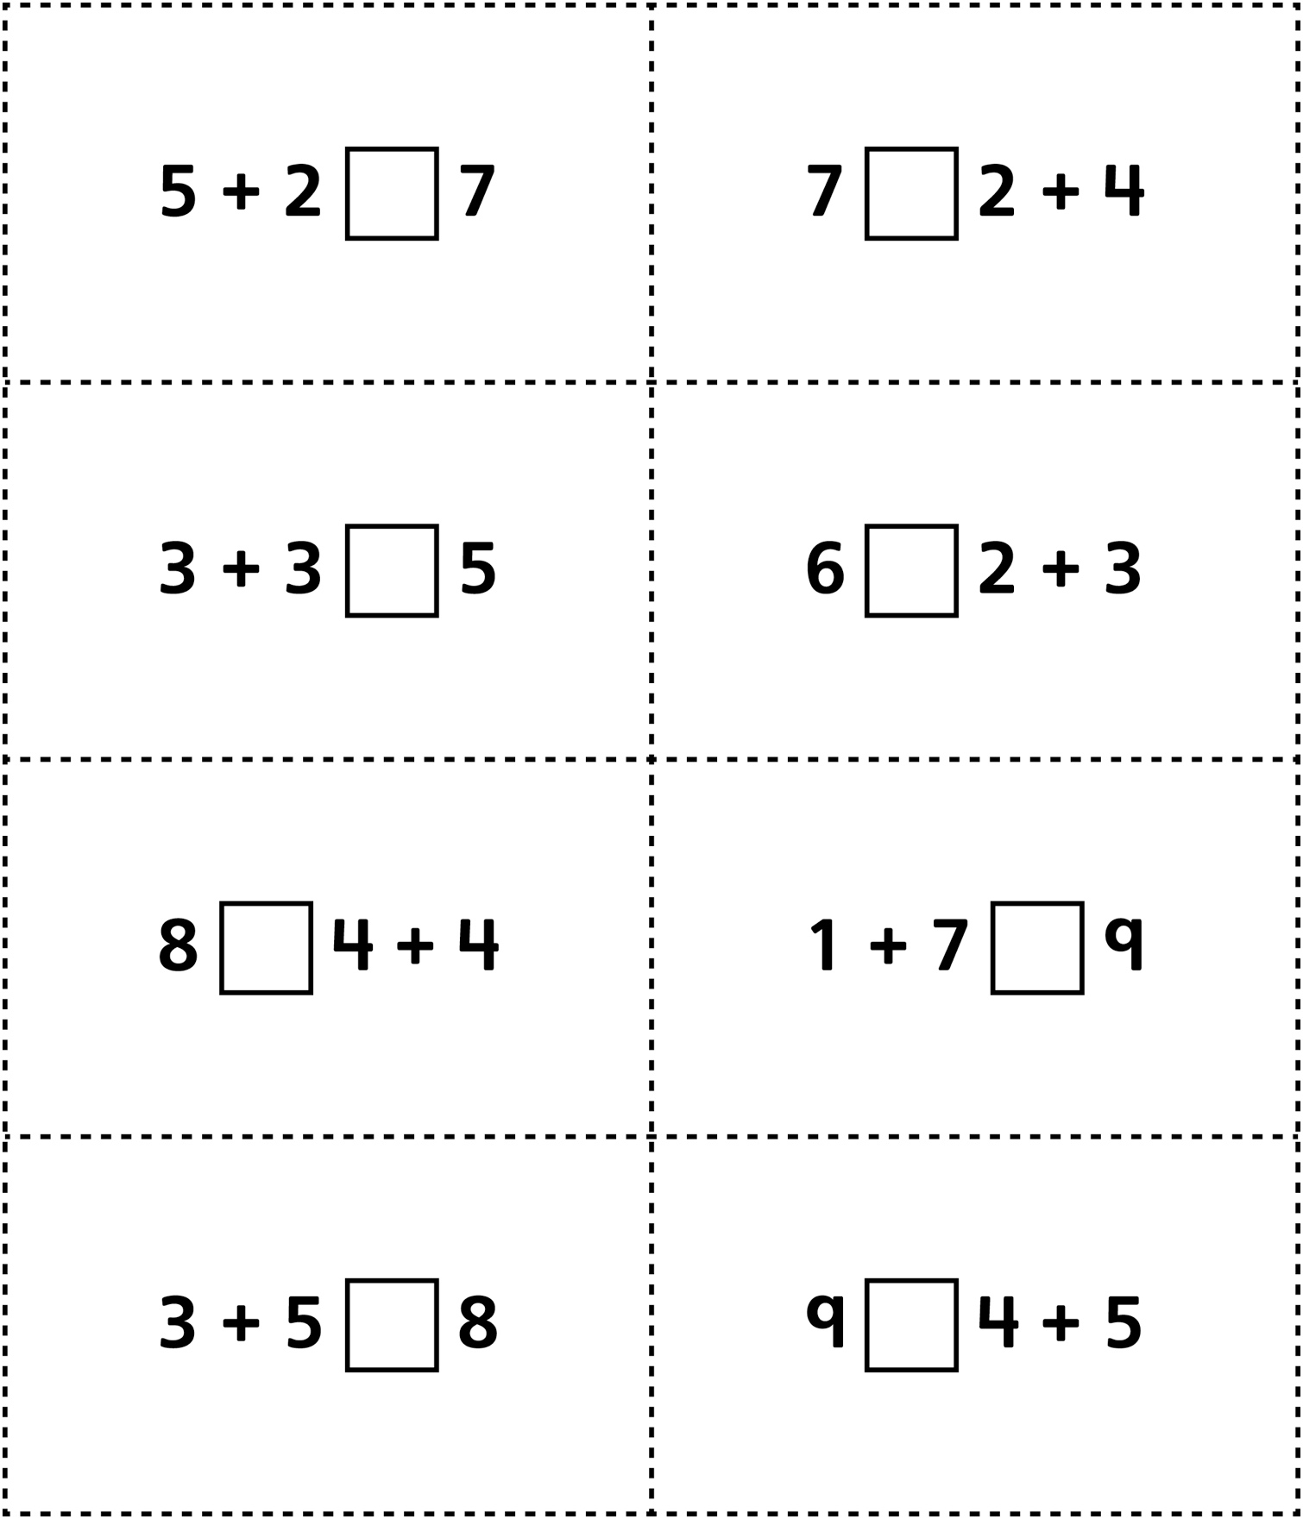

**Equal or Not Equal? Cards  
(for Extension)**

**Master 35c**

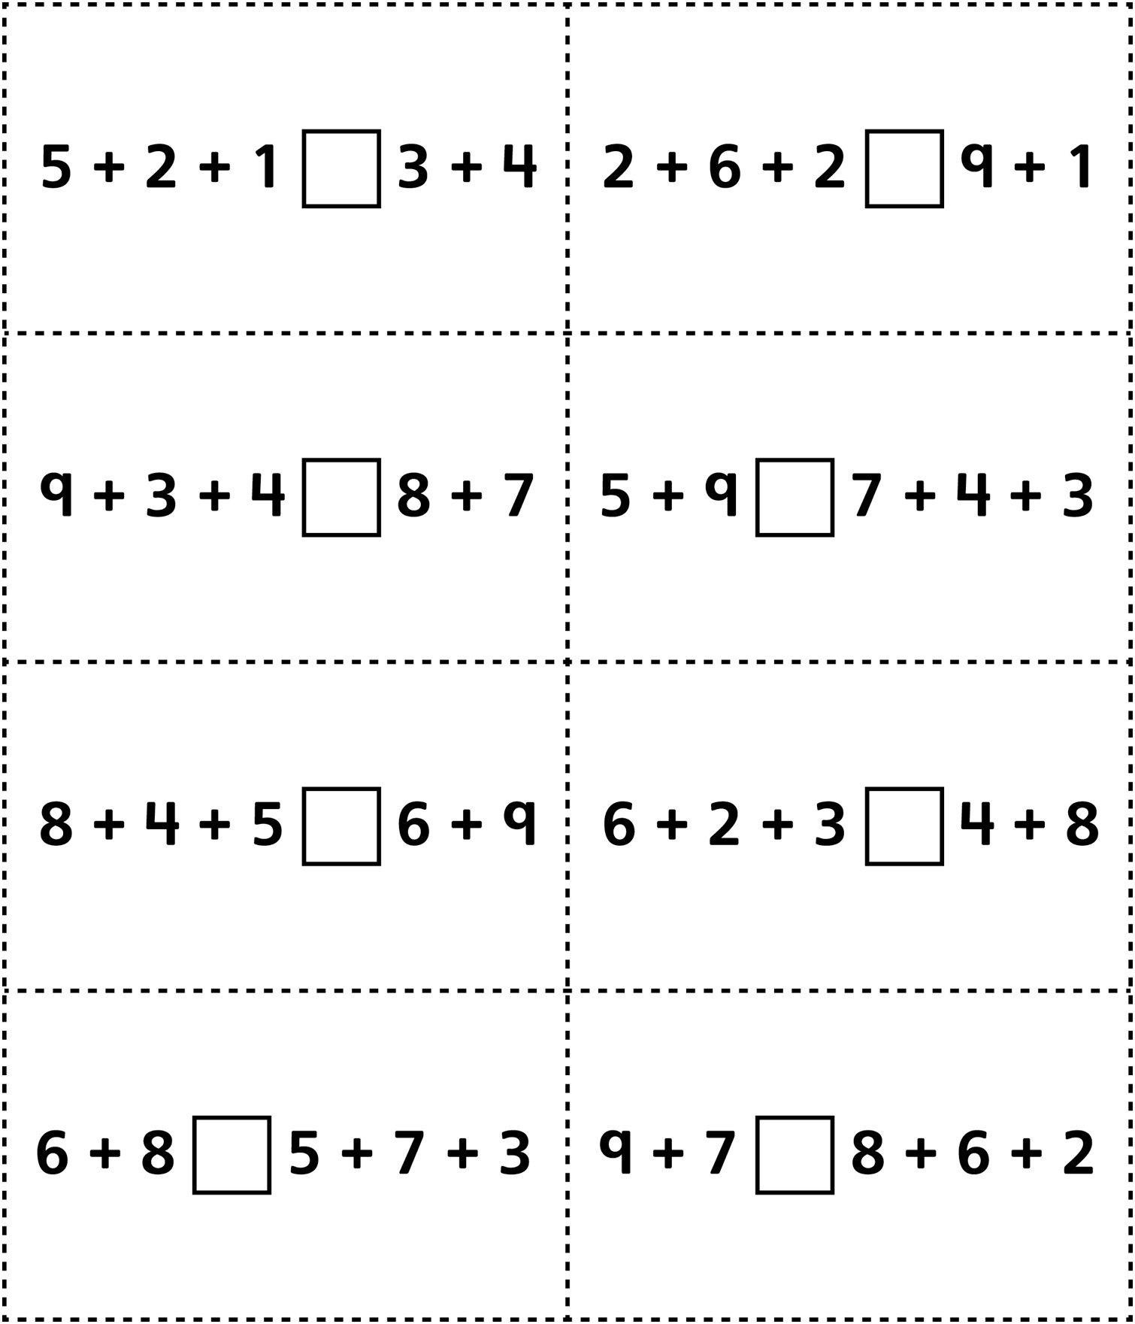

**Equal or Not Equal? Cards  
(for Combined Grades Extension)**

**Master 35d**

