Expressing Equality and Inequality Behaviours/Strategies
- Student chooses a number, but struggles to  decompose number into two parts and model it with cubes. | - Student models equality with cubes, but  struggles to record different expressions of  the same quantity as equalities (cannot write  number sentence).  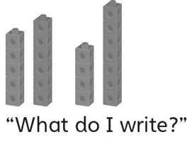 | - Student models equality, but does not consider  zero, or thinks the same cubes in the opposite  order is not an equality.  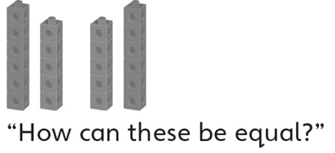
Observations/Documentation
- Student models equality, but struggles to model inequality. | - Student models inequality, but struggles to  use the not equal symbol when comparing  expressions.  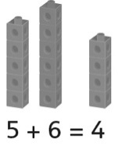 | - Student models equality and inequality, records  different expressions of the same quantity as  equalities, and understands and uses the equal  (=) and not equal (≠) symbols when comparing  expressions.  5 + 6 = 4 + 7  5 + 6 ≠ 4 + 5
Observations/Documentation

Big Idea |  |  |  |  | Indicators from Learning Progression
Curriculum Expectations addressed

Student Names
Student can create equal and unequal sets.
(Activity 15)
Student can compare sets
to identify the unequal set. (Activity 15)
Student can identify equal and unequal number sentences.
(Activity 16)
Student knows when to use the equal and not equal signs.
(Activities 16, 17, 20)
Student can model equality and inequality.
(Activities 16, 20)
Student can model a number sentence/ expression with manipulatives.
(Activities 16, 17, 18, 19)
Student realizes that the order in which numbers are added does not matter.
(Activities 18, 20)
Student realizes that adding or subtracting zero does not affect the
number.
(Activities 18, 20)
Student can find the missing number in a number sentence.
(Activities 19)
Student can write different expressions of the same quantity as equalities.
(Activity 20)

Name: _______________________

 | Not Observed | Sometimes | Consistently
Creates equal and unequal sets.
(Activity 15)
Compares sets to identify the unequal set.
(Activity 15)
Identifies equal and unequal number sentences.
(Activity 16)
Knows when to use the equal and not equal signs.
(Activities 16, 17, 20)
Models equality and inequality.
(Activities 16, 20)
Models a number sentence/ expression with manipulatives.
(Activities 16, 17, 18, 19)
Realizes that the order in which numbers are added does not matter.
(Activities 18, 20)
Realizes that adding or subtracting zero does not affect the number.
(Activities 18, 20)
Finds the missing number in a number sentence.
(Activities 19)
Writes different expressions of the same quantity as equalities.
(Activity 20)

Strengths:

Next Steps:

