The Great Dogsled Race Line Master 1
(Assessment Master)

Name: _____________________________

Add and Subtract to 100 | Not observed | Sometimes | Consistently
Estimates sums and differences
Extends known sums and differences to solve other equations
Develops mental and personal addition and subtraction strategies
Models and symbolizes addition and subtraction
Compare and Order Numbers
Compares quantities to 100
Orders three or more quantities
Finds how many more/less one quantity is compared to another
Strengths:

Next Steps:

Connecting Home and School Line Master 2–1



NOTE TO THE TEACHER

You may wish to send families a The Great Dogsled Race letter outlining a familiar activity or two they can do at home with their children.

Create a letter using this template and select one or two activities from the suggestions on the next page. Simply delete these instructions and cut and paste the activities you have selected, adapting them to fit your needs.

Connecting Home and School Line Master 2–2

Dear Family:

We have been working on The Great Dogsled Race, which focuses on adding and subtracting to 100, and comparing and ordering numbers. Try this activity at home with your child.

 – – – – – – – – – – – – – – – – – – – – – – – – – – – – – – – – – – – – – – – – – –

Reading the Story: As you read the story, encourage your child to follow along as Darryl and Natalie take care of the dogs. They can count scoops of food, tally daily exercises, and add the number of race-goers. After reading, engage your child in tracking the animals they see regularly and monitoring the differences between numbers that come up in daily life. For example: We saw 6 dogs on the way to school and 4 on the way home. How many more did we see in the morning?

 – – – – – – – – – – – – – – – – – – – – – – – – – – – – – – – – – – – – – – – – – –

Blogging: Encourage your child to keep a daily blog or journal to record important numbers they encounter every day. Explain that regular updates can include important events, weather statistics, and number facts. Talk about special items they would like to include. Invite them to share their blogs with family, friends, and classmates.

 – – – – – – – – – – – – – – – – – – – – – – – – – – – – – – – – – – – – – – – – – –

Race to 50: Use number cubes and counters (any small objects) to play Race to 50. Take turns rolling 2 number cubes and adding the numbers together. Record each answer using tally marks. Each player should keep track of their own score, adding to the tally marks each time they roll 2 number cubes. The first to reach 50 wins the game. Encourage your child to predict each move and to double-check their answers. Extend the game by racing to 100 or racing back from 50 to 0 by rolling number cubes and subtracting tally marks.

 – – – – – – – – – – – – – – – – – – – – – – – – – – – – – – – – – – – – – – – – – –

Sincerely,

___________________________
The Great Dogsled Race Line Master 3
Math Mat

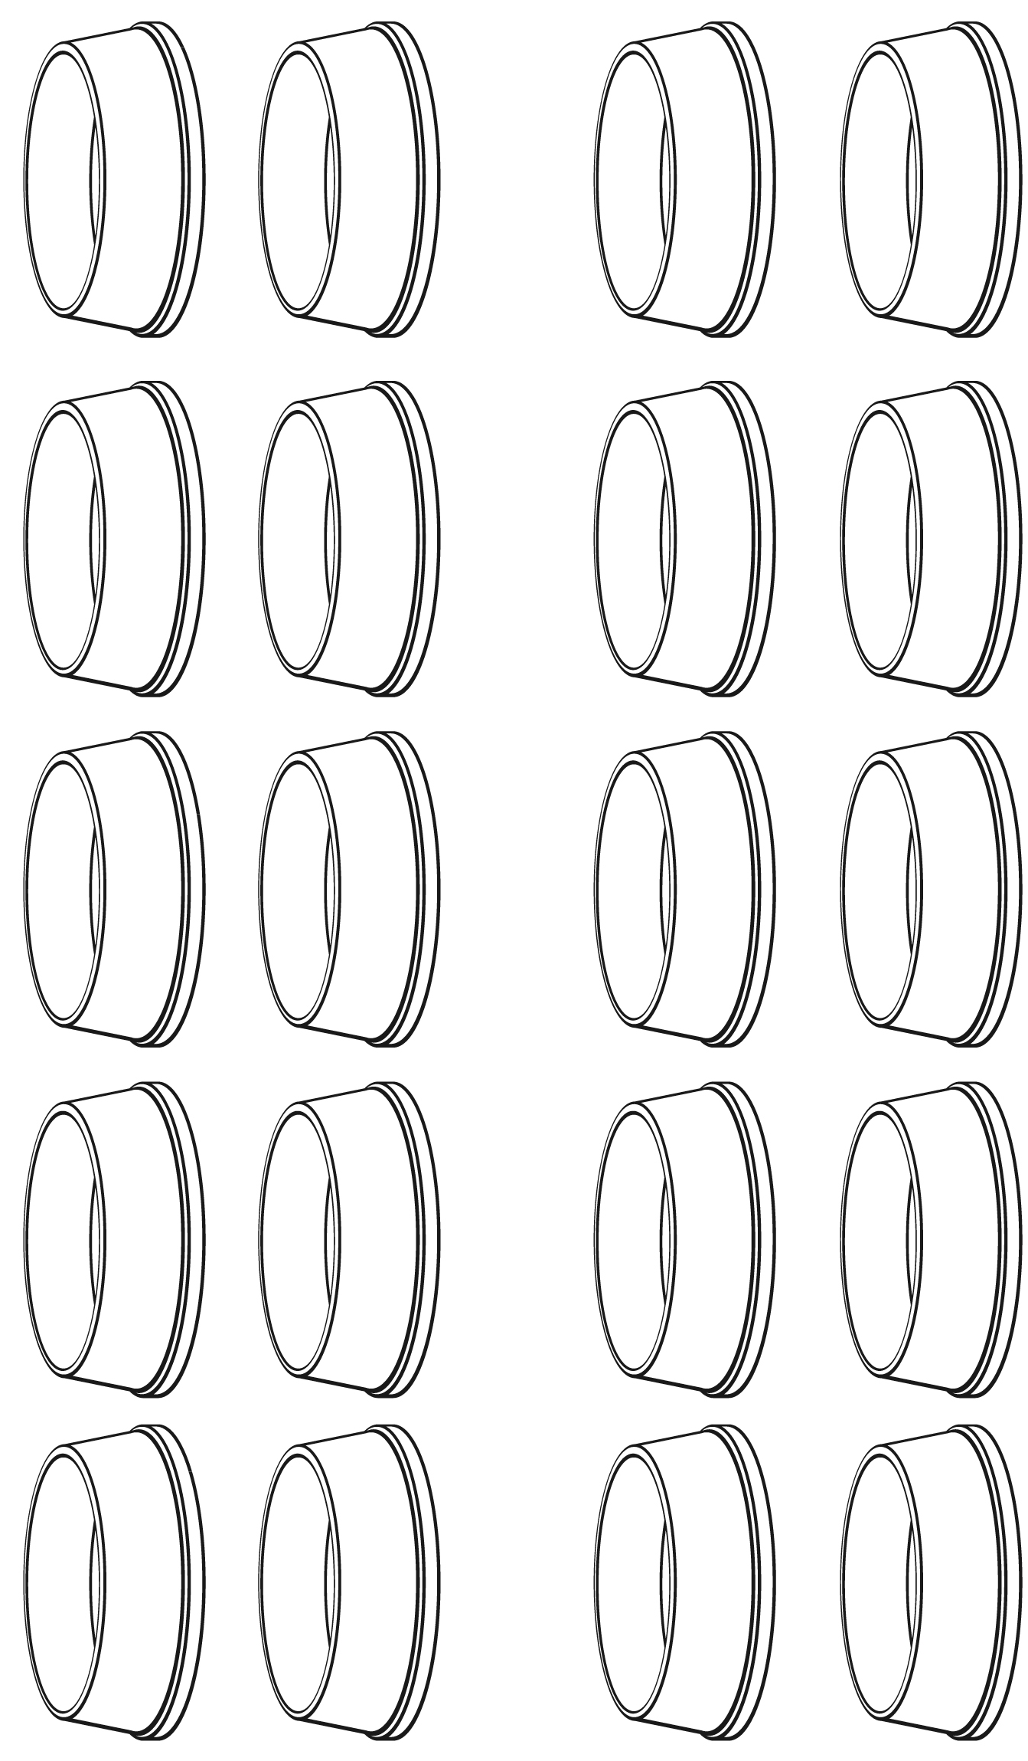

Hundred Chart Line Master 4

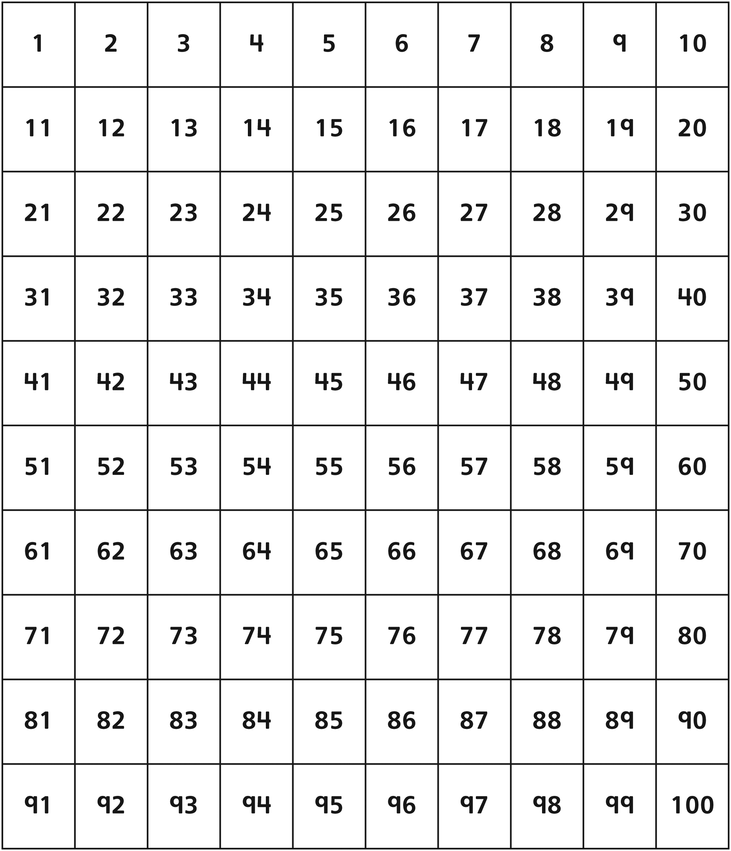
Modelling Addition Line Master 5
Name: _____________________________

Solve using words, numbers, and/or drawings.

____ + ____ = _______

Circle the tool(s) you used:
- Base Ten Blocks
- Hundred chart
- Number line
- Other: _____________________

Modelling Subtraction Line Master 6
Name: _____________________________

Solve using words, numbers, and/or drawings.

____ – ____ = _______

Circle the tool(s) you used:
- Base Ten Blocks
- Hundred chart
- Number line
- Other: _____________________

Making 10 Line Master 7
Name: _____________________________

25 + 15 = _______

33 + 27 = _______

11 + 29 = _______

Numeral Cards Line Master 8–1
1 | 2 | 3 | 4 | 5
6 | 7 | 8 | 9 | 10
11 | 12 | 13 | 14 | 15
16 | 17 | 18 | 19 | 20
21 | 22 | 23 | 24 | 25

Numeral Cards Line Master 8–2
26 | 27 | 28 | 29 | 30
31 | 32 | 33 | 34 | 35
36 | 37 | 38 | 39 | 40
41 | 42 | 43 | 44 | 45
46 | 47 | 48 | 49 | 50

Numeral Cards Line Master 8–3
51 | 52 | 53 | 54 | 55
56 | 57 | 58 | 59 | 60
61 | 62 | 63 | 64 | 65
66 | 67 | 68 | 69 | 70
71 | 72 | 73 | 74 | 75

Numeral Cards Line Master 8–4
76 | 77 | 78 | 79 | 80
81 | 82 | 83 | 84 | 85
86 | 87 | 88 | 89 | 90
91 | 92 | 93 | 94 | 95
96 | 97 | 98 | 99 | 100

Fifty Chart Line Master 9

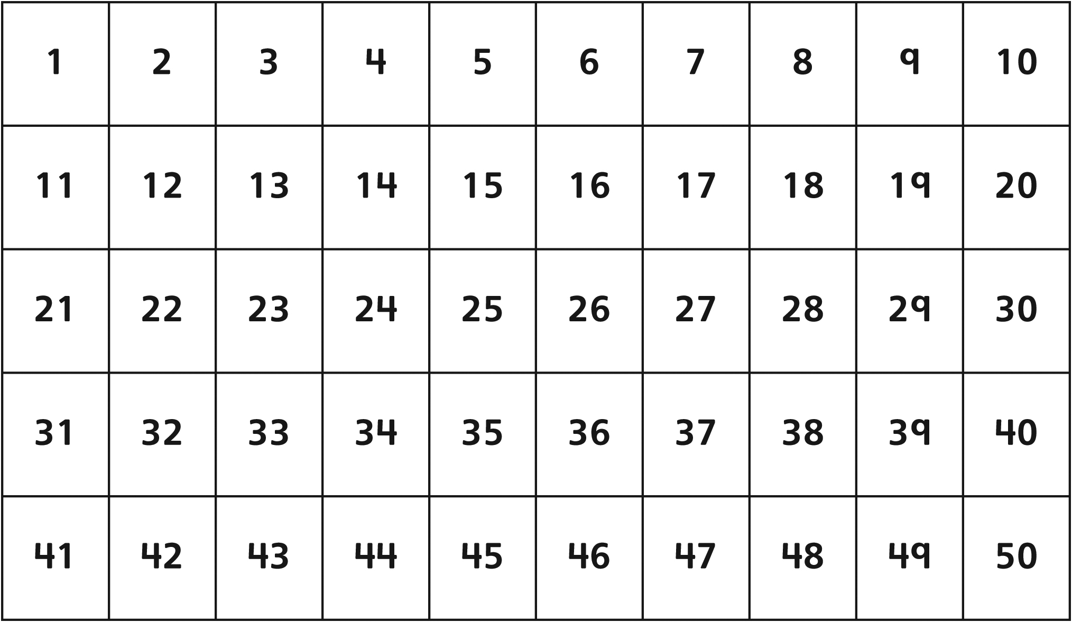

 – – – – – – – – – – – – – – – – – – – – – – – – – – – – – – – – – – – – – – – – – –

Race Map Line Master 10
Name: _____________________________

Record your checkpoints along the route.

|_______________________________________________________________________________________|
0 kilometres 100 kilometres

Checkpoint Number | Distance from Start in kilometres
Start | 0 kilometres
1
2
3
4
End | 100 kilometres

The distance between the start and Checkpoint 1 is __________________________.

The distance between Checkpoints 1 and 2 is __________________________.

The distance between Checkpoints 2 and 3 is __________________________.

The distance between Checkpoints 3 and 4 is __________________________.

The distance between Checkpoint 4 and the end is __________________________.

Class Blog Line Master 11
Name: _____________________________

CLASS NUMBER FACTS: | Class Blog
CLASS NUMBER FACTS: | Today’s date is ___________________________  Our daily update…  Total number of students today: ______________
NEWS:

PHOTOS:

PHOTOS: | Read Comments Likes

Dogsled Math Problems Line Master 12–1
 – – – – – – – – – – – – – – – – – – – – – – – – – – – – – – – – – – – – – – – – – –
The longest distance between checkpoints during the race is 63 kilometres and the shortest distance is 17 kilometres. What is the difference between 63 and 17? Use words, numbers, and/or drawings to show your thinking.

 – – – – – – – – – – – – – – – – – – – – – – – – – – – – – – – – – – – – – – – – – –
The oldest racer to compete was 71 years old and the youngest racer was only 18 years old. What is the difference between their ages? Use words, numbers, and/or drawings to show your thinking.
Dogsled Math Problems Line Master 12–2
 – – – – – – – – – – – – – – – – – – – – – – – – – – – – – – – – – – – – – – – – – –
41 people read the blog on Day 6, and 52 people read it on Day 7. How many people read the blog altogether on Day 6 and Day 7?

 – – – – – – – – – – – – – – – – – – – – – – – – – – – – – – – – – – – – – – – – – –
38 people read the blog on Day 8, and 62 people read it on Day 9. How many people read the blog altogether on Day 8 and Day 9?

