Big Buddy Days Line Master 1
(Assessment Master)
Name: _____________________________

Build Pictographs | Not observed | Sometimes | Consistently
Collects data by determining (most) categories in advance
Chooses an appropriate method to collect data
Chooses an appropriate method to organize data
Creates displays using simple pictographs
Interpret Pictographs
Interprets displays by noting how many more/less than other categories
Reads and interprets information from data displays
Strengths:

Next Steps:

Connecting Home and School Line Master 2–1

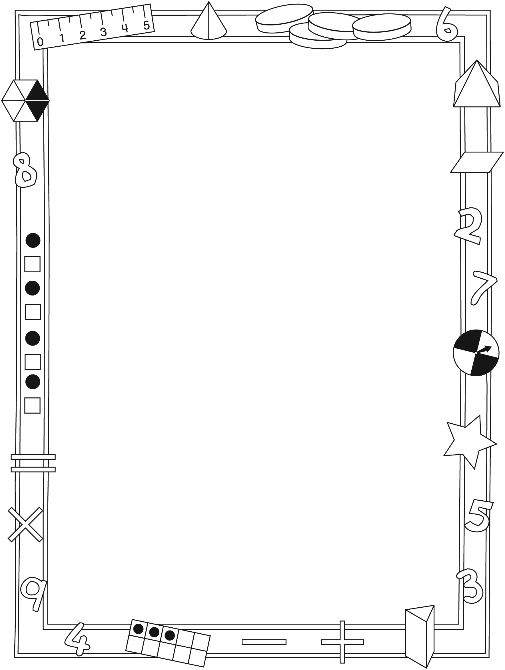

NOTE TO THE TEACHER

You may wish to send families a Big Buddy Days letter outlining a familiar activity or two they can do at home with their children.

Create a letter using this template and select one or two activities from the suggestions on the next page. Simply delete these instructions and cut and paste the activities you have selected, adapting them to fit your needs.

Connecting Home and School Line Master 2–2

Dear Family:

We have been working on Big Buddy Days, which engages children in conversations, investigations, and activities that help to develop their understanding of the big math idea that “Collecting and displaying data can help us predict and interpret situations.” Particular focus is placed on building and interpreting pictographs. Try this activity at home with your child.

– – – – – – – – – – – – – – – – – – – – – – – – – – – – – – – – – – – – – – – – – –

Reading the Story: As you read the story, enjoy talking about the various ways information is displayed, and what you learn from the pictographs.

– – – – – – – – – – – – – – – – – – – – – – – – – – – – – – – – – – – – – – – – – –

Graphing at Home: With your child, create pictographs at home. For example, you could sort and graph the number of spoons, scoops, forks, and spatulas in the utensil drawer. Once you have organized the household items, talk about which is more and which is less and how many items there are altogether.

– – – – – – – – – – – – – – – – – – – – – – – – – – – – – – – – – – – – – – – – – –

Newsworthy: Explore and talk about pictographs on appropriate topics that appear in the news, on TV, on the Internet, or in books or magazines you read together. Talk about what they mean. Many will be too complex for your child to understand, but he/she may recognize the form and structure of the pictograph. Talk about which category is more and which category is less.
Being an informed citizen means being able to interpret graphs!

– – – – – – – – – – – – – – – – – – – – – – – – – – – – – – – – – – – – – – – – – –

Sincerely,

___________________________

Big Buddy Days Math Mat Line Master 3

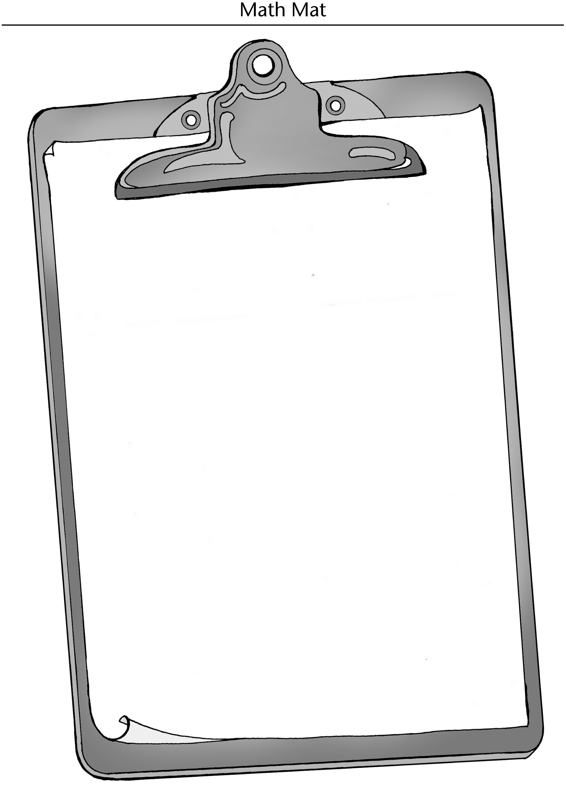

Mystery Tally Charts Line Master 4–1
Name: _____________________________

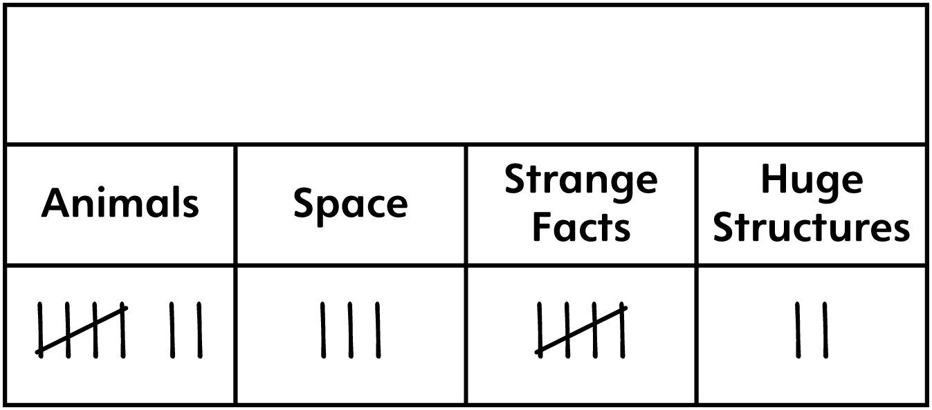

1. What do you think this tally chart is about?

2. What could be the title of this tally chart?

3. What question could this data be answering?

4. What might the answer be?

Mystery Tally Charts Line Master 4–2
Name: _____________________________

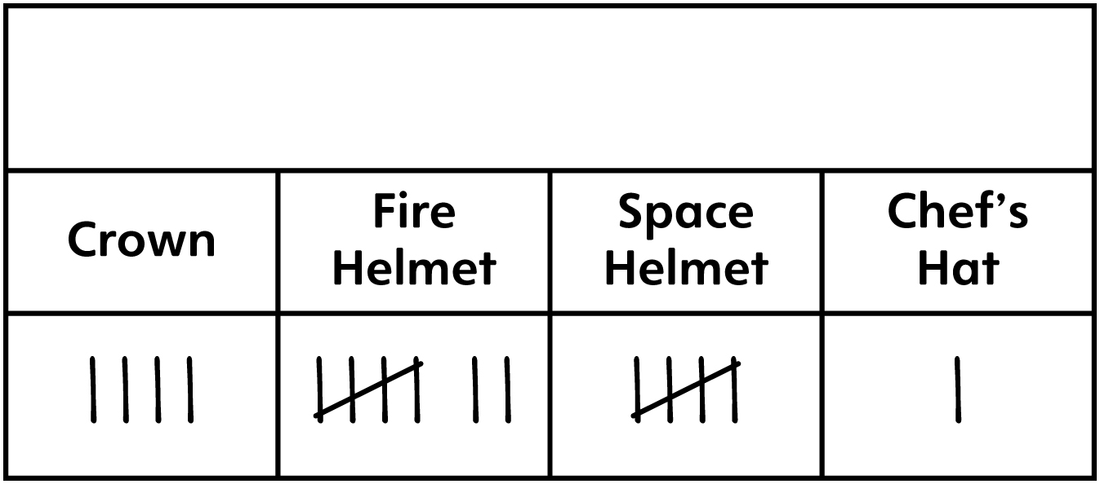

1. What do you think this tally chart is about?

2. What could be the title of this tally chart?

3. What question could this data be answering?

4. What might the answer be?

Graphing Grid Line Master 5
Name: _____________________________
Pictograph Title: _____________________________

Fact Finder Line Master 6–1
Name: _____________________________

1. Draw or glue the pictograph you found in the
space below.
2. Underline or write the title in one colour.
3. Underline or write the labels in a different colour.
4. Circle one of each symbol.

Fact Finder Line Master 6–2
Name: _____________________________

5. What do each of the symbols stand for? Use numbers, words, or drawings to explain.

6. Use words, numbers, or drawings to explain 3 things you learned from the pictograph.

Big Buddy Problems Line Master 7–1

30 children voted on which outdoor activity they want to play.
• 7 children voted for 4-square
• 10 children voted for soccer
• 9 children voted for tag
• 4 children voted for kites

1. Make a pictograph on a graphing grid.

2. Use the data on the pictograph to answer the following questions using words, numbers, and/or drawings.
a) How many children voted for each game?

b) Which game was the most popular?

c) By how many votes did the game win?

Big Buddy Problems Line Master 7–2

Arts Activity Ideas
Paint | Sing | Build Clay Models | Make Sticker Crafts

Use the data on the pictograph to answer the following questions using words, numbers, and/or drawings.

1. a) So far, how many children voted on what Arts activity to do?

b) Suppose 18 children are voting altogether. How many children still have to vote?

c) Suppose all of the remaining votes are for making sticker crafts. Show this on the pictograph.

2. a) How many children voted to make sticker crafts?

b) How many more children voted to paint rather than to make sticker crafts?

c) How many children would need to change their vote to so that making sticker crafts would have more votes than painting?

