Getting Ready for School Line Master 1
(Assessment Master)
Name: _____________________________

Estimate and Measure Length, Duration, and Distance Around | Not observed | Sometimes | Consistently
Estimates and measures length, distance, and time
Explores time
Uses personal and familiar referents to estimate measures
Selects and uses appropriate measuring tools
Compare, Order, and Describe Measures
Compares and orders objects according to length, distance, and time
Uses relative terms to describe length, distance around, and time
Strengths:

Next Steps:

Connecting Home and School Line Master 2–1

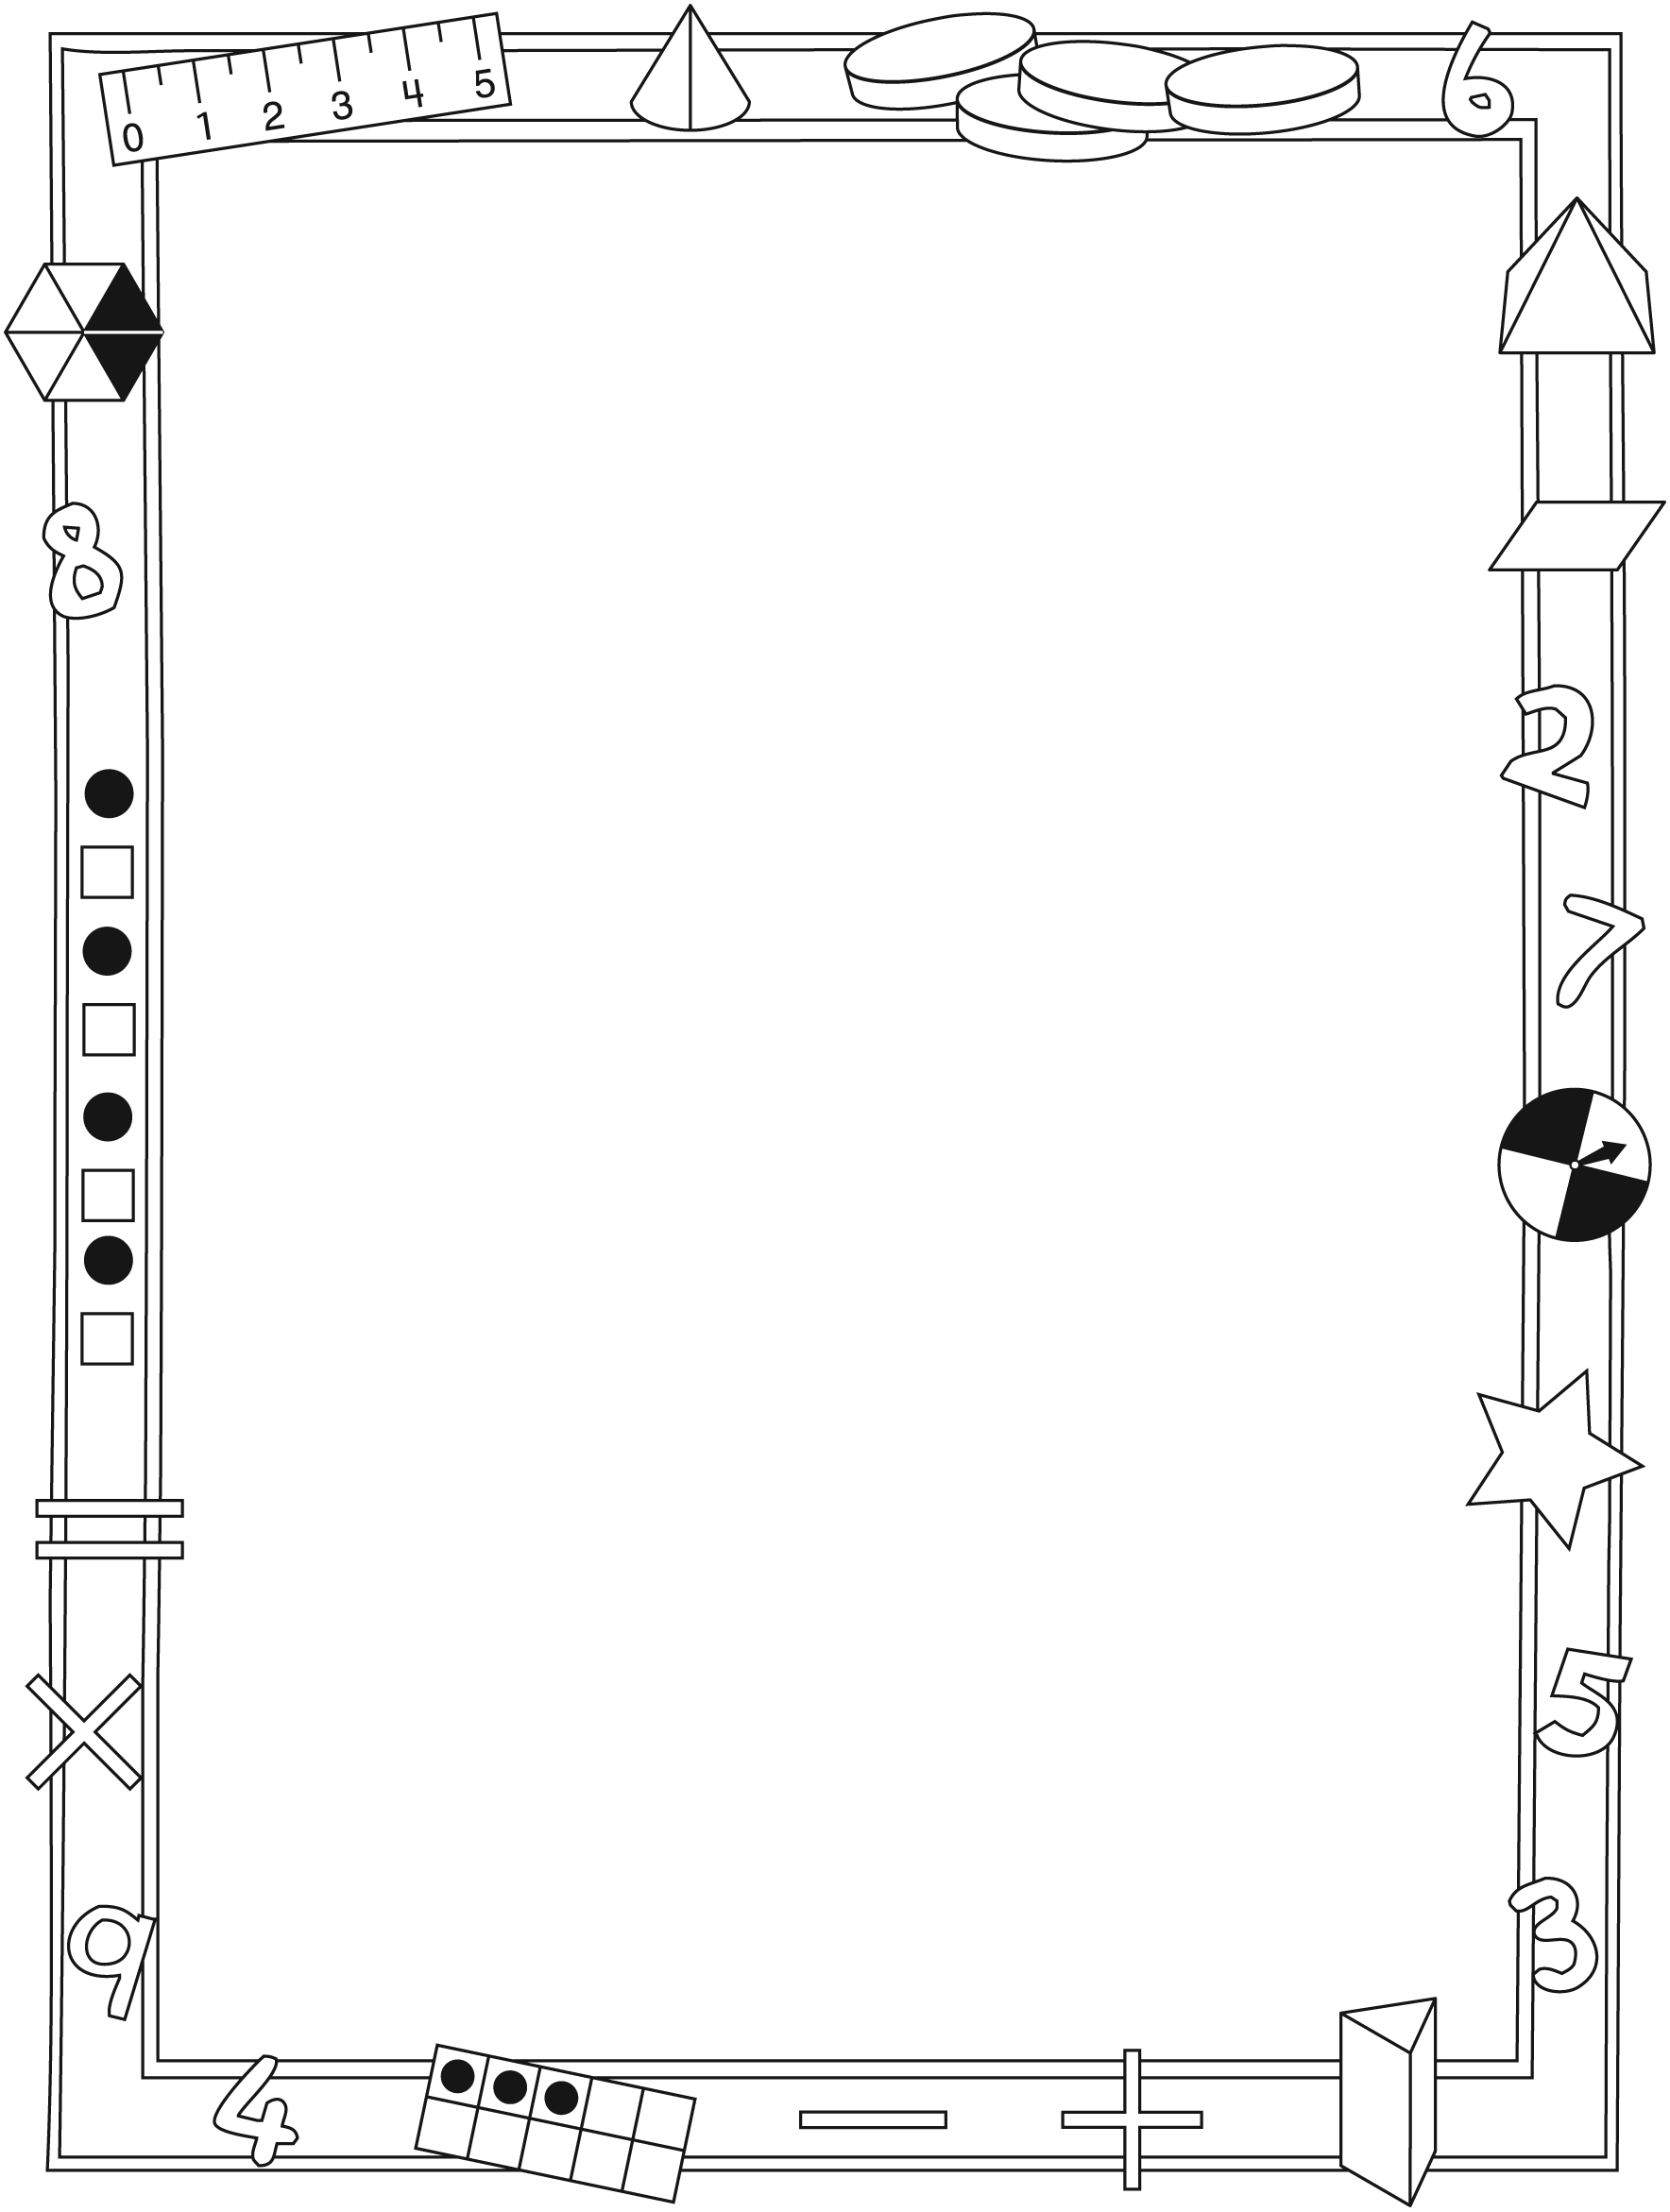

NOTE TO THE TEACHER

You may wish to send families a Getting Ready for School letter outlining a familiar activity or two they can do at home with their children.

Create a letter using this template and select one or two activities from the suggestions on the next page. Simply delete these instructions and cut and paste the activities you have selected, adapting them to fit your needs.

Connecting Home and School Line Master 2–2

Dear Family:

We have been working on Getting Ready for School, which engages children in conversations, investigations, and activities that help to develop their understanding of the big math idea that “Units can be used to measure and compare attributes.” Particular focus is placed on estimating, measuring, and comparing length, time, and distance around. Try this activity at home with your child.
– – – – – – – – – – – – – – – – – – – – – – – – – – – – – – – – – – – – – – – – – –
Reading the Story: As you read the story, enjoy talking about the different ways Addie measures length, height, and distance. If you have string or paper clips on hand, you can measure and compare the distance around your wrists, heads, and waists. Measure from your feet to your shoulders in hand widths. How do your measures compare with each other? How do your measures compare with Eric’s?
– – – – – – – – – – – – – – – – – – – – – – – – – – – – – – – – – – – – – – – – – –
How Many Steps? Have your child measure distance by counting heel-to-toe steps or strides. Encourage comparison. For example, ask: Do you think it takes more or fewer baby steps from the front door to the kitchen or from the kitchen to your bedroom? Discuss a reasonable way of figuring this out and then try it. Estimate and measure other distances, always estimating the greatest and least distances before embarking on a common unit of measure.
– – – – – – – – – – – – – – – – – – – – – – – – – – – – – – – – – – – – – – – – – –
How Long Is 1 Minute? See how well your child can sense how long 1 minute is. Set a timer, and have your child close her/his eyes. Have your child raise her/his hand when it feels like 1 minute is up. Do this several times and see whether the estimates get closer to 60 seconds with experience.
– – – – – – – – – – – – – – – – – – – – – – – – – – – – – – – – – – – – – – – – – –
Scavenger Hunt: Look at a ruler to get a sense of how long 10 centimetres is. Trying coming up with a personal measure that will help your child estimate and measure 10 centimetres. Send your child on a scavenger hunt to find and list things that are about 10 centimetres. Use a ruler to check how close the estimates were.
– – – – – – – – – – – – – – – – – – – – – – – – – – – – – – – – – – – – – – – – – –
Sincerely,

___________________________

Getting Ready for School Line Master 3
Math Mat

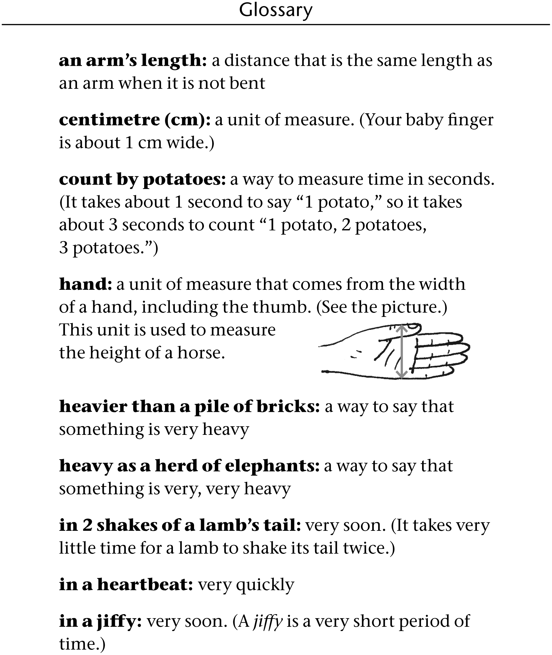

My Order Form Line Master 4
Name: _____________________________

 | My estimate | My measure
Distance around wrist
Distance around ankle
Distance around head
Distance around waist

When I compare my measures, I know…

My _______________________________________ is the longest around.

My ______________________________________ is the shortest around.

My Jumps Line Master 5
Name: _____________________________

Jump | My estimate | My measure
1 | _________ ________________ | _________ ________________
2 | _________ ________________ | _________ ________________
3 | _________ ________________ | _________ ________________
4 | _________ ________________ | _________ ________________

I discovered…

My longest jump was…

My shortest jump was...

Measuring Different Ways Line Master 6
Name: _____________________________

Units | My estimate | My measure
linking
cubes
craft
sticks
straws

What did you notice about using different units of measure?

Training Activity Line Master 7
Name: _____________________________

My training activity is _________________________________________.

I measured in centimetres. Here is a record of my results.

My estimate | My measure

The longest distance was _________________________________.

The shortest distance was _________________________________.

My closest estimate was _________________________________.

Measuring Paths Line Master 8
Name: _____________________________

Paths | My estimate  in centimetres | My measure  in centimetres
_____________ | _______________________ | _______________________
_____________ | _______________________ | _______________________
_____________ | _______________________ | _______________________

Order the paths from longest to shortest.

Longest Shortest

____________________ ___________________ ___________________

My Superhero Profile Line Master 9

My name is __________________________________.

I am also known as __________________________________.

I am _______________ centimetres tall.

I am...

I can...

Here is my picture:

Measuring Problems Line Master 10–1

Centimetres
Name: _____________________________

This line is 10 centimetres long.
__________________________________________

Use this line to picture what 100 centimetres would
look like.
Cut a piece of string that you think is 100 centimetres long.
Measure it. What did you discover?

Now cut another piece of string that you think is
100 centimetres long.
Measure it. What did you discover?

Was your estimate closer?

Try one more time.
Order your strings from shortest to longest.

________ centimetres ________ centimetres ________ centimetres

Measuring Problems Line Master 10–2

Centimetres
– – – – – – – – – – – – – – – – – – – – – – – – – – – – – – – – – – – – – – – – – –
This line is 1 centimetre long.
____

What can you find that is about 1 centimetre long?

– – – – – – – – – – – – – – – – – – – – – – – – – – – – – – – – – – – – – – – – – –
This line is 10 centimetres long.

What can you find that is about 10 centimetres long?

– – – – – – – – – – – – – – – – – – – – – – – – – – – – – – – – – – – – – – – – – –
This line is 15 centimetres long.

What can you find that is about 15 centimetres long?

– – – – – – – – – – – – – – – – – – – – – – – – – – – – – – – – – – – – – – – – – –

Measuring Problems Line Master 10–3

Comparing Measures
Name: _____________________________

Addie and Eric took turns practising their kicking skills.
They kicked a paper ball with their left foot and then with their right foot.
They measured each kick with their strides.

Addie | Left foot | Right foot | Which kick went farther?  How much farther?
Try 1 | 12 strides | 8 strides
Try 2 | 13 strides | 5 strides

Eric | Left foot | Right foot | Which kick went farther?  How much farther?
Try 1 | 14 strides | 20 strides
Try 2 | 18 strides | 21 strides

What else do you notice?

Measuring Problems Line Master 10–4

Measuring 1 Minute
Name: _____________________________

Record 4 activities you think you can do in 1 minute.

Use a 1 minute timer to time yourself. What did you discover?

My activity | My discovery (circle)
Activity 1 | less than 1 minute  about 1 minute  more than 1 minute
Activity 2 | less than 1 minute  about 1 minute  more than 1 minute
Activity 3 | less than 1 minute  about 1 minute  more than 1 minute
Activity 4 | less than 1 minute  about 1 minute  more than 1 minute

